**Preliminary Eligibility Application – Individual Resources**

**National Register of Historic Places**

December 11, 2024

(please type or print)

**Property Information:**

Name (current or common):

Other Name(s) (historic or other):

Address (current): Street:

City, State, Zip:        County:

Acreage: Current:        Historic:

Property Use (ex: residence, school, farm, retail, warehouse, church, mill, battlefield):

Current:        Historic:        Property type:

Building or buildings Structure Site Object

Date of Construction:        Architect/Builder (if applicable/known):

**Significance:** Check the box(es) by the criterion under which you believe this property is eligible. Refer to the National Park Service’s National Register Bulletin 15: *How to Apply the National Register Criteria for Evaluation* – pages 11-24 available at: [How to Apply the National Register Criteria for Evaluation](https://www.nps.gov/subjects/nationalregister/upload/NRB-15_web508.pdf)

You will elaborate on this selection in your “Brief History” below.

Criterion A (event)

Criterion B (person)

Criterion C (design/construction (architecture))

Criterion D (information potential and/or archeology)

**Sponsor:**

Name(s):         Address: Street:

City, State, Zip:        County:

Telephone:        Email:

**Property Owner(s) (if different than sponsor):**

Name(s):

Owner Consent: Yes No­­­­ (owner consent is required for National Register listing)

Address: Street:

City, State, Zip:        County:

Telephone:        Email:

**Form Prepared By (if different than either of the above):**

Name(s):

Company/Organization:

Address: Street:

City, State, Zip:        County:

Telephone:        Email:

**Date Submitted**:

**Reasons for Nominating the Property (Explain all that apply):**

Recognition (explain):         Grant Assistance (explain; have you inquired as to the availability of grants or received a grant application?):

Tax Incentives (explain; have you inquired about the applicability of tax incentives or received application forms?):         Other public interest in this nomination (explain):

Brief history: Provide a brief chronological history of the property including its usage, past owners, and development over time. Why is the property important? When was it important? Why do you think that the property meets the National Register Criteria that you checked on page 1?

Physical description: Provide a brief physical description of the property. Fill in the blanks below and use this information to write a narrative, including dates of construction of all buildings, alterations, additions, and any resources no longer extant.

**Number of Stories**

Historic:         Current:         **Exterior Materials** (ex: weatherboard, vinyl siding, brick veneer, stucco; brick, stone foundation)

Historic:         Current:         **Type of Construction** (ex: log, wood frame, brick)

Historic:         Current:         **Roof Shape/Material** (ex: gable roof, asphalt shingle; hip roof, metal)

Historic:         Current:         **Trim Type/Material** (ex: wood porch ornamentation, limestone lintels)

Historic:         Current:         **Floor Plan** (ex: rectangular, L-shaped, irregular)

Historic:         Current:         **Windows** (wood, metal, vinyl)

Historic:         Current:         **Interior Features** (ex: fireplaces, staircases, wainscoting)

Historic:         Current:         **Interior Materials** (ex: plaster or gypsum board walls and ceilings, floor finish materials)

Historic:         Current:

**Alterations** (include ALL changes and dates; ex: rear addition c. 1925; windows replacement c.1964; kitchen renovation including new cabinets and fixtures c. 1995). Remember to note and show all plan/wall changes on your floor plans.

**Other Buildings on Property** (include type and date; ex: detached garage c. 1940, barn c. 1920, smokehouse c. 1860)

**Landscape** (ex: rural, city lot, wooded, sidewalks, site features (stone walls, formal gardens, orchards, vegetation, etc.)

**Archeological Potential**: Has there been an archeological survey of the property or are there known archeological resources on the property (ex: ruins, artifacts, foundation remains, etc.)? If so, explain:

*Scan this completed form along with the written Physical Description and Brief History together and submit as one PDF.*

**Please submit all of the following items in PDF**

Recent color photographs: Provide clear, high-resolution photographs reflecting the current condition and appearance of the property. Scan these into PDF format on an 8 ½ x 11-inch page with no more than two photos per page. The minimum accepted photo size is 4” x 6” per photo. Please include the property name, address, and the date the photos were taken at the top of each page. Ensure that the photos are captioned with their number and printed in numerical order as numbered on the accompanying floorplans/site plan.

Be sure to show representative interior, exterior, and setting views. For individual buildings, provide two interior photos per primary room from opposite corners, and at least one of smaller rooms such as bathrooms, showing as much of the entire room as possible. For exterior photos, provide at least one photo per elevation of the building and all additions. Also provide photos of all other buildings, structures, objects, and sites on the property. Avoid having people in the photographs. Please number the photos in consecutive order and identify each photo by number and directional arrow on the site and floor plans (see the attached sample plans) so that we can take a virtual tour of the property. We cannot review your property without photographs. *Submit all of the photographs together as one single PDF.*

Current floor plan: Provide a current floor plan of each floor of the building (see the attached sample plan) scan as a PDF. A hand sketch is acceptable. Identify each photo by number and directional arrow on the floor plan. Identify rooms either by number, name, or usage, using language that is consistent with your physical description below. **You must** **clearly identify alterations on the floor plan of the building.** Plan/wall changes should be identified by color-coding or patterns, based on the date of the alteration, if appropriate (see the attached sample plan). Be sure to include all changes to the property, including those that have occurred within the last 50 years. *Submit the floor plans, site plan, and location map together as one single PDF.*

Site Plan: Provide a general site plan and key exterior photographs to the site plan. Show all buildings (house, shed, barn, garage, etc.), landscape features or other items of interest (grave, shelter, millstone, etc.). Also show approximate locations of buildings that have been lost over time. A hand sketch is acceptable (scan as a PDF). Make sure to label all buildings, features and items. *Submit the floor plans, site plan, and location map together as one single PDF.*

Location Map: Provide a map that identifies where the property is located. Maps such as a tax map or Google/Bing Maps are acceptable, provided they are accurately scaled, clearly legible and show the building footprint. Please label all streets. **No aerial photos accepted.** *Submit the floor plans, site plan, and location map together as one single PDF.*

Sanborn Fire Insurance Maps (if available): Sanborn Fire Insurance Maps (Sanborn Maps) are highly detailed maps of America’s towns and cities, published between the 1870s and 1960s. They indicate the location, use, plan, construction materials, and number of stories of individual buildings in a community and are an invaluable research tool. **If these are available for the location of this property, you must provide them.** For more information on Sanborn Maps and where to locate them, see *Documenting a Property in Georgia*, Section III. Maps, available at: [Research and Documentation Tools | Georgia Department of Community Affairs](https://dca.georgia.gov/community-assistance/historic-preservation/research-and-documentation-tools)

Historic photographs: Provide historic photographs of the building if available, both interior and exterior. Historic photographs can be critical to our ability to advise you regarding eligibility, so please make an effort to find any available. Please do not send original photographs. *Submit and Sanborn Fire Insurance Maps and other supporting documents such as historic photographs, newspapers, and/or historic maps together as one single PDF.*

We will contact you via email after we review your property with a formal recommendation as to whether you should pursue nomination. Please remember that this initial submission is only preliminary documentation and does not guarantee eligibility. National Register nomination will require additional research and completion of the 10-900 form, which is available on our website. See website for more information about the full nomination process. Note that any eligibility determinations expire after three years from the date of a determination letter. Even during those three years, eligibility may require reassessment if any portion of the property has undergone significant changes or alterations. Please feel free to contact HPD’s National Register Specialist, at 404-486-6377 or by email at [Donald.Rooney@dca.ga.gov](mailto:Donald.Rooney@dca.ga.gov) with any questions.

If this form is more than one year old, please contact our office to see if an updated form is available. Submit your complete application, formatted into the four total PDFs described above, to the National Register Online Database as directed in the NR-TIGERS National Register External User Guide available at: <https://dca.georgia.gov/community-assistance/historic-preservation/national-register-historic-places/national-register>

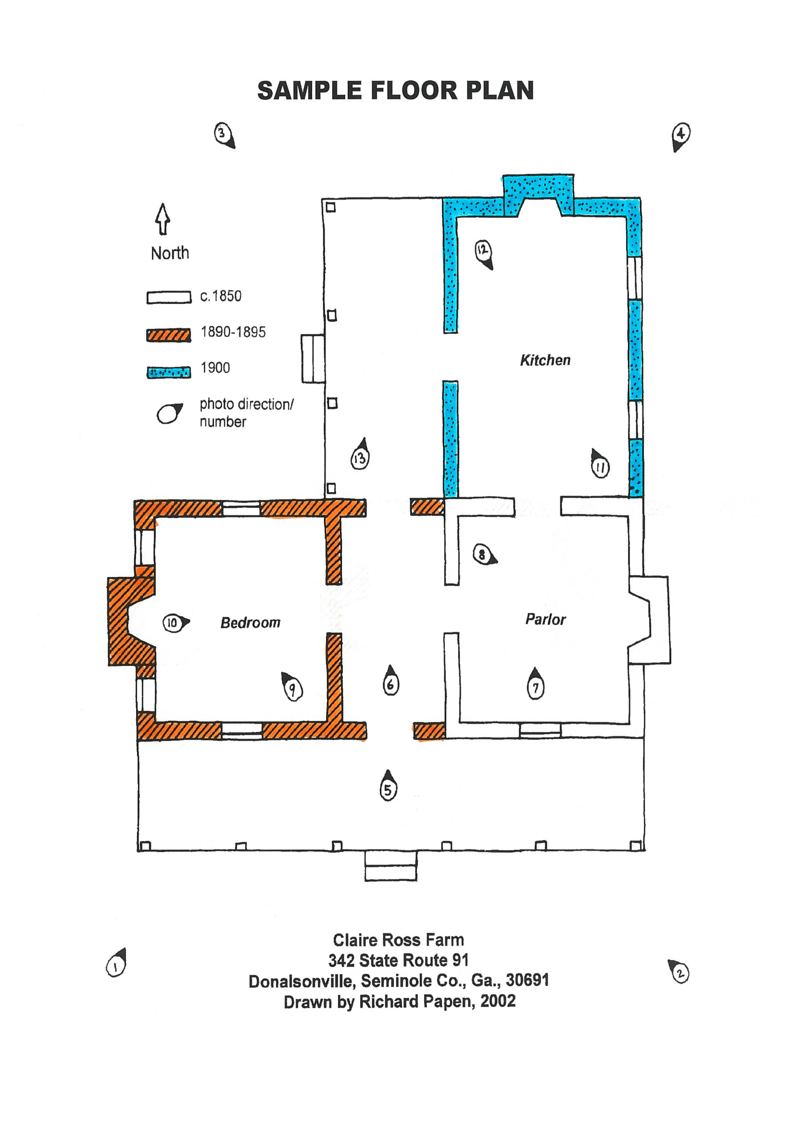

Sample Site Plan

