## EMPHASYS APPLICATION PORTAL INSTRUCTIONS

1. Follow the link ([Georgia DCA - Housing Finance & Development (emphasys-hft.com))](https://ghfafa.emphasys-hft.com/FundingAppCollector/Account/LogOn?ReturnUrl=%2fFundingAppCollector%2fapplications) to register for the Emphasys Developer account and access the Application Collector Portal, where you will complete and submit the application. Upon first visit to the Application Collector Portal, click “Register” to create an account.

1. Graphical user interface, text, application

   Description automatically generatedClick “Fill Out an Application” on the upper left side of the screen under **Applications**.
2. 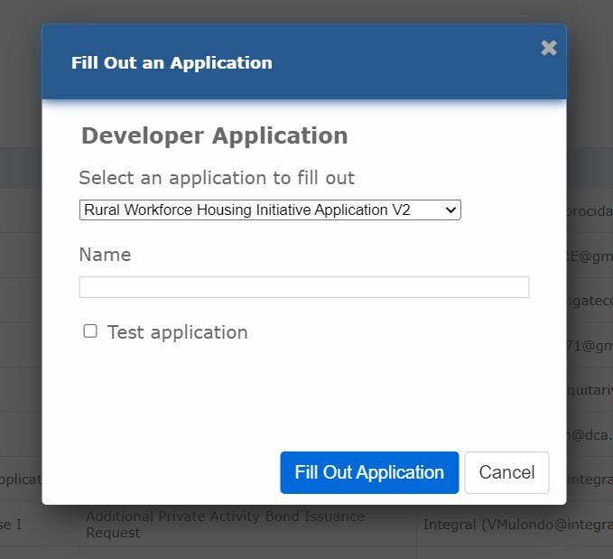Select the “2025 CHIP Application” and enter the name of the applicant filling it out. The name of the applicant should include the Nonprofit, PHA or City/County Name and the CHIP application year. **Do not** check the box next to “Test Application.” Click “Fill Out Application”
3. To proceed forward with the application, you must click the “Save and Next” button. If you want to skip a question, Click the “Save and Next” button.

1. All boxes on the left side panel must be checked with a green check mark. If all boxes are not checked, the application is not complete, and you will get an error message at the submission.

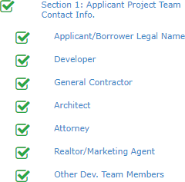

1. At the checklist portion of the application, you must select and upload each requirement. If all boxes are not checked, the application is not complete, and the system will not let you submit the application.

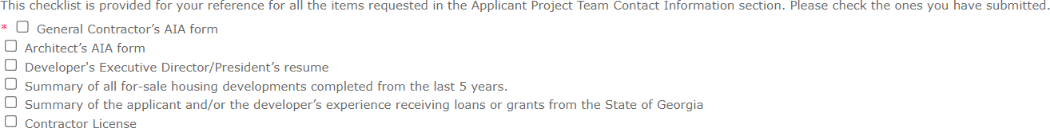

1. Once you get to the end of the application, you might see an error message like the picture below. This message shows you which sections you have not completed, giving you an opportunity to review and add information as requested.

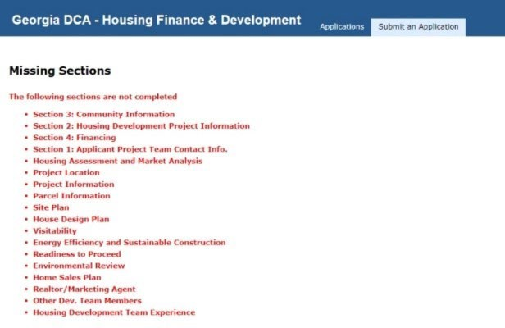

1. You can now submit the application once you have submitted the required documents and reviewed the checklist.

