
DCA HMIS Lead Reporting Manual

Contents

Reports Workspace 3
Section 1: HMIS “Canned” Reports 6
BNLs (By Name Lists) 7
HMIS Exports 11
HMIS Reports 20
Client Reports 31
Enrollment Reports 47
Referral Reports 63
Service Reports 68
Section 2: Custom Reports 96
FYXX LSA Data Quality Reports 98
Client Reports 102
CE Basic Reports 107
Data Quality Report 109
Homeless Information 112
CoC Specific Reports 117
Section 3: CoC Admin Queries 118
Client Data Quality 118
Setup Data 127
LSA Data Quality 130
CE 135
User Data 139
UDA 143
Section 4: Agency Monitoring Reports 147
Reporting Glossary 157

Reports Workspace
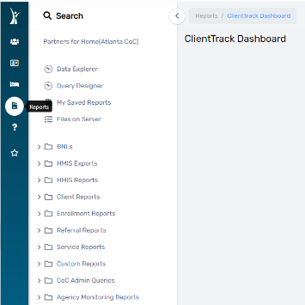
Understanding the relationship between user access levels and report availability is crucial for effective utilization of the 'Reports Workspace.' This diagram provides a clear guideline for users to comprehend their access rights and the range of reports they can leverage based on their roles within the system.
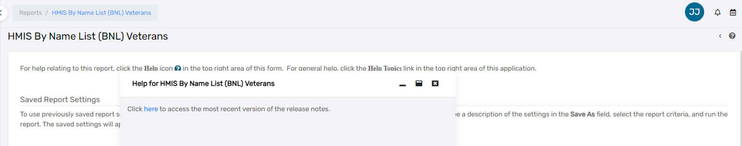
This document outlines the feature of integrated documentation within selected reports in the Reports Workspace. When a specific report is chosen, users may find additional documentation accessible through a '?' icon in the upper right corner, providing supplementary information and guidance.

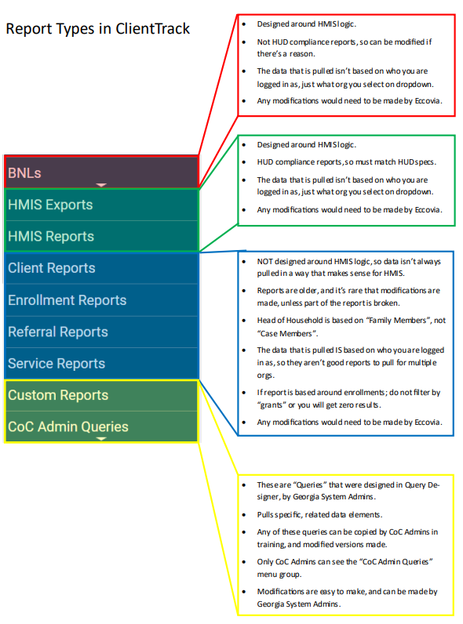

Report Types in ClientTrack

BNL

Designed around HMIS Logic. Not a HUD Compliance Report, so it can be modified if there is a reason. The data pulled is not based on who you logged in as, just what organization you select in the dropdown.

HMIS Exports/Reports

Designed around HMIS Logic. HUD Compliance reports, so they match HUD Specs. The data pulled is not based on who you logged in as, just what organization you select in the dropdown. Any modifications must be made by Eccovia.

Client, Enrollment, Referral, Service Reports
NOT designed around HMIS logic, so data isn’t always pulled in a way that makes sense for HMIS. Reports are older, and it’s rare that modifications are made, unless part of the report is broken. Head of Household is based on “Family Members”, not “Case Members”. The data that is pulled is based on who you are logged in as, so they aren’t good reports to pull for multiple orgs. If report is based around enrollments; do not filter by “grants” or you will get zero results. Any modifications would need to be made by Eccovia.

Custom Reports & Admin Queries
These are “Queries” that were designed in Query Designer, by Georgia System Admins. Pulls specific, related data elements. Any of these queries can be copied by CoC Admins in training, and modified versions made. Only CoC Admins can see the “CoC Admin Queries” menu group. Modifications are easy to make and can be made by Georgia System Admins.

Section 1: HMIS “Canned” Reports
- This section provides essential information on the availability and access of pre-built reports, commonly known as "canned" reports, within the (Your COC) HMIS Database.
- These reports are designed to streamline data analysis and reporting processes for users, offering pre-configured solutions for common data analysis needs.
- Canned" reports come with predefined configurations, saving users time and effort in setting up complex reporting parameters.
- The Reports Workspace offers a user-friendly interface, making it easy for users to navigate and access the pre-built reports.
- Designed to streamline data analysis processes, these reports cater to common reporting needs and assist users in extracting meaningful information from the HMIS Database.

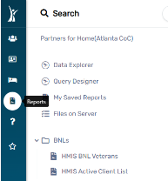
BNLs (By Name Lists)

HMIS BNL Veterans
Report Description
The purpose of this report is to provide an overview of basic demographic data quality and information for veterans actively enrolled in a program. The report focuses on key Universal Data Elements (UDEs) related to veterans' personal information and enrollment details.

This report covers the following Universal Data Elements (UDEs) for actively enrolled veterans:

- Name: 3.01
- SSN: 3.02
- Age based on – DOB: 3.03
- Race: 3.04
- Ethnicity: 3.05
- Gender: 3.06
- Earliest date for – Project Entry Date 3.10

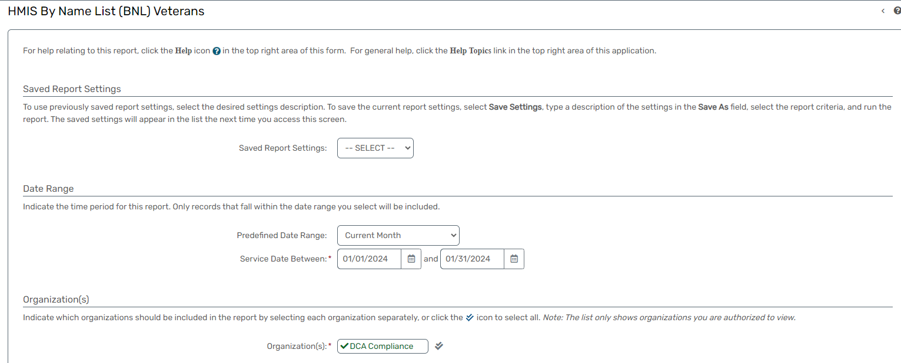

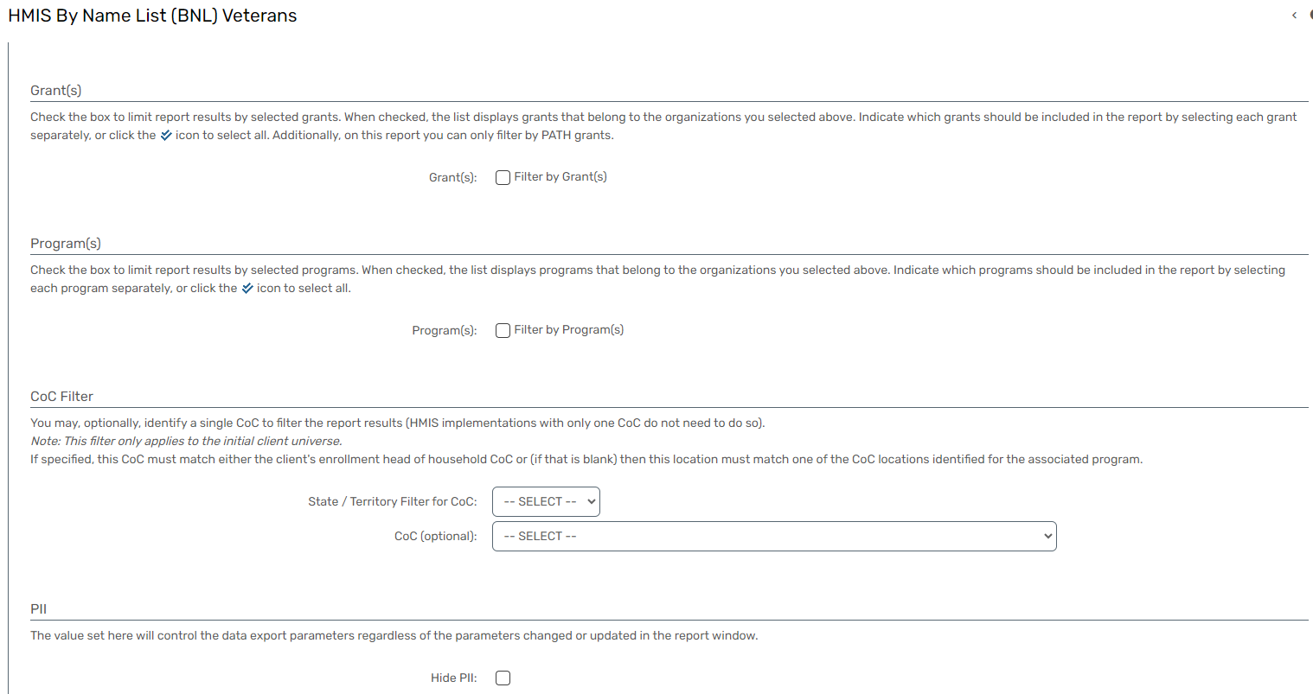

HMIS Active Client List
Report Description
This report aims to provide comprehensive data for clients actively enrolled in a program, including the start date of enrollment and exit dates if applicable. Additionally, the exported report will identify clients with missing data elements that may impact other reports, enhancing data integrity.

This report will show data quality & information for:
- Universal Data Elements (UDEs 3.01-3.917)
- Household Type
- Youth Household Type
- Chronically Homeless
- Date of Engagement
- Date of Determination
- Runaway Youth Status
- VA Medical Status
- Days Enrolled in Reporting Period
- Total Days Enrolled in Project
- Bed Nights in Report Period
- Total Bed Nights in Project

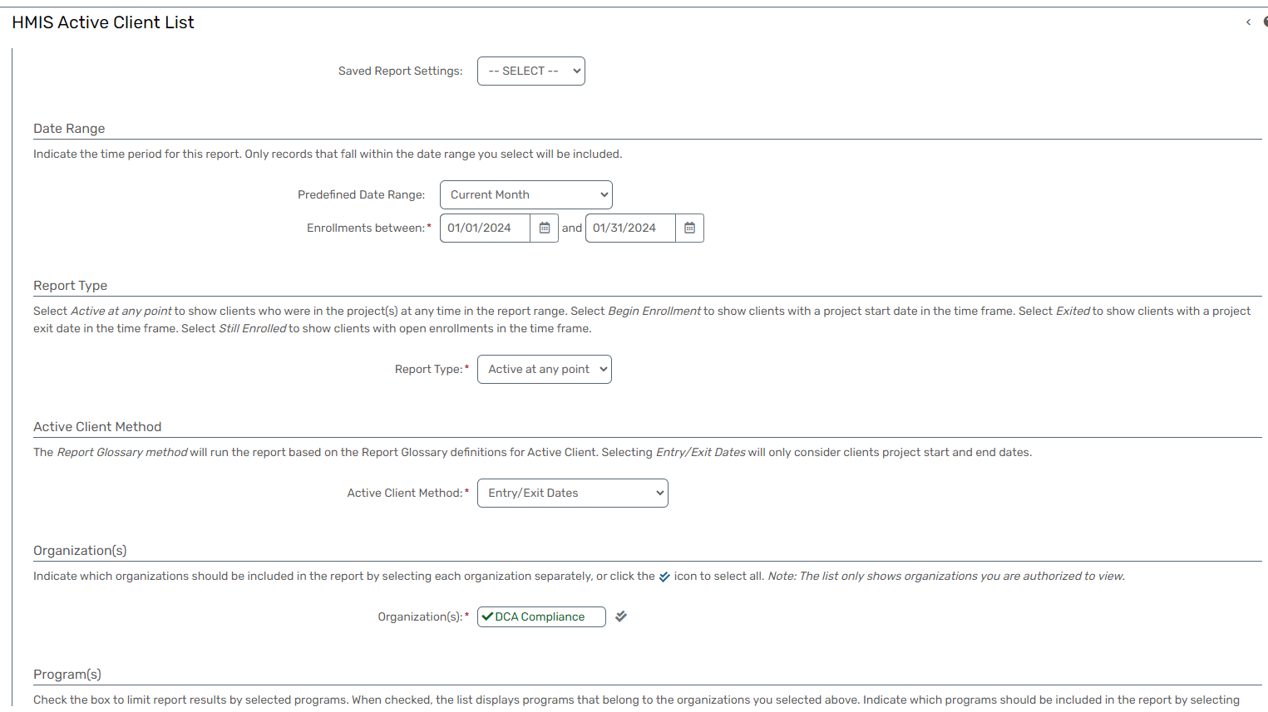

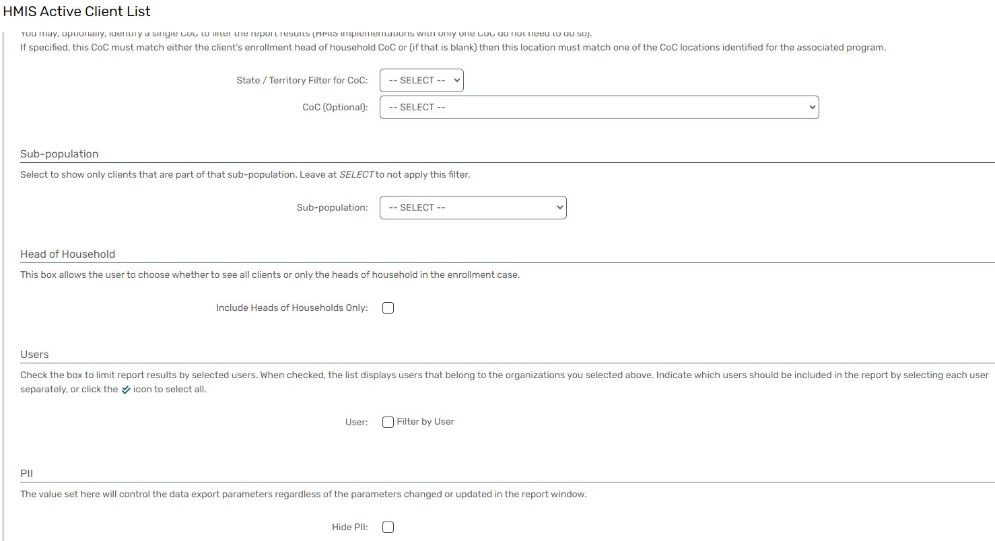

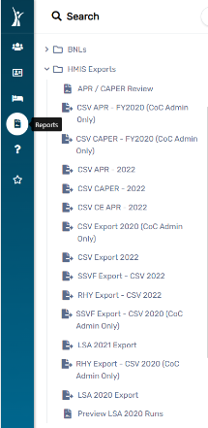
HMIS Exports

APR/CAPER Review
Report Description

This condensed report is designed to provide a quick and comprehensive overview of overall data quality following the export of an Annual Performance Report (APR) or Consolidated Annual Performance and Evaluation Report (CAPER) in CSV format.

The summary aims to highlight key metrics and identify areas for potential data quality improvements.
- They are designed for direct integration into Sage, minimizing manual data entry efforts.
- Enables users to focus on correcting records with identified errors or incongruences.
- Ensures compliance with HUD submission requirements by addressing both missing data and incongruent household information.

CSV APR – FY20XX (select the appropriate fiscal year)
Report Description

- This Compliance Report is specifically designed for HUD submission and intended for seamless integration into Sage.
- The report is configured to display only client records with data errors, including missing data and incongruent information, such as household inconsistencies, multiple heads of household, or minors incorrectly listed as heads of household.
- This comprehensive report is designed to present data quality and information for Universal Data Elements (UDEs 3.01-3.917) and Project Descriptor Elements (PSDEs 4.02-4.20) across all clients, with a specific breakout for the sub-population of Chronically Homeless individuals.

CSV CAPER - FY20XX (select the appropriate fiscal year)
Report Description
- This Compliance Report is specifically designed for ESG (Emergency Solutions Grants) funded projects and intended for seamless integration into Sage.
- The report displays only client records with data errors, focusing on clients with a Date of Engagement and Current Living Situation recorded. Additionally, the report identifies incongruent household data, such as missing heads of household or multiple persons listed as heads of household, including minors.
- This comprehensive report is designed to present data quality and information for Universal Data Elements (UDEs 3.01-3.917) and Project Descriptor Elements (PSDEs 4.02-4.20) across all clients, with a specific breakout for the sub-population of Chronically Homeless individuals.
- They are tailored for ESG funded projects, ensuring alignment with project-specific reporting requirements.
- Focuses on clients with a Date of Engagement and Current Living Situation, enhancing data relevance.
- Designed for direct integration into Sage, minimizing manual data entry efforts.

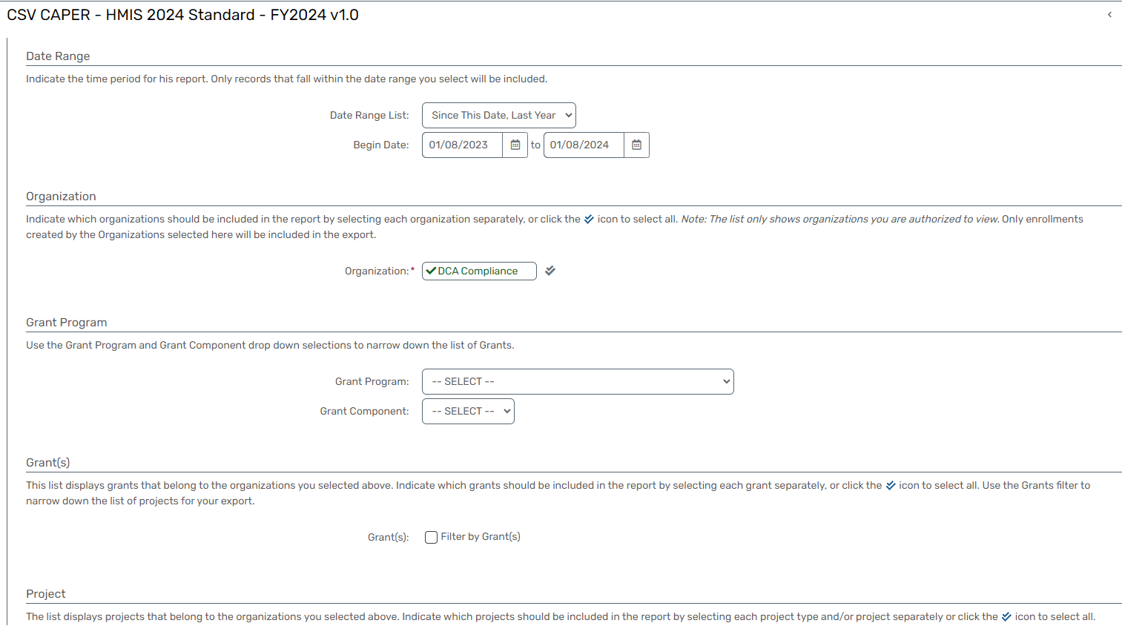
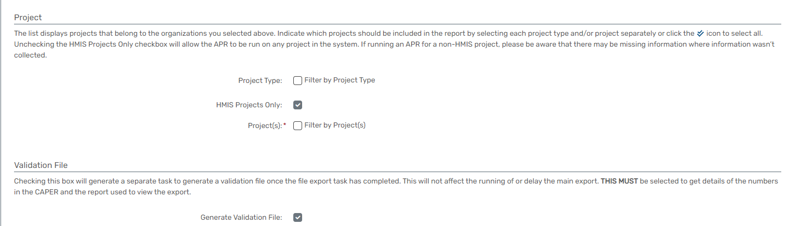

CSV CE APR - FY20XX (select the appropriate fiscal year)
Report Description

- This report is designed to provide comprehensive data quality and information for clients enrolled in the CoC's Coordinated Entry System (CES).
- The focus is on ensuring the accuracy, completeness, and consistency of client data within the CES.
- The focus includes Personally Identifiable Information (PII), key activity metrics, and other relevant information to assess such as: Personally Identifiable Information, Number of Persons Served, Number of Households Served, Assessment Type, Prioritization, Status Access Events, Referral Events, Total Coordinated Entry Activity During the Year, to improve the overall functioning of the CES.
- Facilitates ongoing monitoring of client data within the Coordinated Entry System.
- Identifies areas for data quality improvement, supporting accurate assessments and program decision-making.
- Enables the generation of comprehensive reports for program evaluation and compliance purposes.
- Provides insights into the demand for CES services, aiding in resource allocation and program planning.

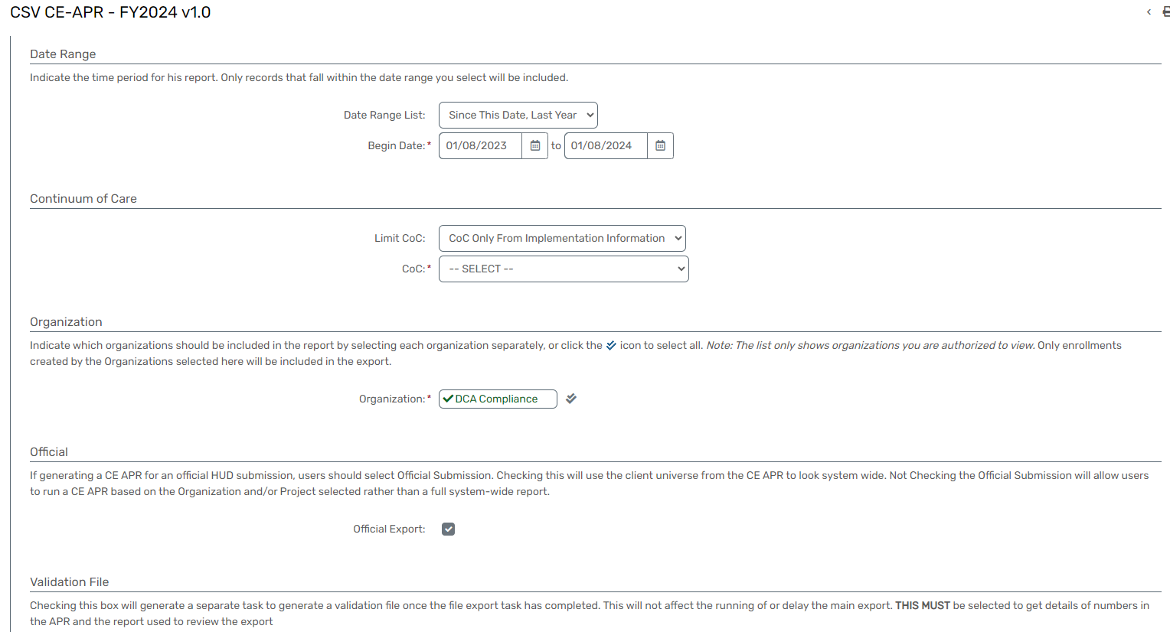

CSV Export - FY20XX (select the appropriate fiscal year)
Report Description
- This report is designed to provide a snapshot of key metrics and Personally Identifiable Information (PII) for clients enrolled in the Coordinated Entry System (CES).
- The report includes essential data elements such as the number of persons served, number of households served, assessment types, prioritization status, access events, referral events, and total CES activity during the year.
- Facilitates a holistic assessment of CES program performance based on key metrics. Supports ongoing monitoring of Personally Identifiable Information to ensure compliance with privacy regulations.

- Provides insights into the demand for CES services, aiding in resource allocation and program planning.
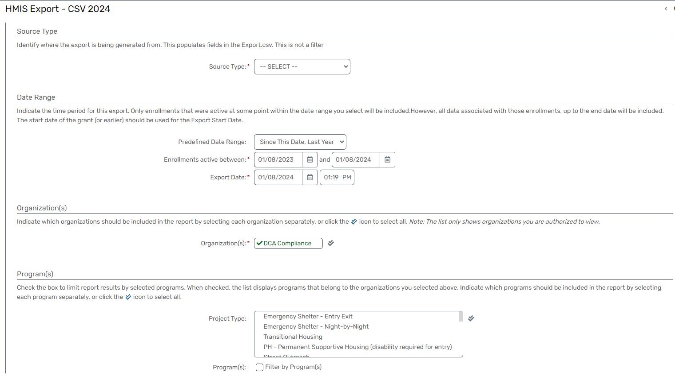
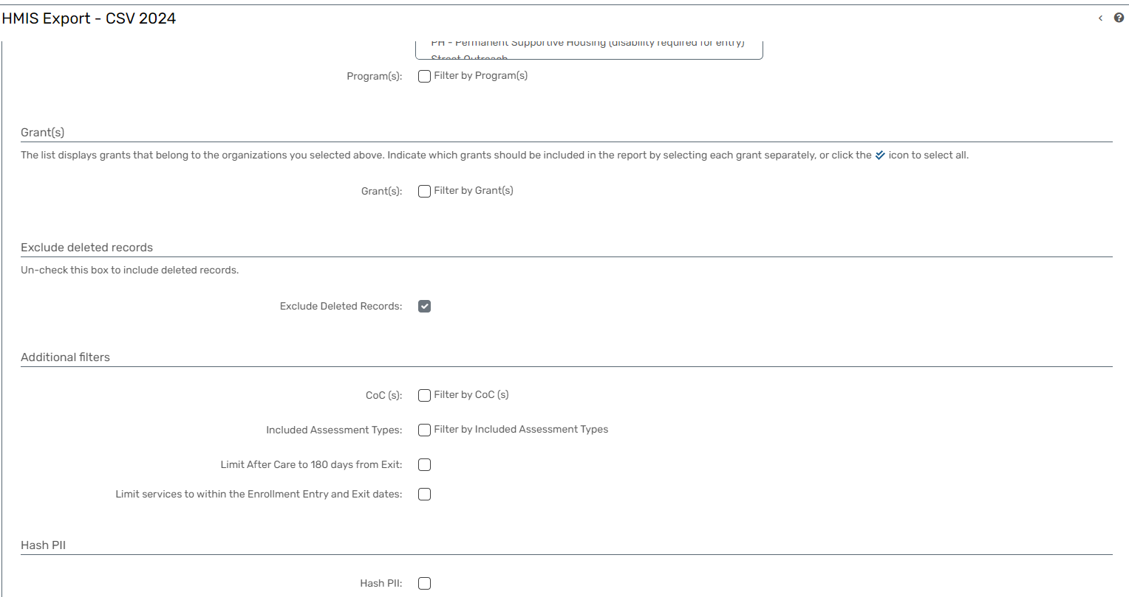

SSVF Export – CSV FY20XX (select the appropriate fiscal year)
Report Description
- This report is specifically designed for export into another database or software, providing a CSV file that displays all Universal Data Elements (UDEs) collected for each individual client.
- The report aims to offer a comprehensive dataset that can be seamlessly integrated into external systems for further analysis and processing.
- Facilitates easy integration of comprehensive UDE datasets into other databases or software systems.
- Streamlines the process of sharing and transferring client data with external stakeholders or partners.
- Enables users to conduct custom analysis and reporting using the exported UDE dataset in external tools.

RHY Export – CSV FY20XX (select the appropriate fiscal year)
Report Description
- This CSV export report is specifically designed for Runaway Homeless Youth (RHY)- funded projects and is intended for upload into RHYMIS (Runaway and Homeless Youth Management Information System).
- The report aligns with RHY HMIS resources provided on the HUD Exchange.
- Ensures compatibility with RHYMIS, facilitating a smooth upload process.
- Adheres to the data standards outlined in RHY HMIS resources, promoting consistency and accuracy.
- Streamlines the submission of RHY client data to RHYMIS in a format compliant with RHY HMIS requirements.

LSA Export - FY20XX (select the appropriate fiscal year)
Report Description
- This report is designed for the HUD Longitudinal Systems Analysis submission to HDX 2.0. It generates multiple CSV files containing Entry/Exit client data and Project Descriptor Data Elements (PDDEs), facilitating the longitudinal analysis of homeless services provided under various projects.
- Ensures compatibility with HDX 2.0, facilitating a seamless submission process for the HUD Longitudinal Systems Analysis.
- Adheres to the data standards outlined for HDX 2.0, promoting consistency and accuracy in reporting.
- Streamlines the submission of comprehensive client and project data for longitudinal analysis.

Preview LSA Runs - FY20XX (select the appropriate fiscal year)
Report Description

- A list of Longitudinal Systems Analysis (LSA) reports that have been requested to run.
- The specific reports can vary depending on the context and the requirements of the organization or project.
- It's essential to note that the specific reports requested can vary based on the goals and priorities of the organization or project conducting the Longitudinal Systems Analysis.

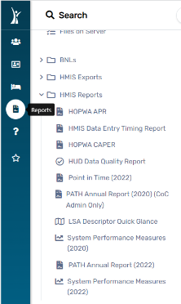
HMIS Reports

HOPWA APR
Report Description
- This APR Report is specifically tailored for projects funded under the Housing Opportunities for Persons with AIDS (HOPWA) program.
- The report is designed to align with HOPWA HMIS Resources available on the HUD Exchange and provides a comprehensive overview of project performance for submission to meet Annual Performance Reporting requirements.
- Ensures compliance with HOPWA reporting requirements, providing a comprehensive overview of project performance.
- Facilitates program evaluation by providing insights into key performance metrics, allowing for targeted improvements and adjustments. Assesses and ensures the quality and completeness of data within the HOPWA HMIS, supporting accurate reporting.

HMIS Data Entry Timing Report
Report Description
- This report is designed to analyze data timeliness within the Homeless Management Information System (HMIS).
- It compares the system-generated date stamp with the dates manually entered by end-users for client enrollment or exit.
- Timeliness is a critical factor affecting data quality and compliance with CoC data timeliness requirements outlined in the MDHA Data Quality Management Plan.
- Pinpoints instances where manual entry dates significantly deviate from system-generated date stamps.
- Provides insights into how timeliness errors may impact the quality of data used in official reports.
- Empowers users with recommendations to enhance data timeliness practices going forward.
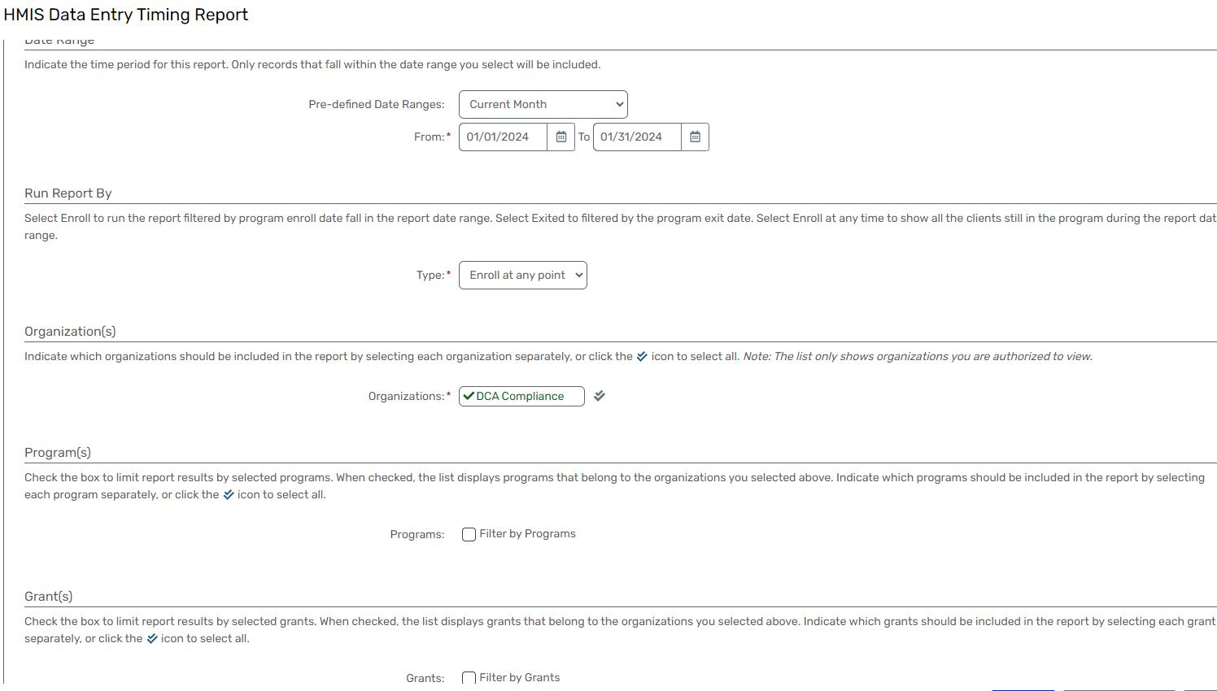

HOPWA CAPER
Report Description
- This CAPER Report is specifically tailored for projects funded under the Housing Opportunities for Persons with AIDS (HOPWA) program.
- Aligned with HOPWA HMIS Resources available on the HUD Exchange, the report aims to provide a comprehensive overview of project performance for inclusion in the Consolidated Annual Performance and Evaluation Report.
- Provides a comprehensive overview of project performance, supporting program evaluation and improvement.
- Assesses and ensures the quality and completeness of data within the HOPWA HMIS, supporting accurate reporting.
- Facilitates compliance with CAPER reporting requirements by providing a detailed account of HOPWA-funded project outcomes.

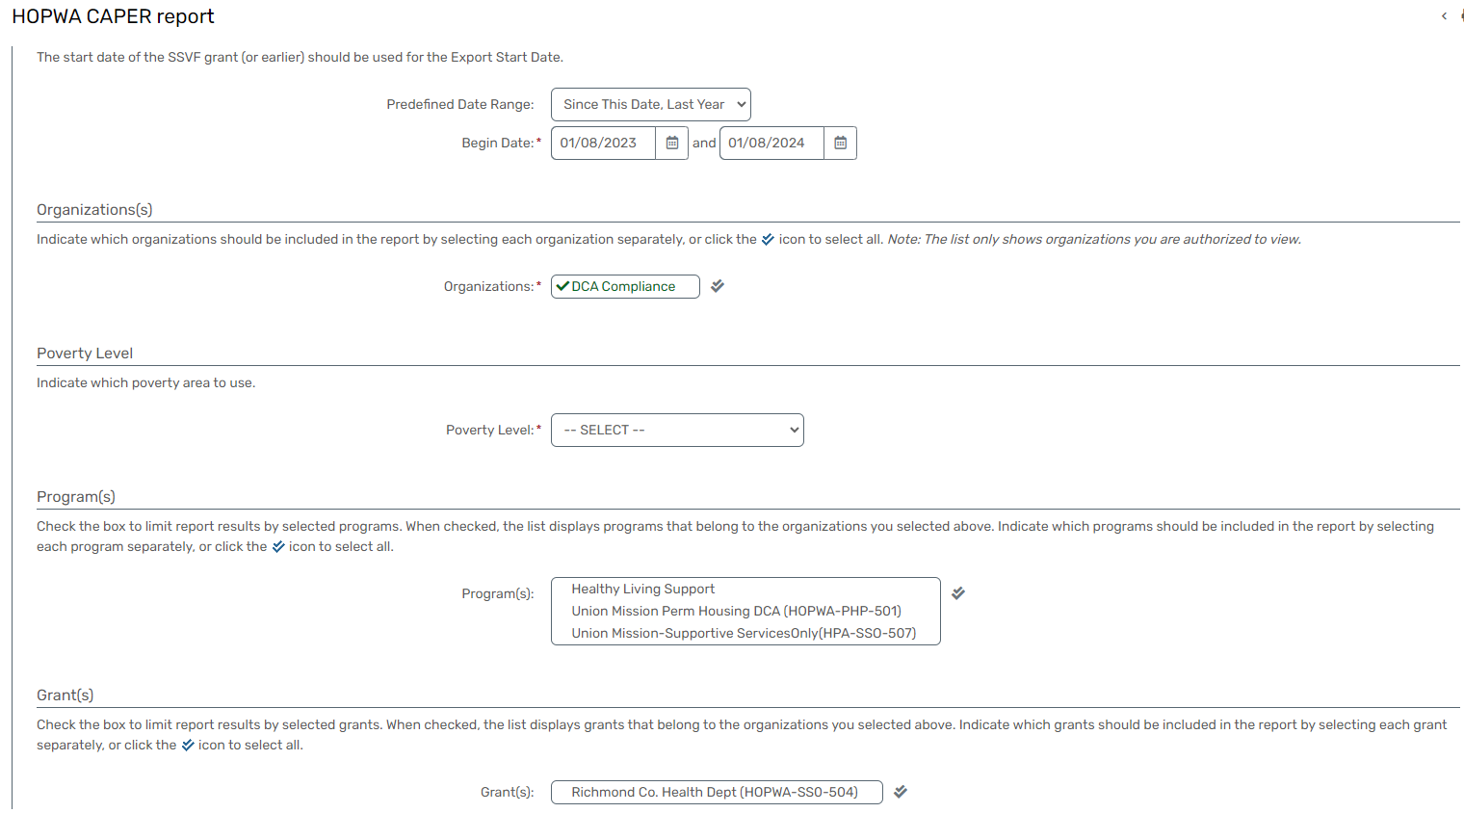

HUD Data Quality Report
Report Description

- This report aims to provide a detailed analysis of data quality for all active clients within a specified time frame in accordance with HUD Data Quality tables.

- Users have the option to export a detailed report for in-depth analysis or download a condensed report for a quick overview of overall data quality.

- This report will show data quality & information for: Personally Identifiable Information, Universal Data Elements, Income and Housing Data Quality, Chronic Homelessness, Timeliness, Inactive Records for Street Outreach & Emergency Shelter

- The HUD Data Quality Report for Active Clients serves as a valuable tool for assessing and ensuring the accuracy and completeness of data within the HMIS Database.

- By covering key data quality dimensions, this report supports ongoing efforts to maintain high standards in data accuracy and reliability.

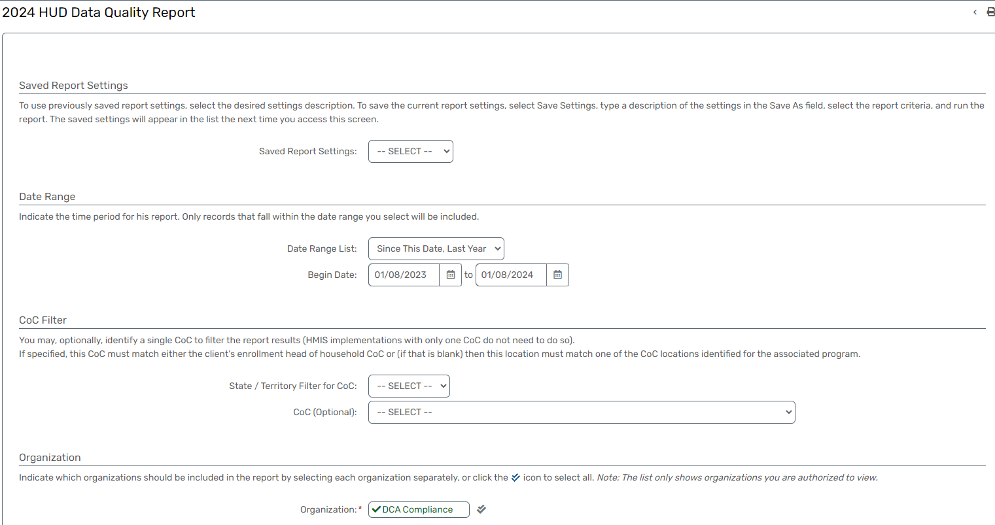

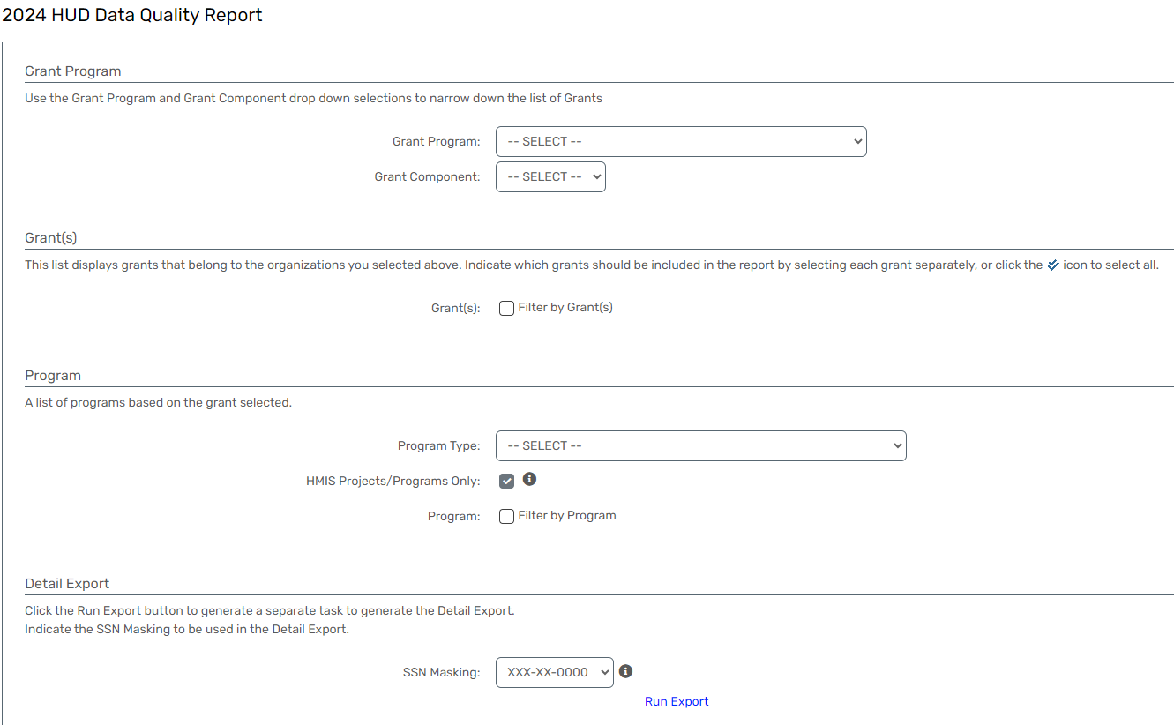

Point in Time - (select the appropriate fiscal year)
Report Description
- This report aims to present data for all clients, broken down by sub-populations, based on an unduplicated one-night count or estimate of sheltered and unsheltered homeless persons.
- It includes clients who have received outreach services and aligns with resources provided by HUD on understanding and collecting PIT data.
- The PIT Homeless Count Report provides a comprehensive overview of homeless persons, both sheltered and unsheltered, incorporating outreach service recipients.
- By following HUD guidelines and leveraging HMIS data, this report supports accurate and meaningful reporting on the homeless population in alignment with HUD's goals and standards.
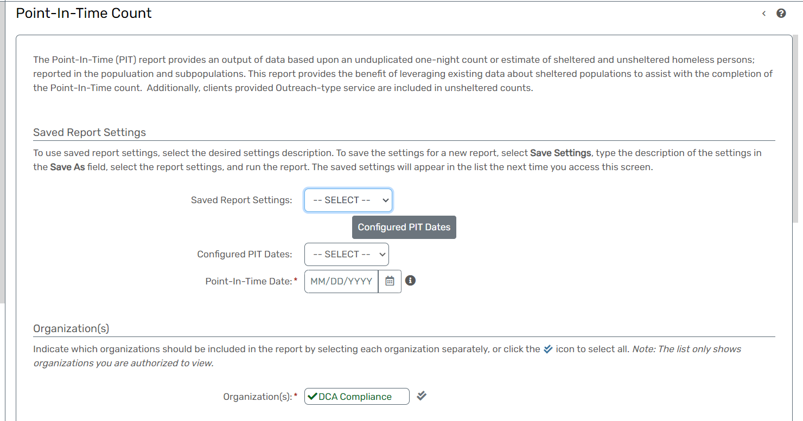
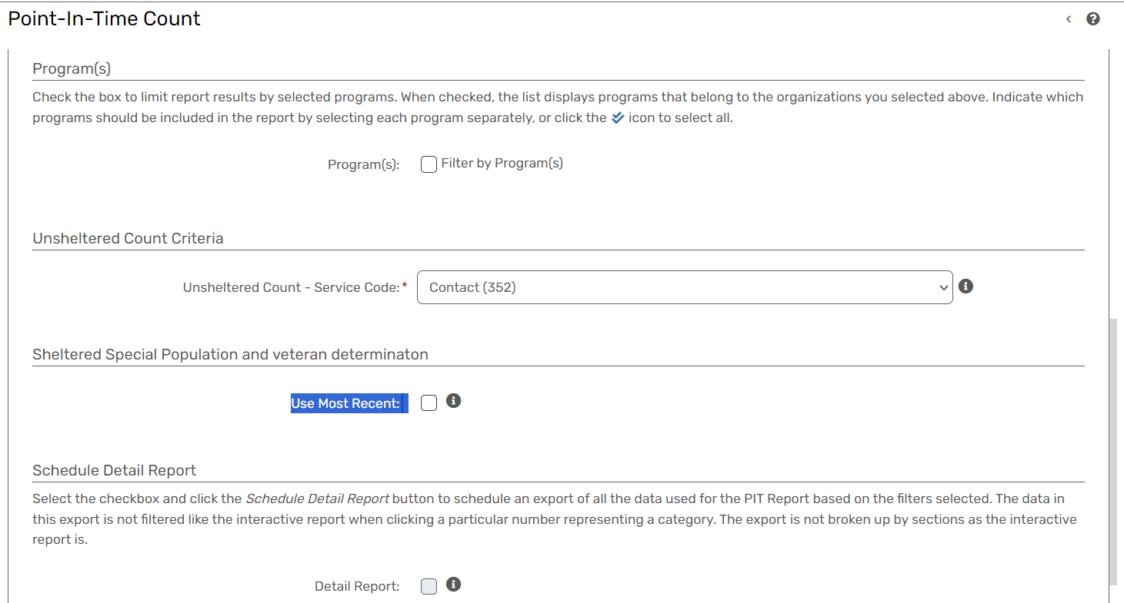

PATH Annual Report - (select the appropriate fiscal year)
Report Description
- This report is designed to provide a comprehensive overview of services and referrals for clients enrolled in the Projects for Assistance in Transition from Homelessness (PATH) program.
- The report specifically focuses on contacts, services, and referrals dated on or after the client's determined PATH status.
- All recorded interactions are attached to the PATH project stay to ensure accurate reporting.
- The PATH Program Services and Referrals Report ensures accurate and comprehensive reporting of PATH-funded services and referrals for clients experiencing homelessness.
- By adhering to HUD guidelines and utilizing PATH HMIS resources, this report supports the effective implementation and evaluation of the PATH program's impact on individuals in transition from homelessness.

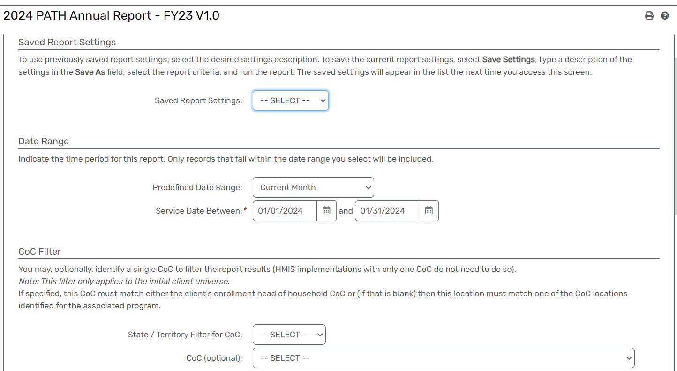

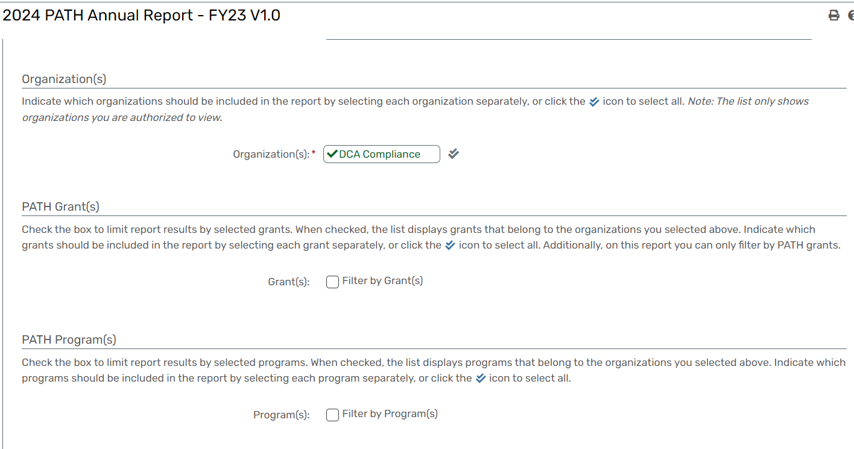

LSA Descriptor Quick Glance
Report Description
- This report is designed to provide a transparent overview of descriptors included and excluded in the Longitudinal Systems Analysis (LSA).
- It offers insights into the rationale behind inclusion and exclusion decisions, fostering a comprehensive understanding of the LSA framework.
- Facilitates a deeper understanding of the specific descriptors considered in the LSA and the reasoning behind their selection.
- Promotes transparency by clearly outlining the criteria and decision-making process for both inclusion and exclusion.
- Empowers users to make informed decisions regarding data collection and reporting based on a comprehensive understanding of descriptor selection.
- Supports quality assurance efforts by providing a clear rationale for the inclusion and exclusion of descriptors in the LSA.

System Performance Measures - (select the appropriate fiscal year)
Report Description
- This section provides an overview of the System Performance Measure (SPM) reports generated within the Homeless Management Information System (HMIS). The reports cover various critical measures designed to assess the effectiveness and impact of homeless services.
- Measure 1: Length of Time Persons Remain Homeless, Measure 2 (M2): Returns to Homelessness within 6, 12, 24 Months, Measure 3 (M3): Number of Persons Homeless, Measure 4 (M4): Employment and Income – CoC Funded Projects Measure 5 (M5): First Time Homeless, Measure 6 (M6): N/A, Measure 7 (M7): Successful Street Outreach Placement & Successful Placement In/Retention of Permanent Housing
- The HMIS System Performance Measure Reports are instrumental in evaluating and enhancing the effectiveness of homeless services. By focusing on key measures, these reports contribute to the continuous improvement of programs and interventions, ultimately working towards the goal of ending homelessness.
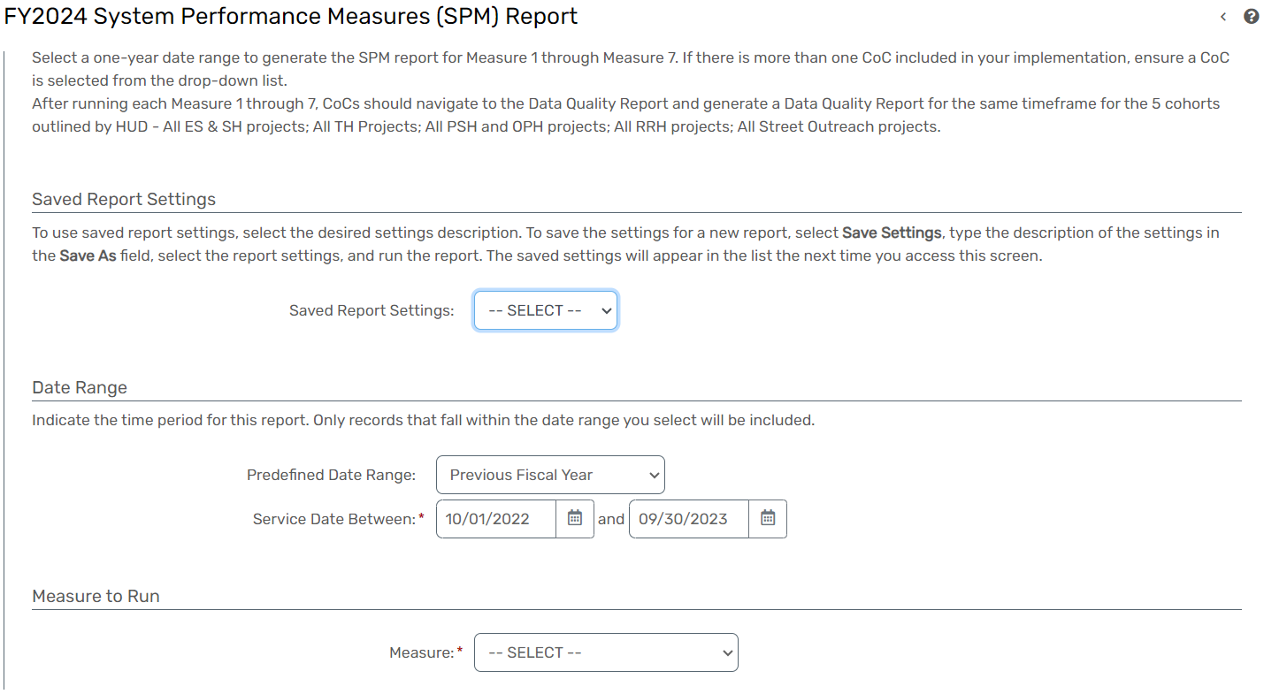

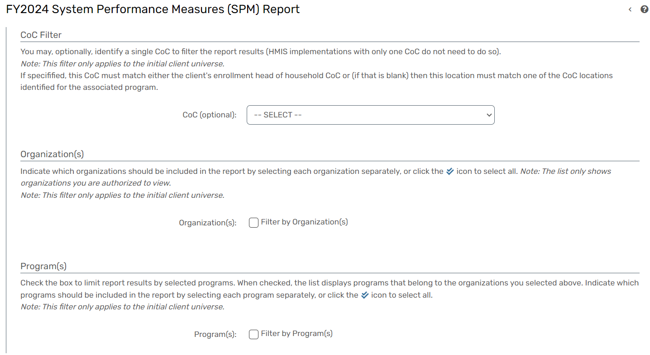

Client Reports
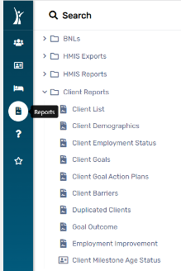
-

Client List
Report Description
- The Client List Report serves to provide a comprehensive listing of all clients in the database within a specified date range.
- Users have the flexibility to sort the report based on various parameters such as Name, Organization, Zip Code, or Date.
- The report includes key client demographic factors, ensuring a holistic view of the individuals served.
- Offers a comprehensive view of clients in the database, aiding in the understanding of the population served.
- Users can tailor the report to their specific needs by choosing from multiple sorting options.
- Facilitates efficient analysis of client demographics and trends, supporting informed decision-making.
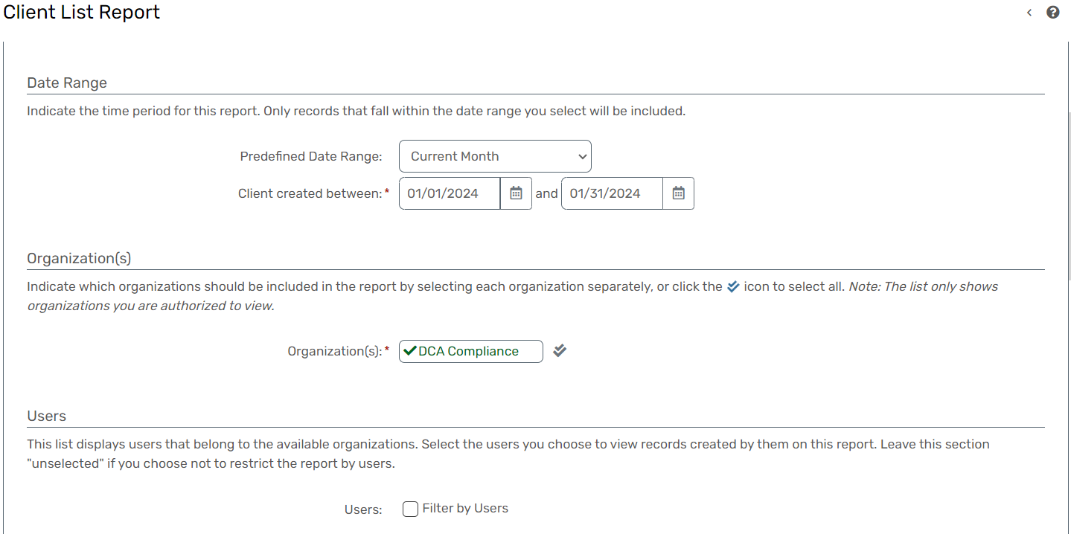
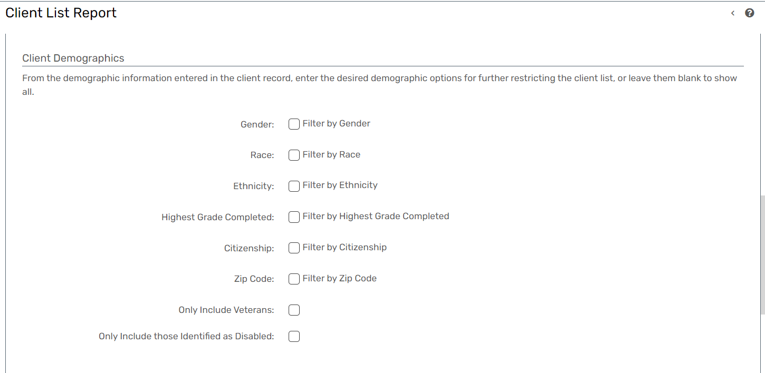
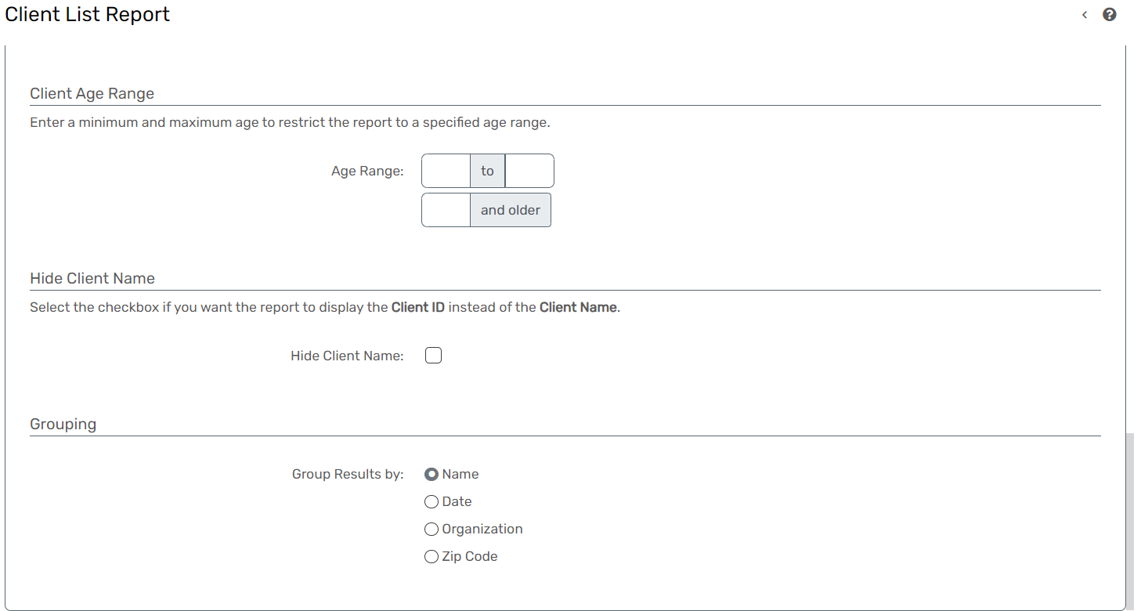
Client Demographics
Report Description
- This report is designed to filter and display information specifically for the Head of Household within a specified date range.
- It presents a list of families, with members listed by their Relationship to the Head of Household.
- The age of each client is calculated as of the current date.
- Targets and presents information specifically for Head of Household individuals, streamlining family-focused data analysis.

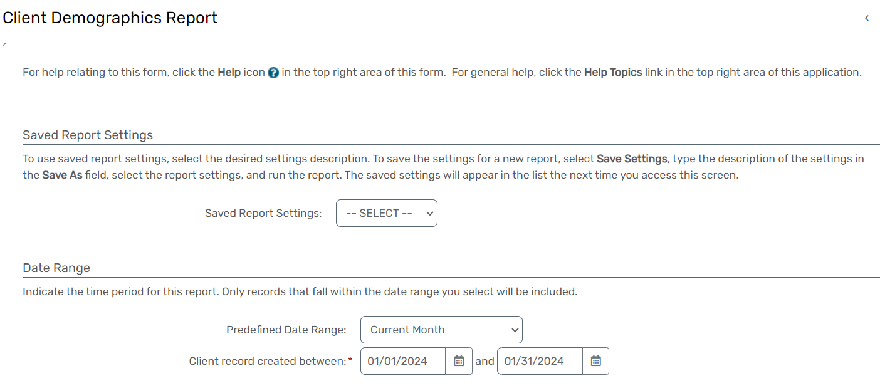

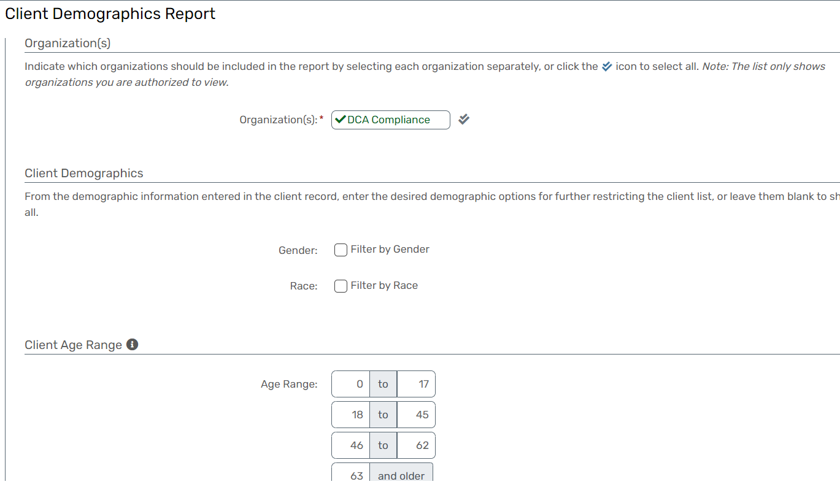

Client Employment Status
Report Description
- The Client Work History Report provides a detailed overview of client work history records, offering insights into individuals' employment experiences and contributing to a comprehensive understanding of their vocational backgrounds.
- Supports service planning by providing information on clients' past employment experiences, informing career counseling and job placement strategies.
- Enables data-driven decision-making by presenting detailed information on clients' employment patterns and transitions.

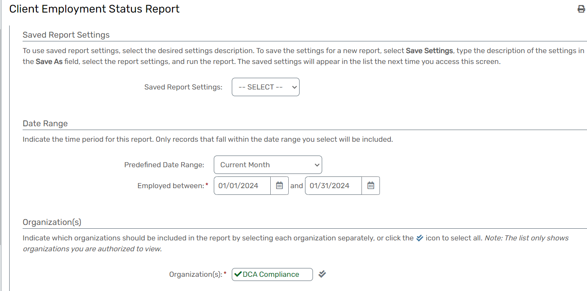

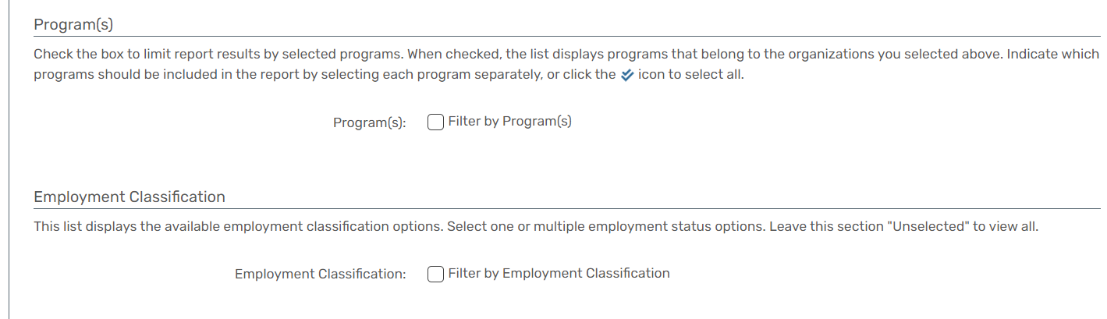

Client Goals
Report Description
- The Client Goals Report identifies clients with active goals based on specific criteria.
- It focuses on goals meeting the following conditions:
- The Goal Date is smaller than the report end date.
- The Target Date is null or greater than the report begin date.
- The Goal Attained status is null, or the Goal Attained Date is greater than the report begin date.
- Identifies clients with active goals, allowing for proactive management and support.
- Enables organizations to focus on clients with goals requiring attention or follow-up.
- Facilitates a systematic approach to goal monitoring and progress tracking.

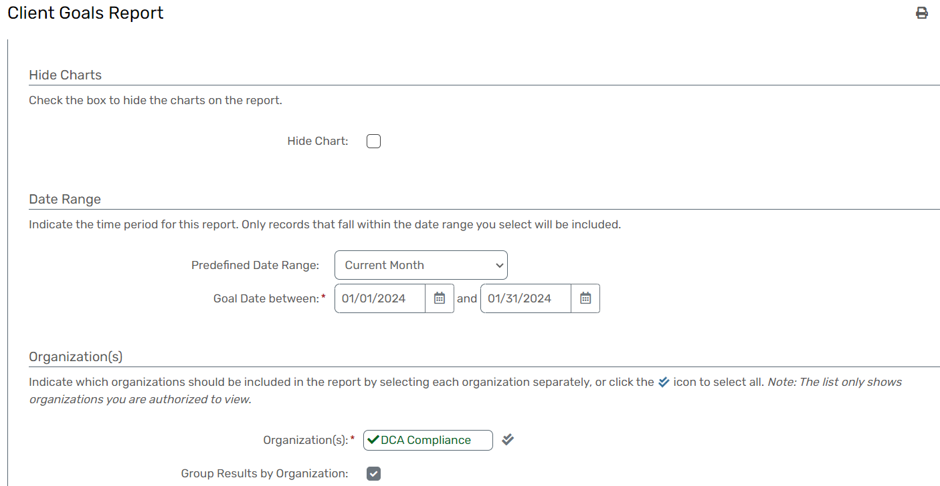
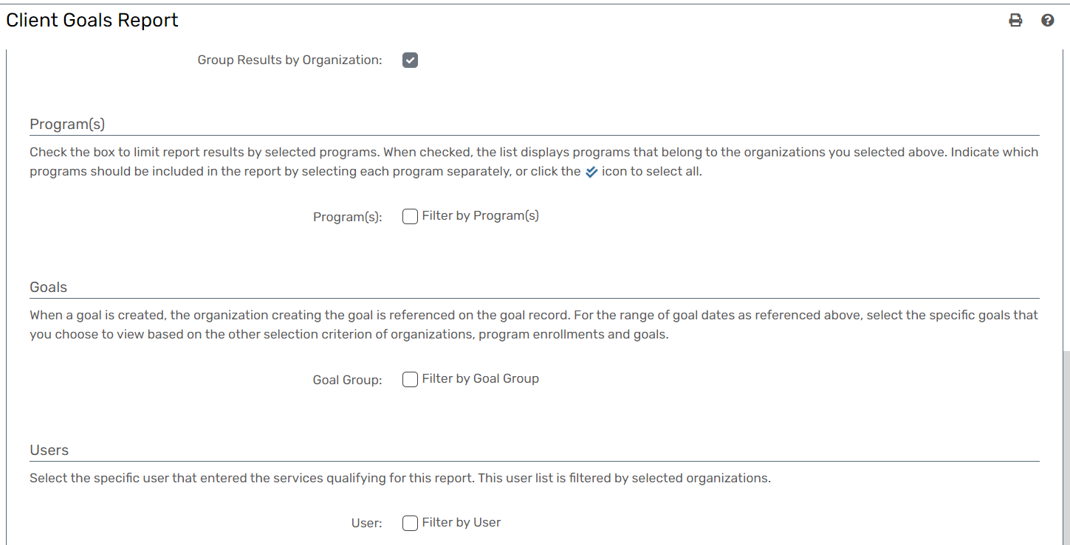

Client Goal Action Plans
Report Description
- The Client Goal Action Plans Report is designed to provide an overview of goal completion based on the completeness of action plan items tied to each goal.
- It serves as a comprehensive tool for assessing the progress and status of goals within the specified timeframe.
- Offers a comprehensive view of goal progress based on the completeness of associated action plan items.
- Provides actionable insights into areas of focus for goal achievement and identifies potential barriers.
- Facilitates data-driven decision-making by presenting detailed information on the status of client goals.
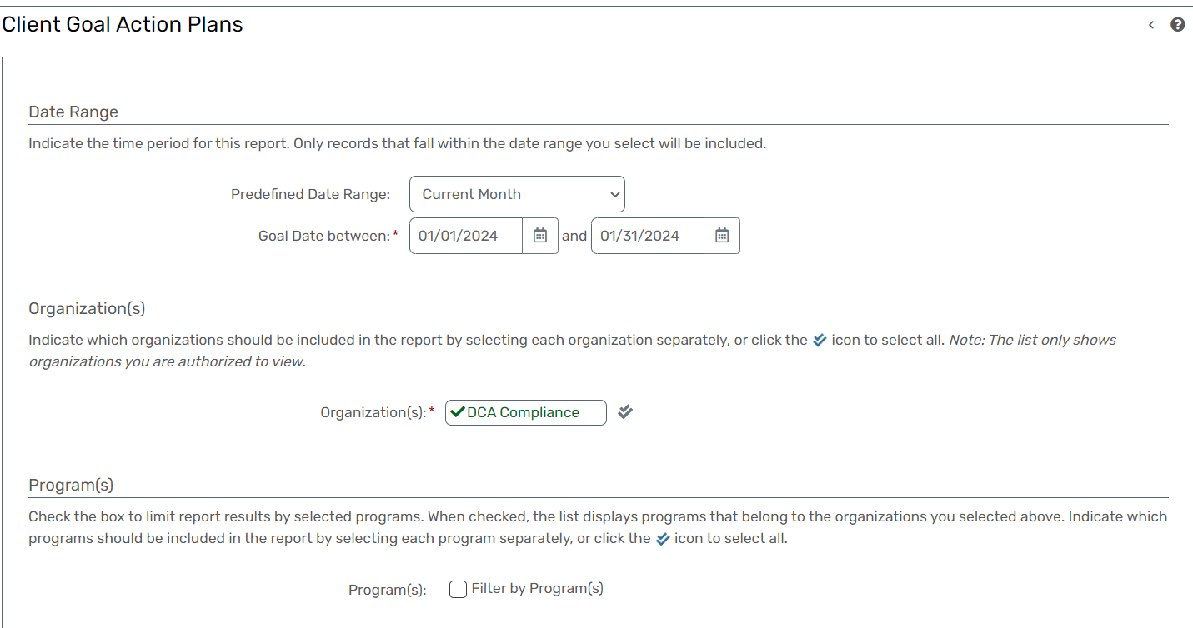
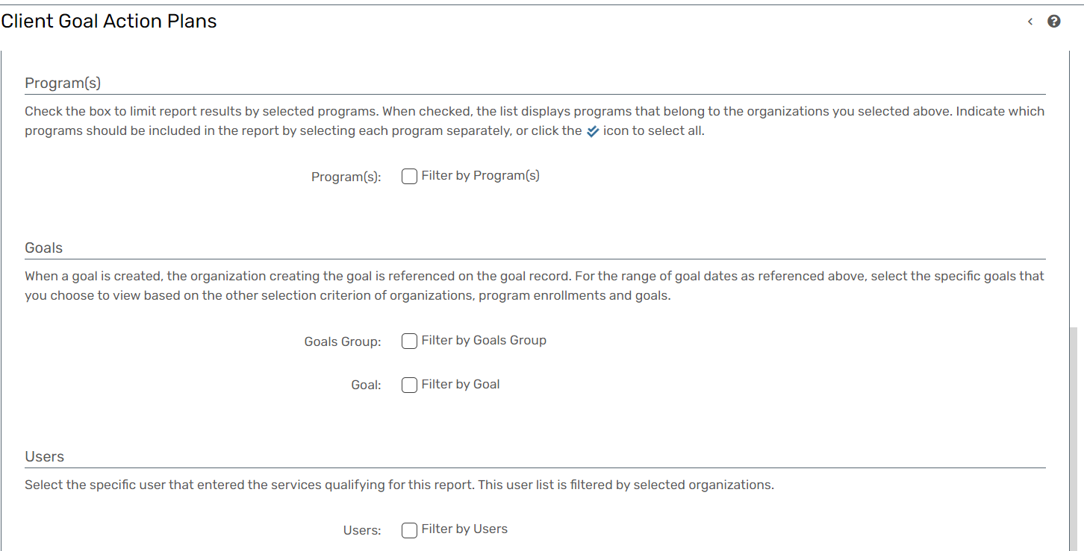

Client Barriers
Report Description
- The Client List by Barrier Sub-Category Report is designed to present a comprehensive list of clients categorized by specific barriers, with the age of each client calculated as of the current date.
- This report provides valuable insights into the demographic distribution of clients based on identified barriers.
- Facilitates an in-depth analysis of clients based on specific barrier sub-categories.
- The age calculation as of the current date ensures up-to-date and accurate demographic information.
- Supports targeted service planning by identifying common barriers and demographic trends.
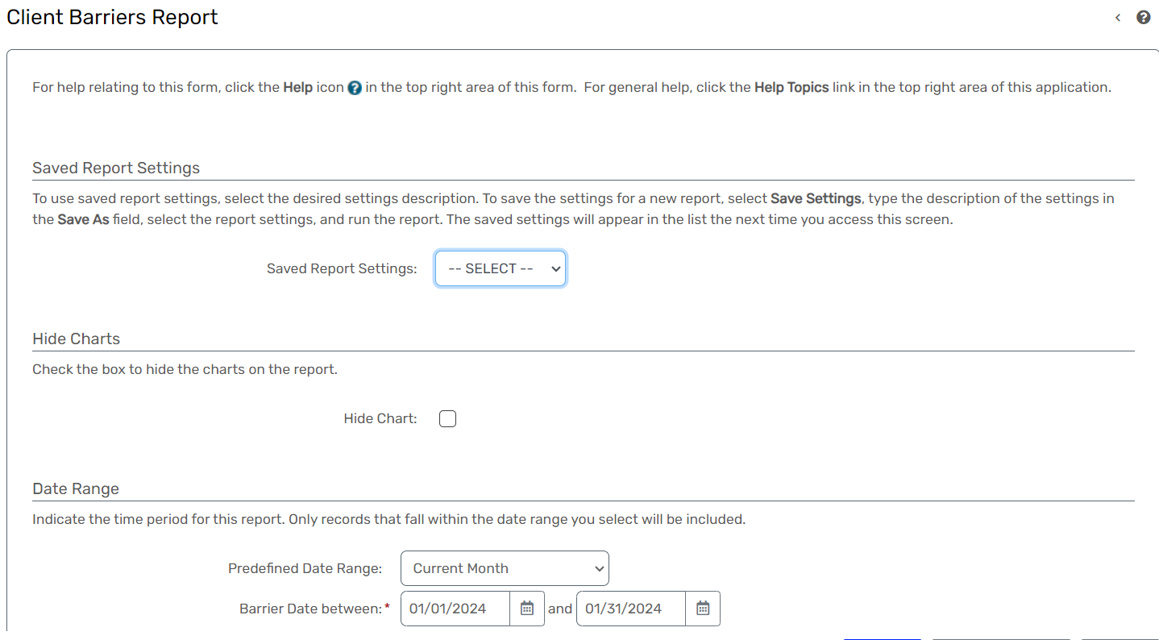

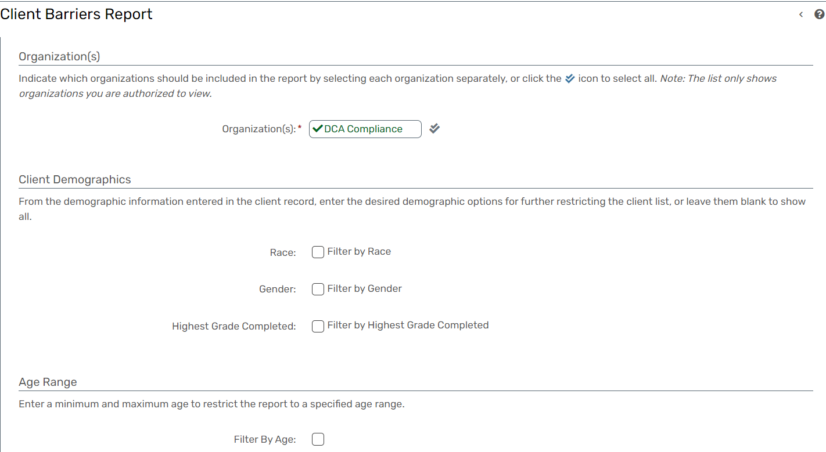

Duplicated Clients
Report Description
- The Duplicate Clients Report is designed to identify and display duplicated client records within the system.
- This report provides multiple filter options to customize the search for duplicates based on various criteria such as Name, Gender, SSN, Date of Birth (DOB), Zip Code, and Client Type.
- Identifies and facilitates the cleanup of duplicated client records, ensuring data accuracy.
- Provides flexibility with multiple filter options to tailor the search for duplicates based on specific criteria.
- Supports efforts to enhance data quality by resolving duplicate client records.
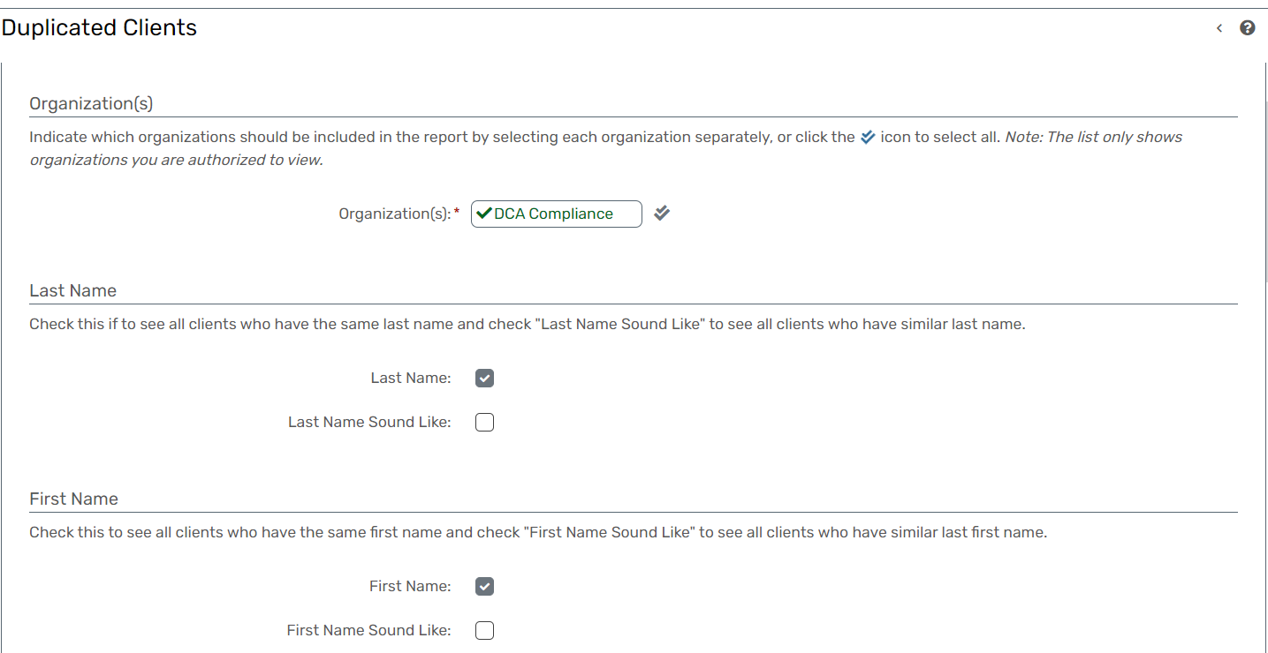
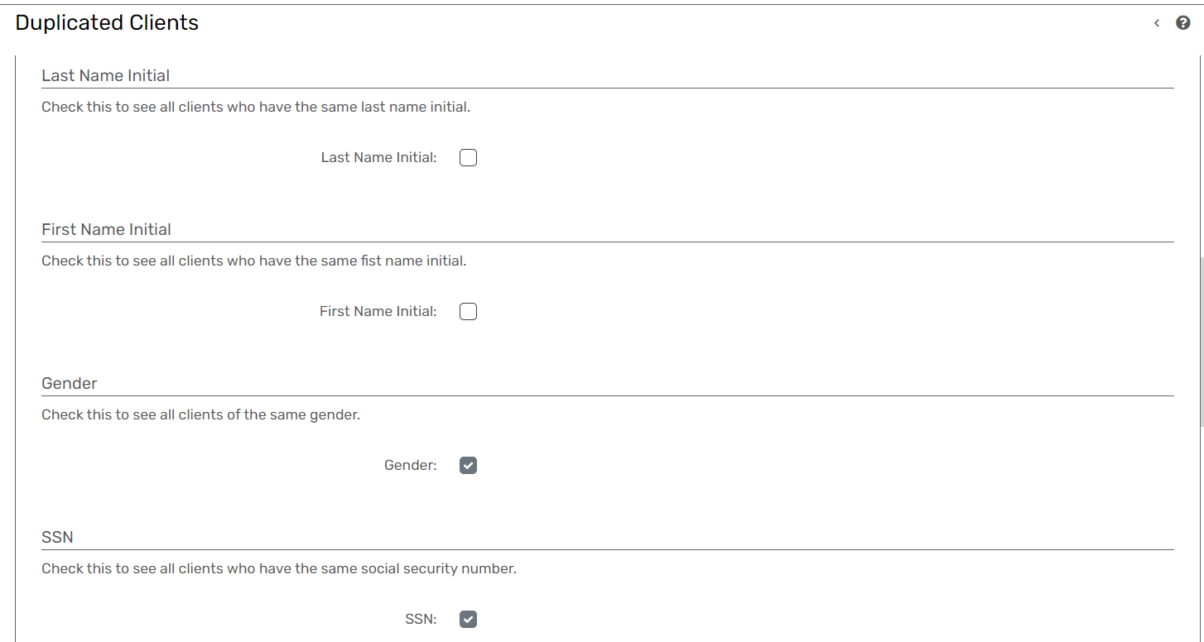

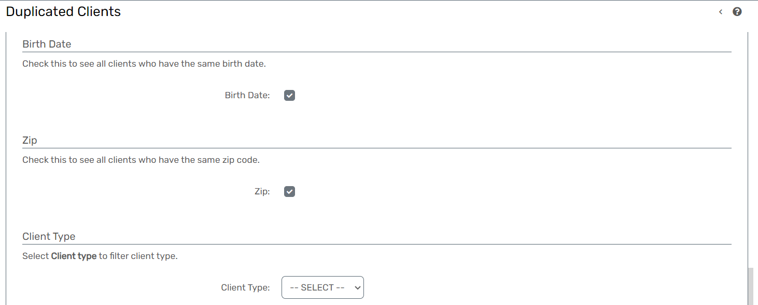

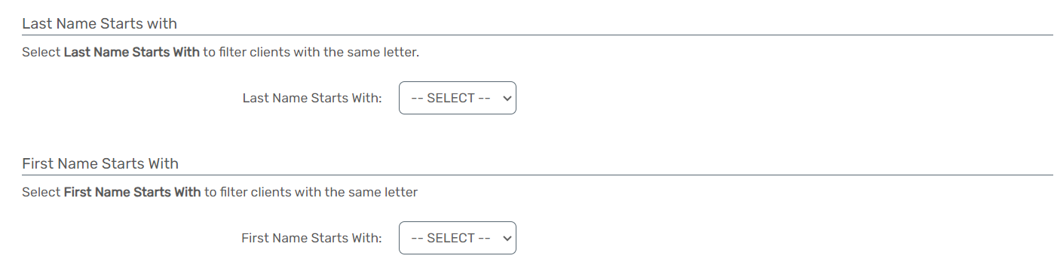

Goal Outcome
Report Description
- The Clients with Active Goals Report is designed to display a list of all clients in the database who have goals within a specified date range.
- The date range is determined by the "Date By" selection, which can include Goal Begin Date, Goal Target Date, Goal End Date, or goals that are still open.
- Provides a focused view of clients with active goals within a specific date range. Offers flexibility in determining the date range based on different goal-related criteria.
- Facilitates timely intervention and support for clients actively working toward their goals.
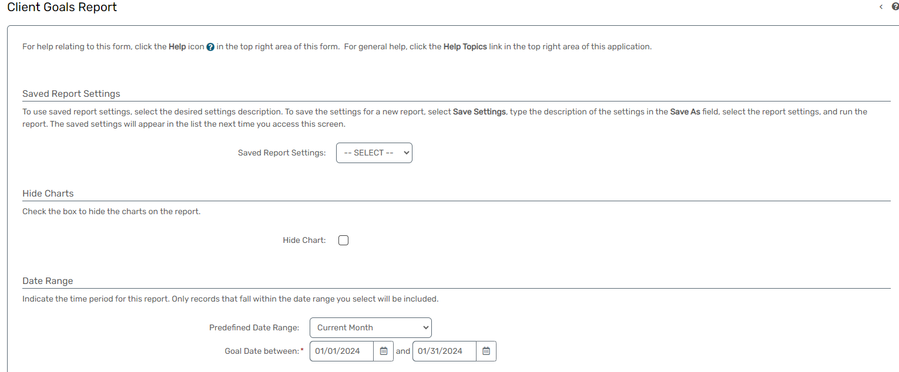
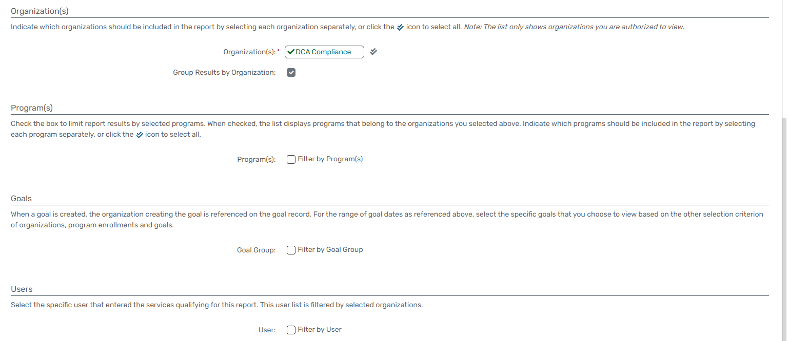

Employment Improvement
Report Description
- The Head of Household Financial Impact Report provides a detailed listing of clients, specifically focusing on the Head of Household, and includes key financial information at entry and exit points.
- This report offers insights into income variations and hours worked during the course of their enrollment.
- This report shows Income at Entry: Financial income upon entry into the program.
- Income at Exit: Financial income at the time of program exit.
- Hours at Entry: Number of hours worked at entry.
- Hours at Exit: Number of hours worked at exit.
- Income Difference: Variation in income from entry to exit.
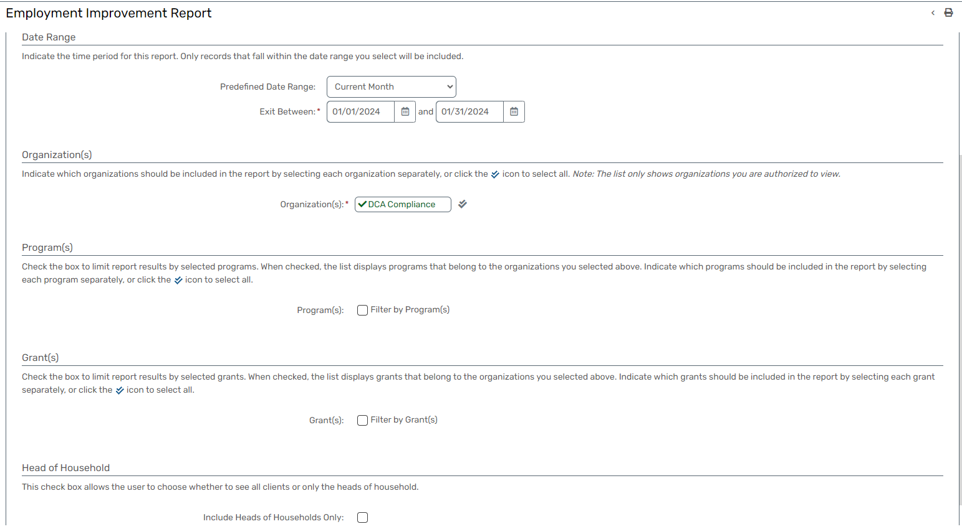

Client Milestone Age Status
Report Description
- The Age Verification Report is designed to display a list of clients, showcasing their current age and the birth date on which they turned or will turn a selected age.
- This report offers additional filters for refining the list, including post and future intervals, and options to include or exclude clients without a date of birth.
- The Age Verification Report enhances data accuracy by providing detailed information on clients' ages and birth dates.
- With flexible filtering options, this report facilitates precise verification within the HMIS Database.
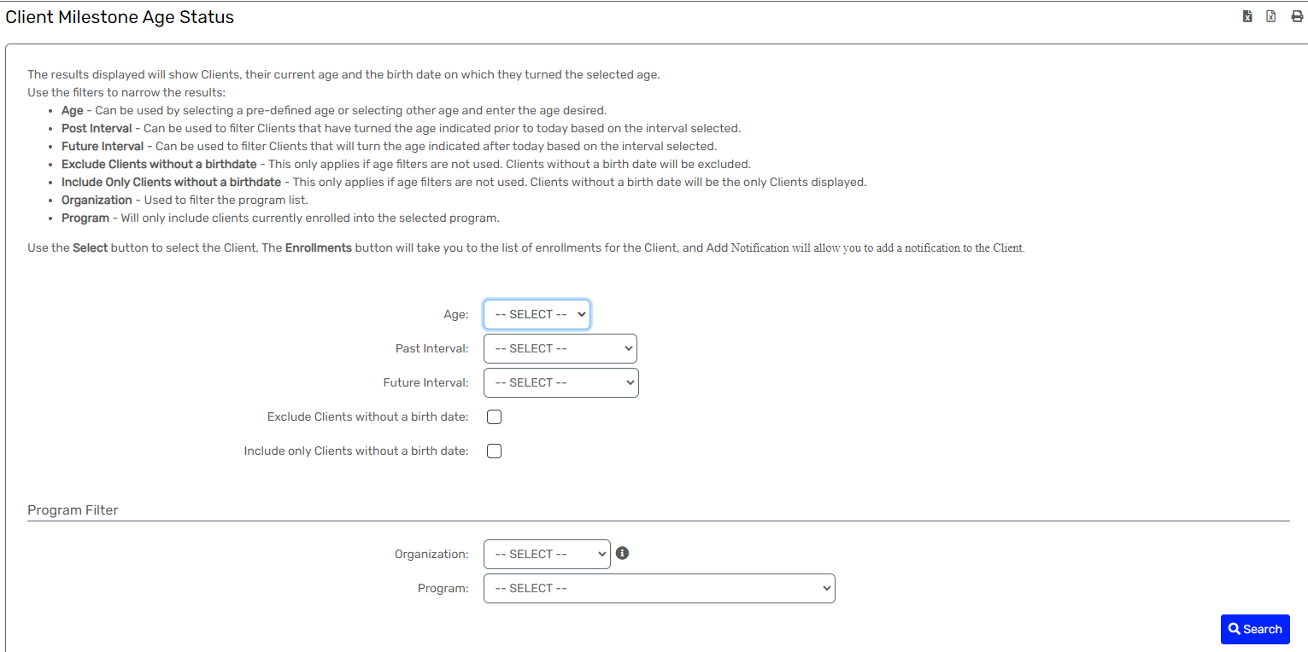

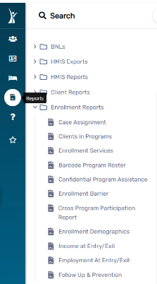
Enrollment Reports

Case Assignment
Report Description
- The Case Manager Client List Report is designed to display a list of clients assigned to selected case managers.
- This report provides valuable insights into the caseloads of specific case managers, facilitating efficient client management and service provision.
- Facilitates efficient management of caseloads by providing a detailed client list for selected case managers.
- Offers flexibility in selecting individual case managers, teams, or departments for the client list.
- Supports service planning by providing a clear overview of clients under the responsibility of specific case managers.
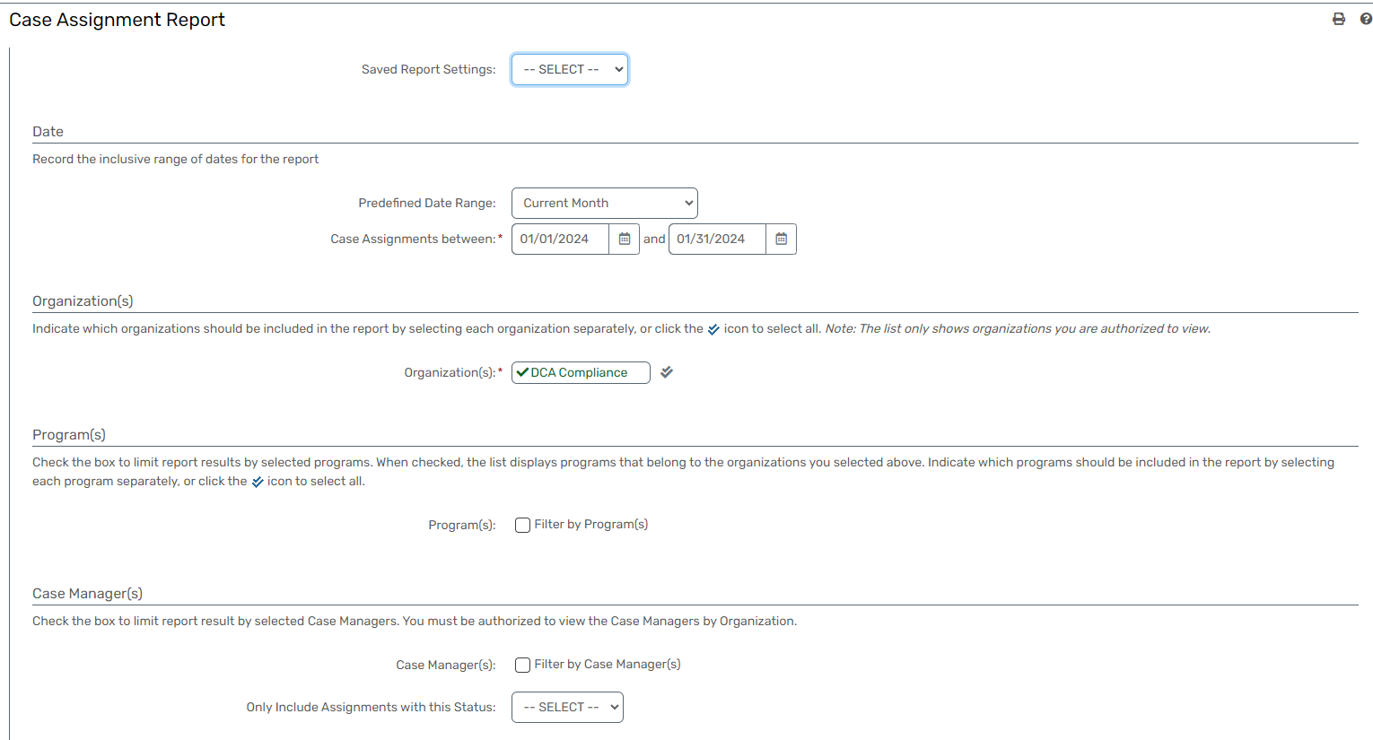

Clients in Programs
Report Description
- The Program Enrollment Status Report is designed to qualify clients based on their enrollment status within specific date ranges.
- This report provides insights into the continuity and duration of client enrollment in programs, facilitating a comprehensive understanding of program participation.
- Unique identifiers for each client, such as Client ID or name, to distinguish individuals within the report.
- Clients enrolled prior to the date range and still enrolled throughout the date range.
- Clients enrolled prior to the date range and ending inside the date range.
- Clients enrolled inside the date range and still enrolled throughout the remainder of the date range.
- Clients enrolled and ended inside the date range.
- Offers a comprehensive analysis of client participation in programs within specific date ranges.
- Facilitates data-driven decision-making by providing insights into the duration and continuity of program enrollment.
- Supports program planning by identifying trends and patterns in client enrollment status.
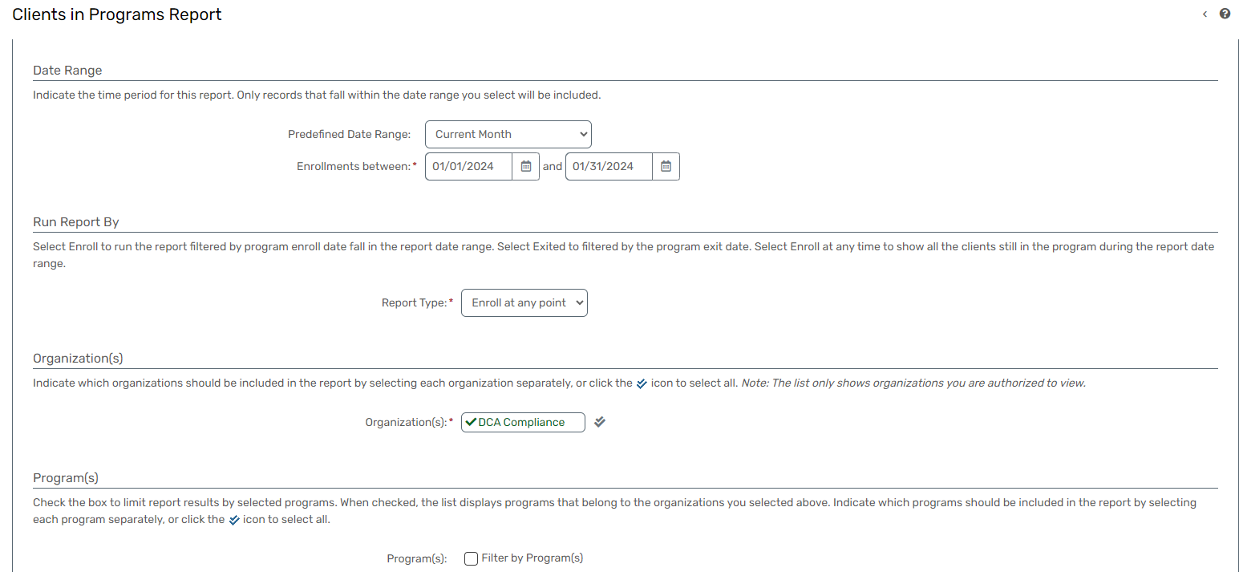
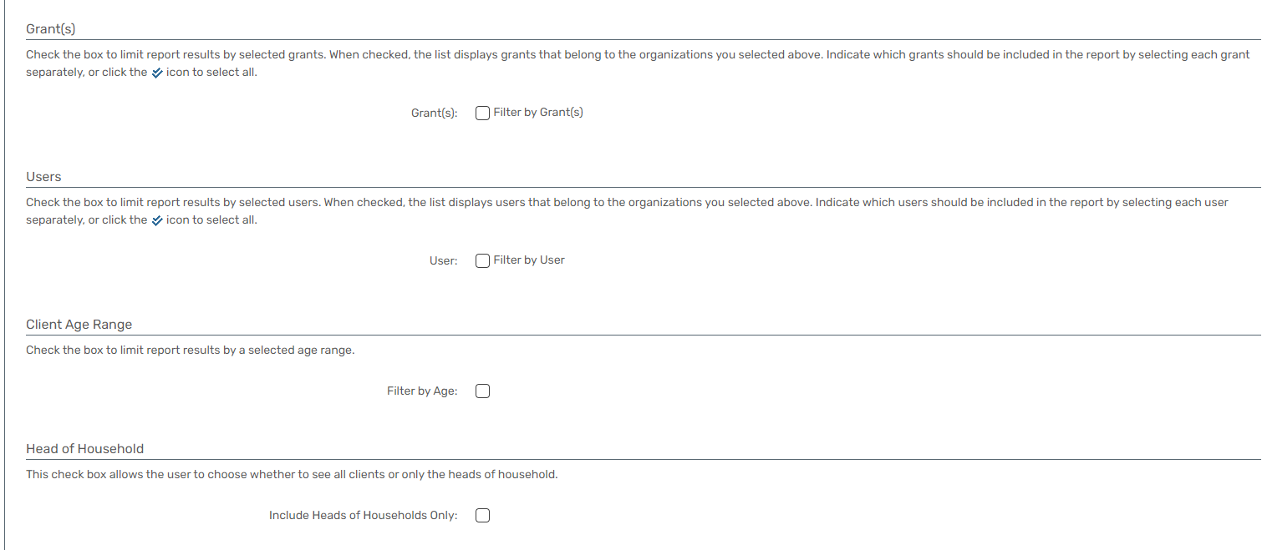

Enrollment Services
Report Description
- The Services Provided During Enrollment Report is designed to display a comprehensive list of services provided to clients during their enrollment in a program.
- Data is grouped by either the program enrolled into or the funding source of the service, depending on the selected grouping option.
- Provides flexibility to analyze services either from a program-centric or funding source perspective.
- Facilitates detailed tracking of services delivered during client enrollments.
- Supports insights into resource allocation by identifying programs or funding sources associated with specific services.

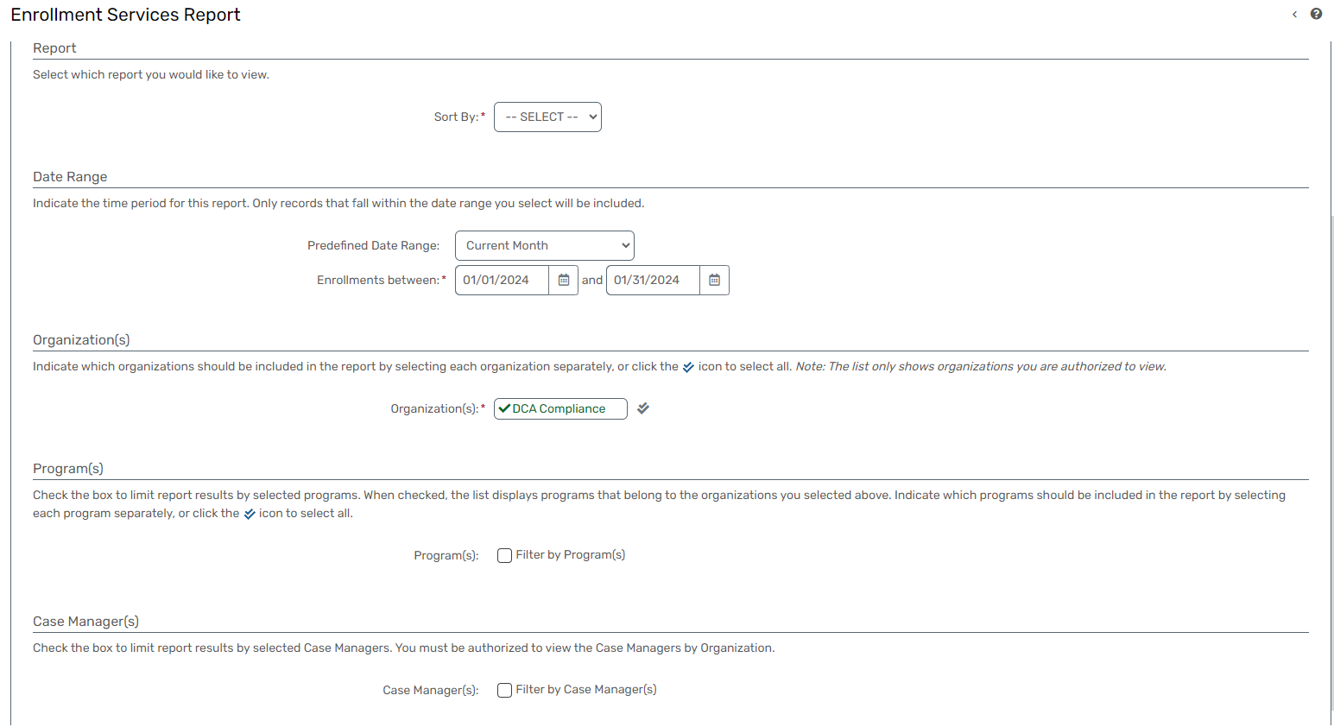

Barcode Program Roster
Report Description
- The Barcode Program Enrollment Tracking Report is designed to track clients who have enrolled in programs.
- This report provides a detailed overview of client enrollments, including key information such as program details, enrollment dates, and associated services.
- Provides a comprehensive overview of client enrollments, aiding in tracking program participation.
- Enables timely intervention by identifying clients actively enrolled and the services they are receiving.
- Facilitates data-driven decision-making for program management and resource allocation.

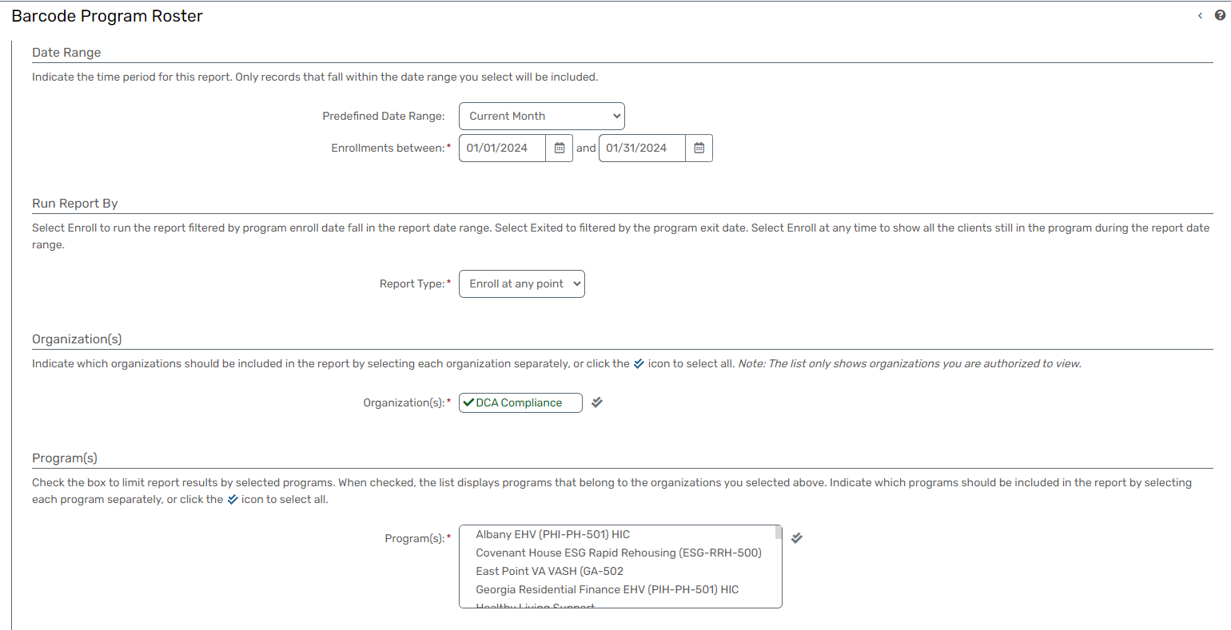

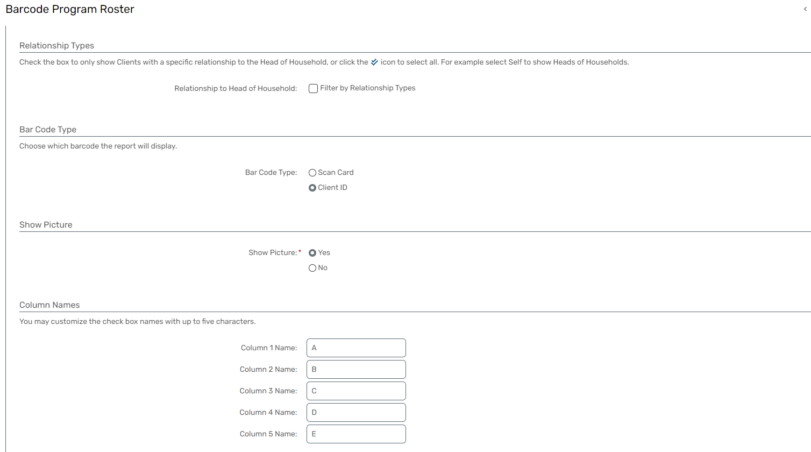

Confidential Program Assistance
Report Description
- The Confidential Program Assistance report shows Customized Funding, Services, and Programs Report allows users to select specific funds, services, and programs based on defined conditions.
- The report output is generated based on 'AND' conditions, providing a detailed overview for the selected combinations, such as Range of Services 'AND' Service Create Agencies or Organizations 'AND' Funds 'AND' Services 'AND' Programs.
- Offers flexibility for users to tailor the report based on specific 'AND' conditions.
- Provides a detailed output for the selected combinations of funds, services, organizations, and programs.
- Supports customized data analysis by allowing users to focus on specific criteria and their intersections.
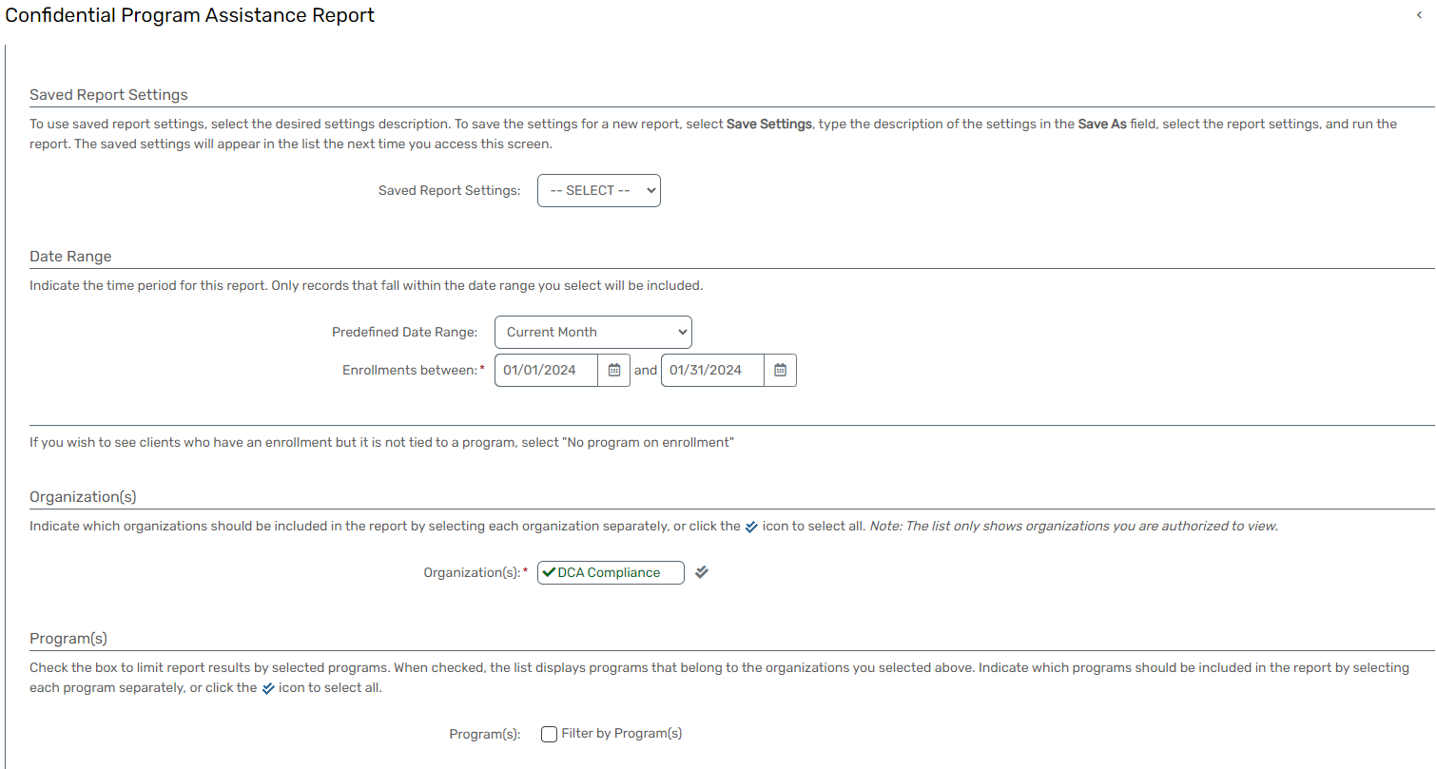
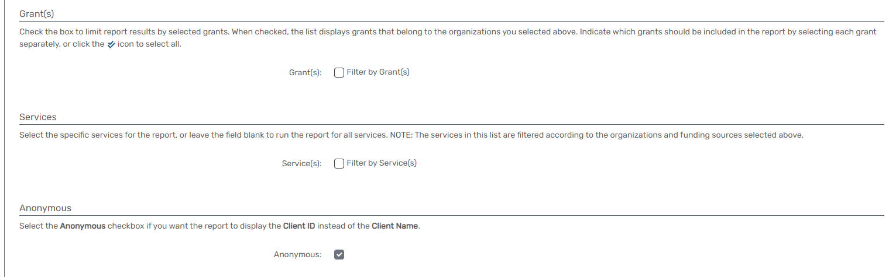

Enrollment Barrier
Report Description

- The Client and Enrollment Barrier Report provides a comprehensive overview by displaying the number of clients, enrollments, and identified barriers at both entry and exit points.
- This report aids in understanding the challenges clients face during their engagement with programs.
- Provides a comprehensive overview of the number of clients served and enrollments recorded.
- Offers insights into the identified barriers, distinguishing between entry and exit points.
- Supports data-driven decision-making by highlighting key metrics related to client engagement and identified barriers.

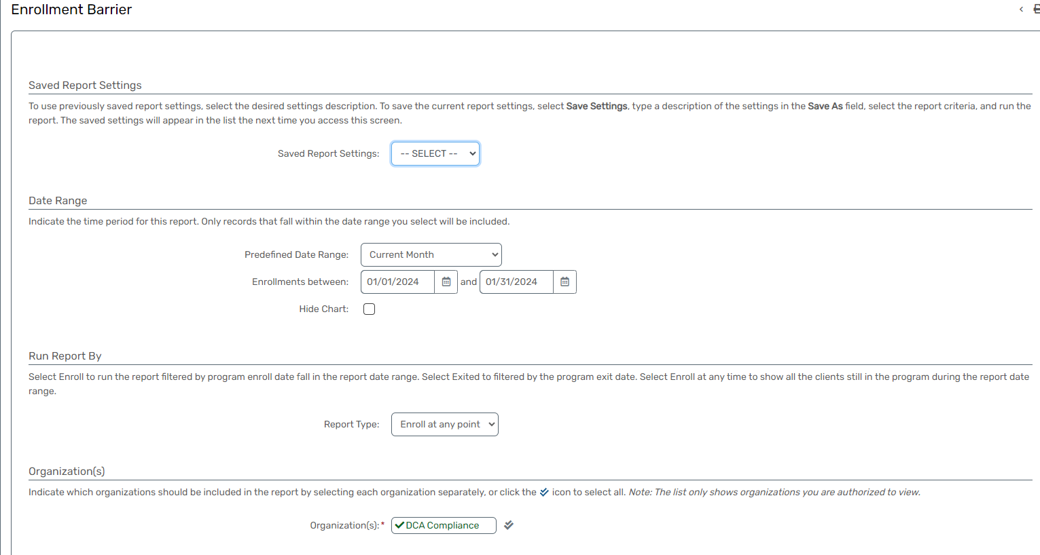

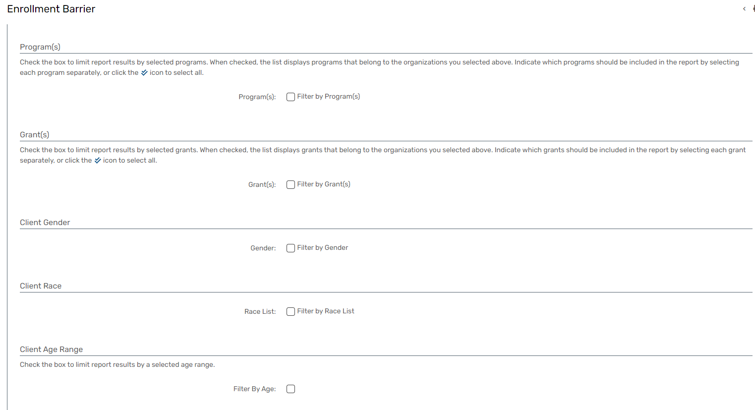

Cross Program Participation Report
Report Description
- The Cross-Program Participation Report provides detailed information on the participation of clients across different programs.
- This report facilitates a comprehensive understanding of clients' engagement with multiple programs, highlighting key metrics and program-specific details.
- Provides a holistic view of clients' engagement by detailing their participation across multiple programs.
- Offers insights into the specific programs in which clients are actively enrolled.
- Supports efficient resource allocation by identifying patterns of cross-program participation.
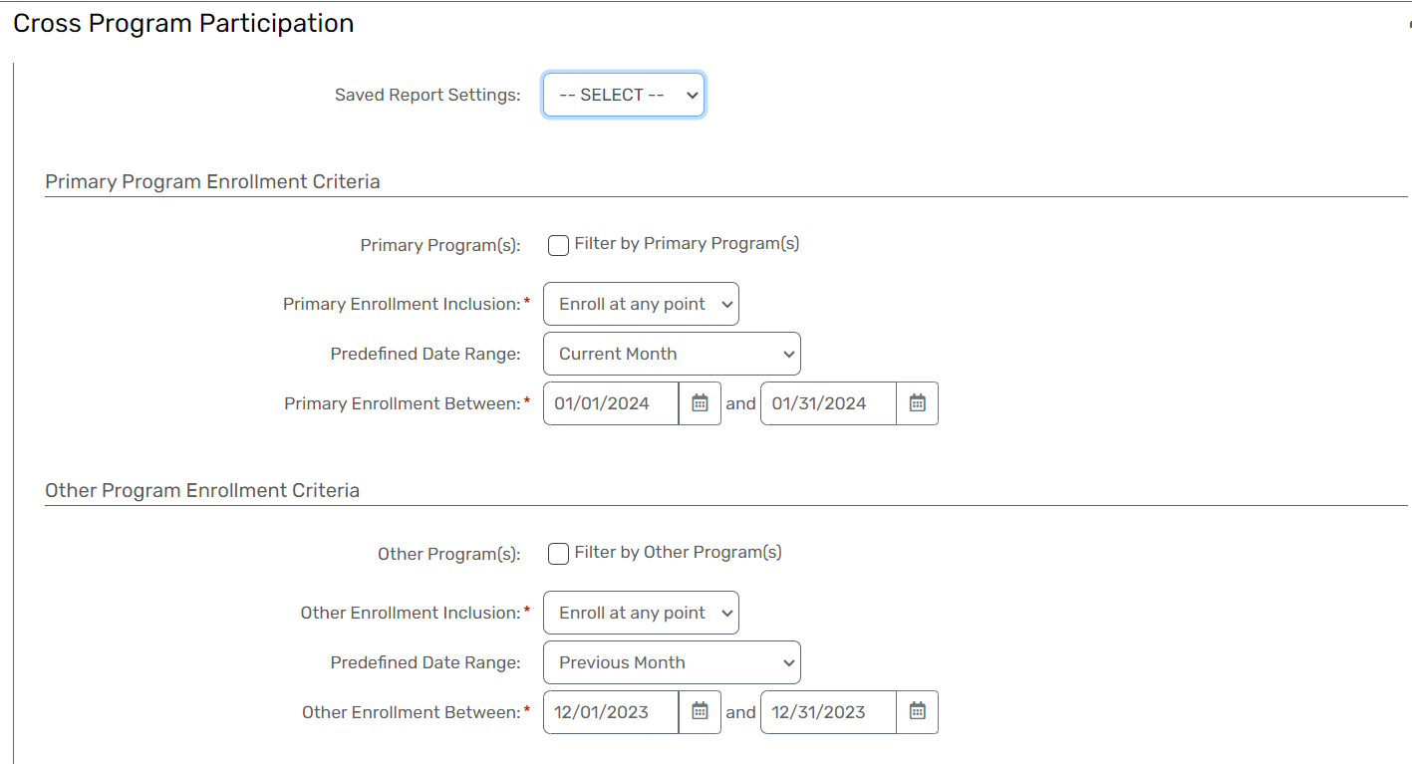

Enrollment Demographics
Report Description
- The Enrollment Demographic Report is designed to display a comprehensive list of clients, showcasing key demographic information at the time of enrollment.
- This report provides insights into the diversity of clients based on race, ethnicity, gender, age range, and religion.
- Provides a comprehensive overview of clients' demographic characteristics at the time of enrollment.
- Supports informed program planning by identifying the diversity of clients served.
- Facilitates data-driven decision-making by presenting key demographic insights for client populations.
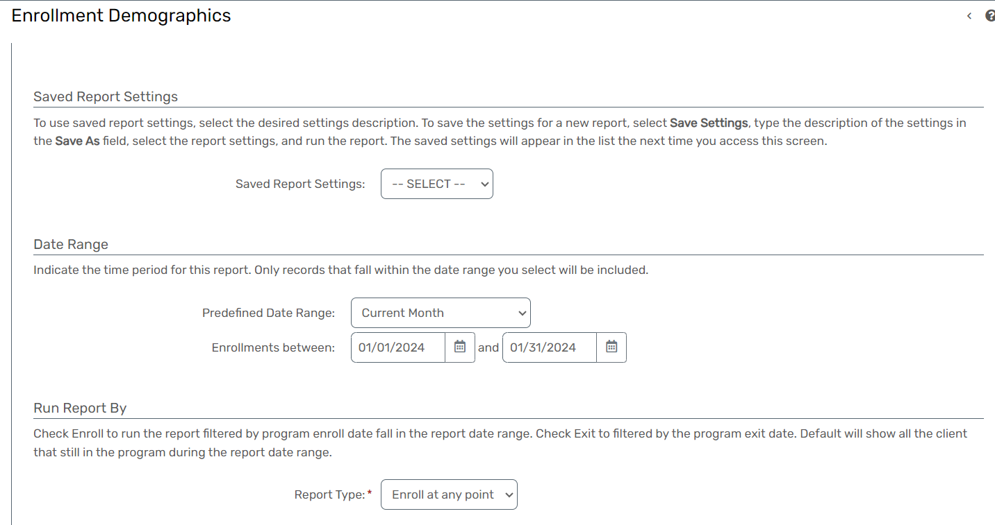
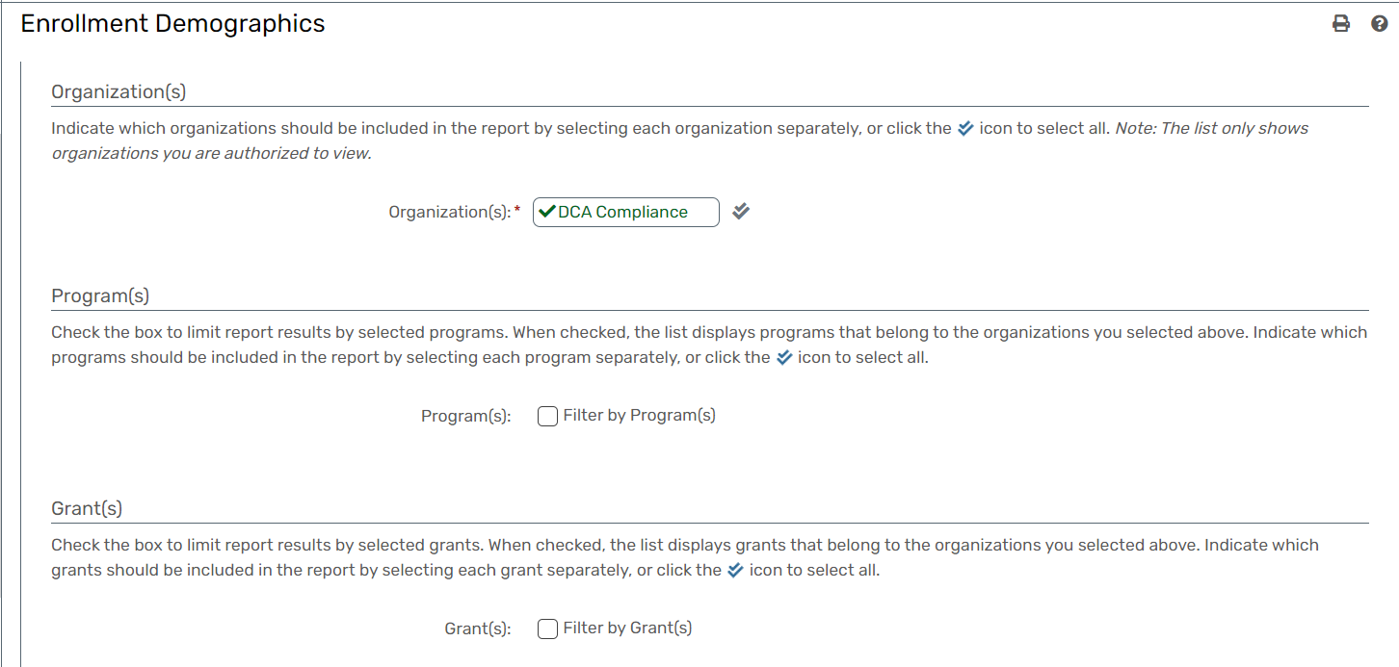
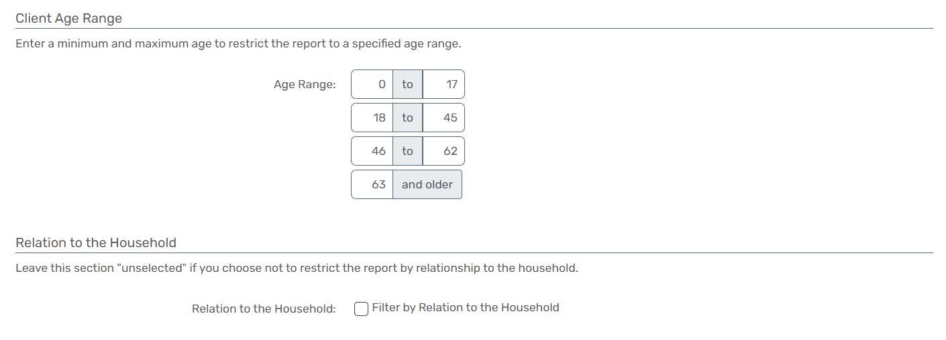

Income at Entry/Exit
Report Description
- The Income Difference Report is designed to calculate and display the difference in client income between enrollment and exit.
- This report provides insights into changes in client income over the course of their engagement with programs.
- Provides insights into changes in client income, highlighting cases where income has decreased.
- Helps in identifying financial trends among clients over the course of their engagement.
- Presents the average income difference for clients with completed assessments.
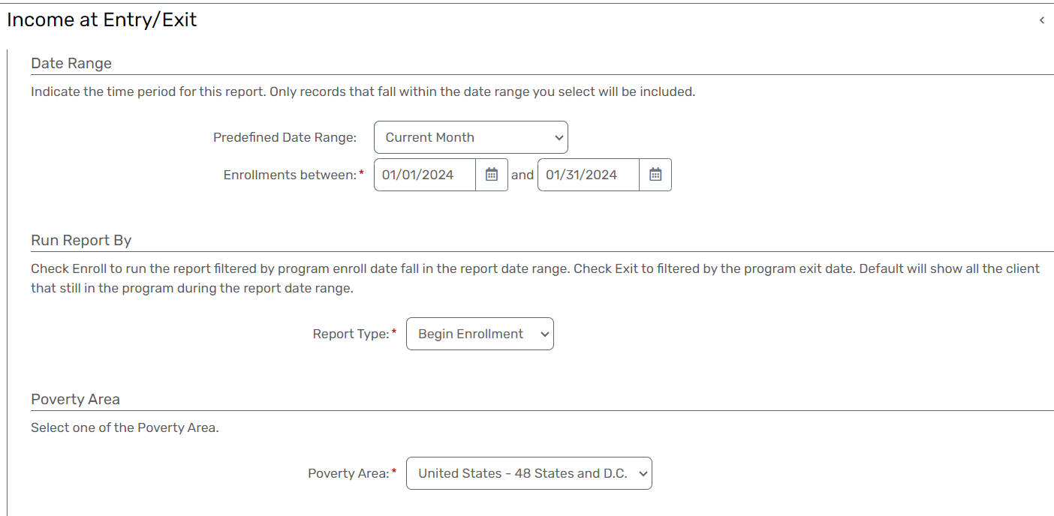
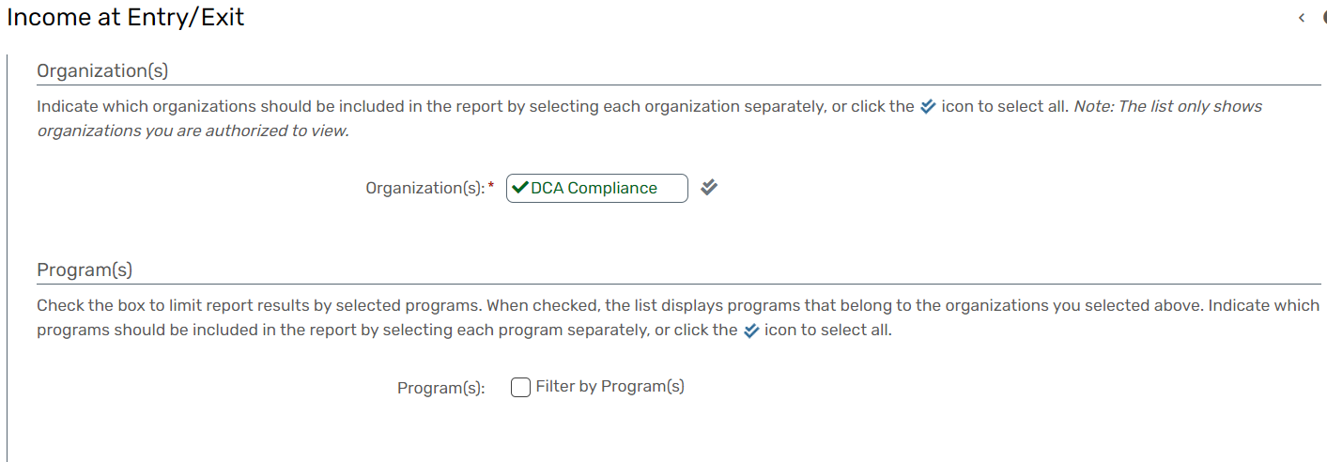
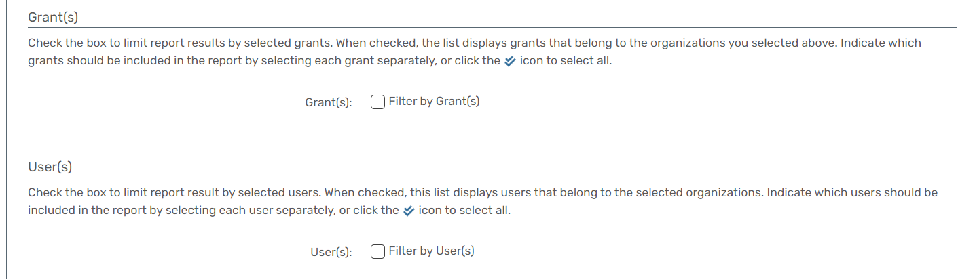

Employment at Entry/Exit
Report Description
- The Employment at Entry/Exit Report provides a detailed analysis of client employment data during a specific date range, focusing on entry and exit points.
- The report categorizes clients based on their employment status, identifies cases with undetermined employment data, and highlights clients with changes in employment status from entry to exit.
- Provides a comprehensive analysis of client employment data, focusing on entry and exit points.
- Helps identify cases where employment data is undetermined at entry or exit.
- Highlights cases where clients' employment status changed from entry to exit.
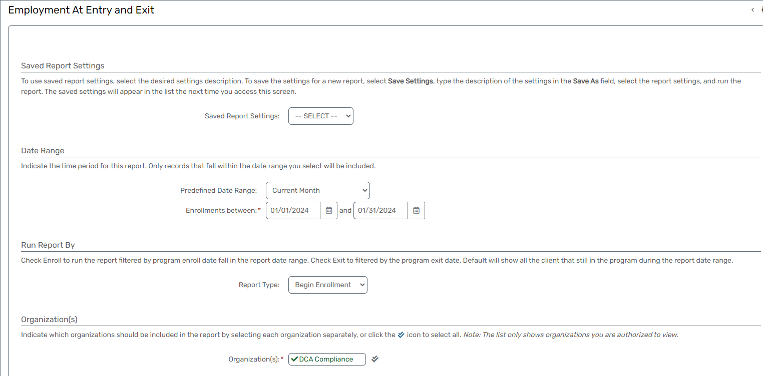
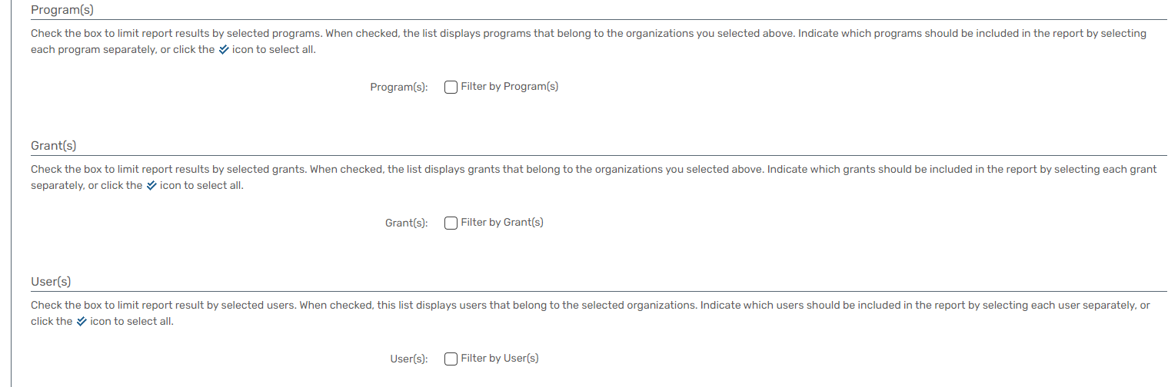

Follow Up & Prevention
Report Description
- The Follow-up & Prevention Report is designed to identify and report services received by clients after they have exited a project.
- The report focuses on enrollments that have exited within a specified date range and captures services provided to clients on or after the enrollment exit date but before the report end date.
- Provides insights into services received by clients after exiting a project.
- Identifies cases where clients are accessing services post-exit, allowing for timely intervention if needed.
- Supports data-driven decision-making by highlighting post-exit service utilization.
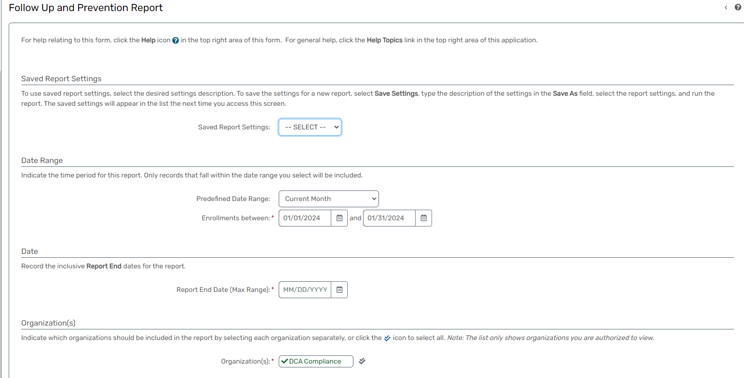
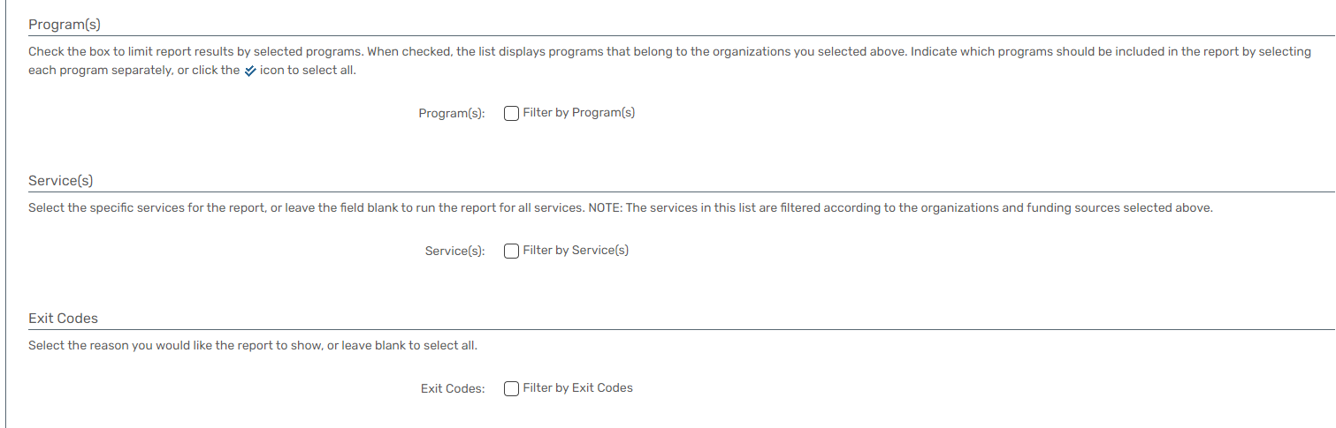

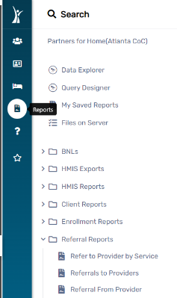
Referral Reports

Refer to Provider by Service
Report Description
- The Refer to Provider by Service Report provides detailed information about the providers offering specific services.
- This report allows users to drill down into the details of service provision, offering insights into the distribution of services among different providers.
- Offers insights into service provision by specific providers.
- Facilitates analysis of service distribution among providers, aiding in resource allocation decisions.
- Helps understand how clients utilize services from different providers.
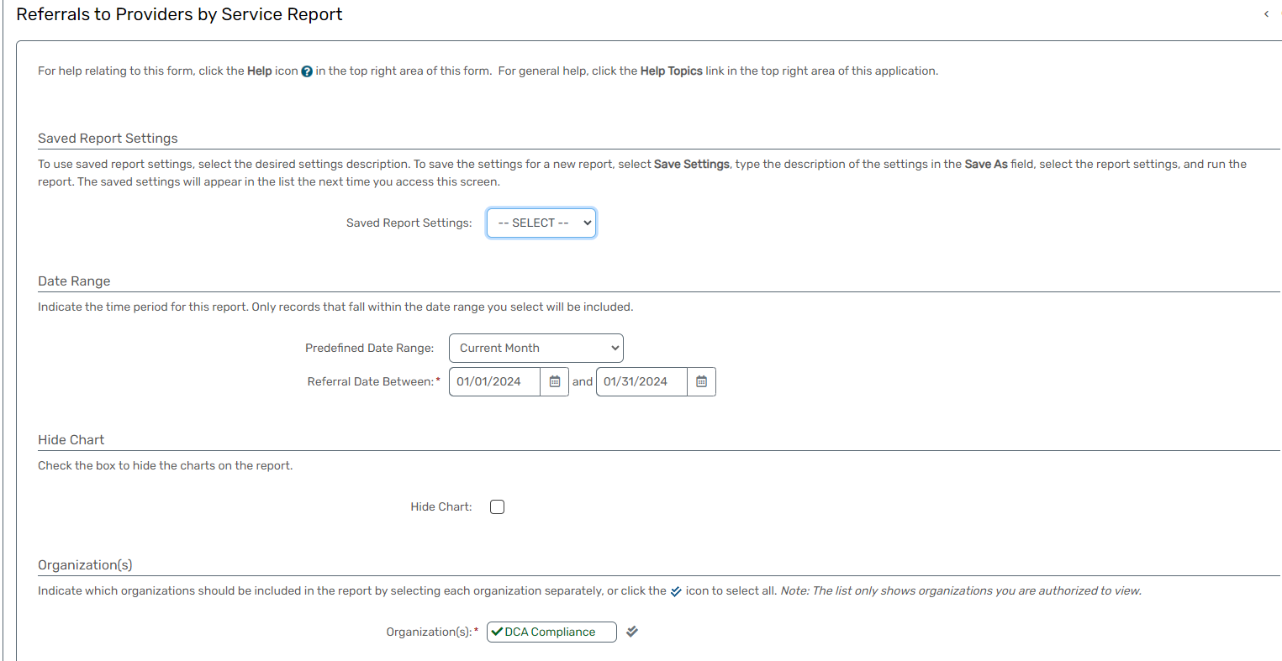
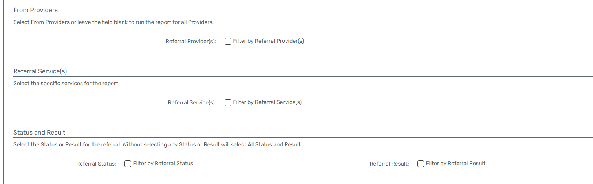

Referrals to Providers
Report Description
- The Provider Referral Report presents detailed information on referrals made by organizations to specific service providers.
- This report includes essential details such as the provider’s name, service, module, referral date, and client information, providing a comprehensive overview of the referral process.
- Enhances transparency in the referral process by providing detailed information on provider referrals.
- Allows analysis of organizations referring clients to specific providers.
- Offers a comprehensive overview of client referrals, aiding in case management.
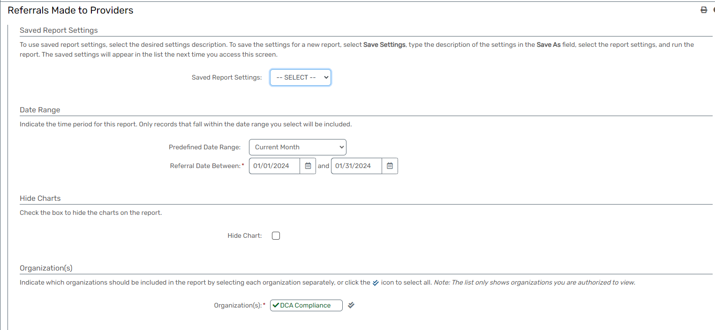
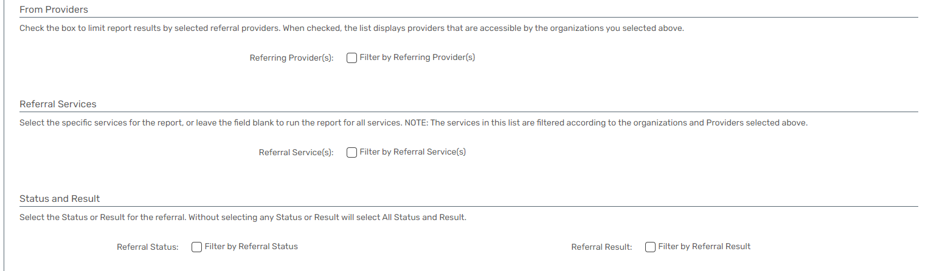

Referral From Provider
Report Description
- The Referral From Provider Report provides details on clients who have been referred to your organization from another provider. This report offers insights into the sources of referrals, including the referring providers, client information, and relevant referral details.
- Identifies the providers referring clients to your organization. Provides insights into client referrals, aiding in understanding the origin of clients accessing your services. Facilitates collaboration with referring providers, fostering a coordinated approach to client care.
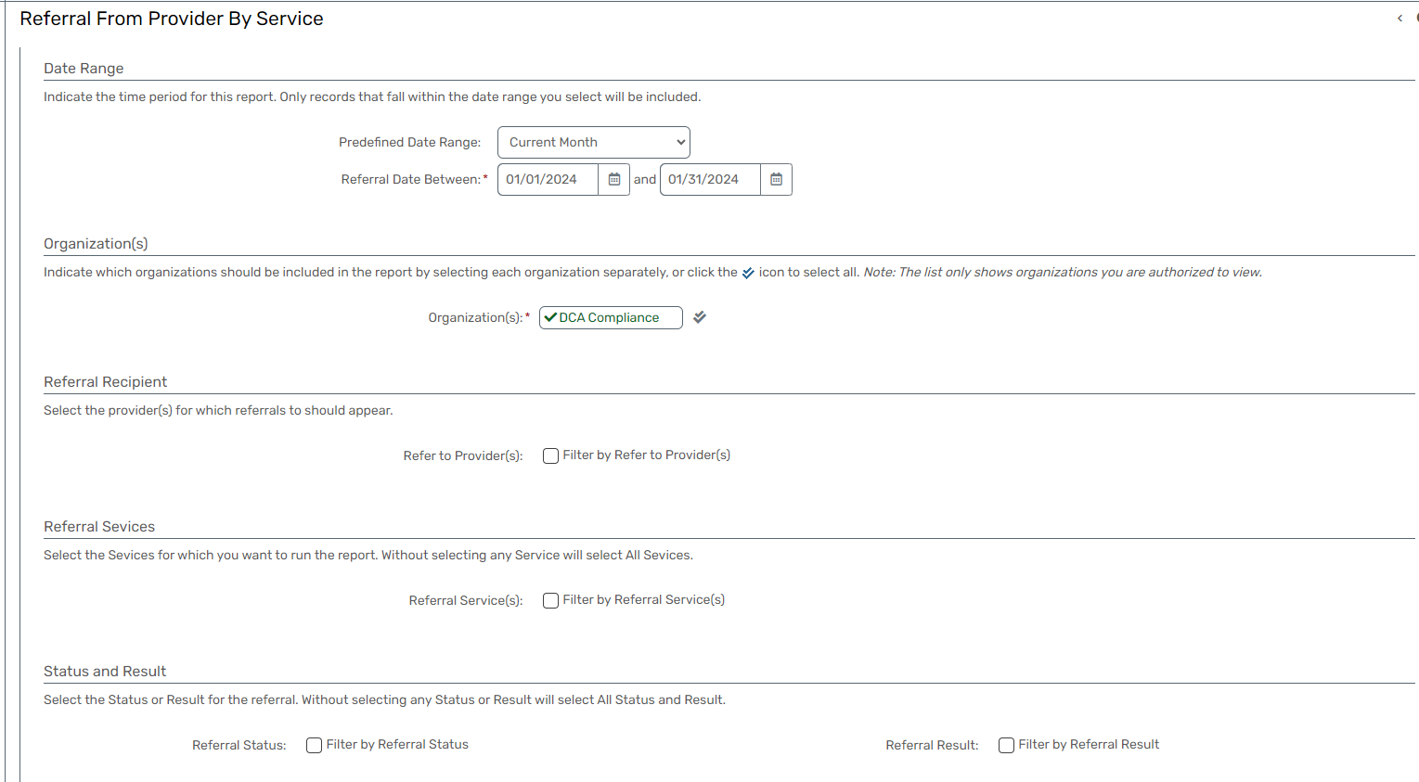

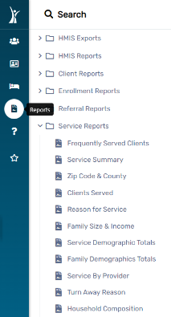
Service Reports

Frequently Served Clients
Report Description
- The Frequently Served Clients Report offers a comprehensive analysis of clients who have been frequently served, with multiple filter options available.
- This report allows users to explore client service patterns based on organization, user, service, and various client sub-populations such as Minimum Number of Services, Veterans, and AIDS/HIV cases.
- They all work together providing valuable insights into service utilization.
- Enables users to customize the report based on specific organizational, user, and service criteria.
- Provides insights into the service utilization patterns of clients, considering various sub-populations.
- Supports optimizing resource allocation by identifying frequently served clients and tailoring services accordingly.
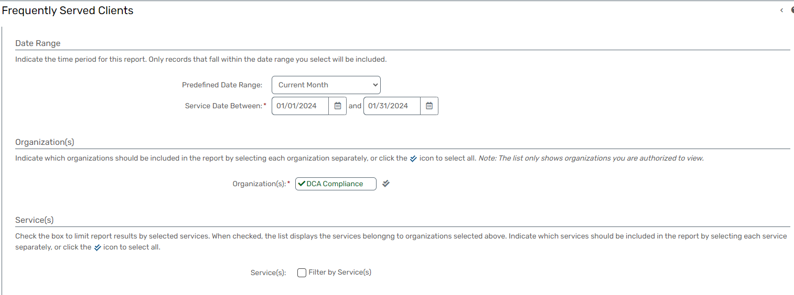
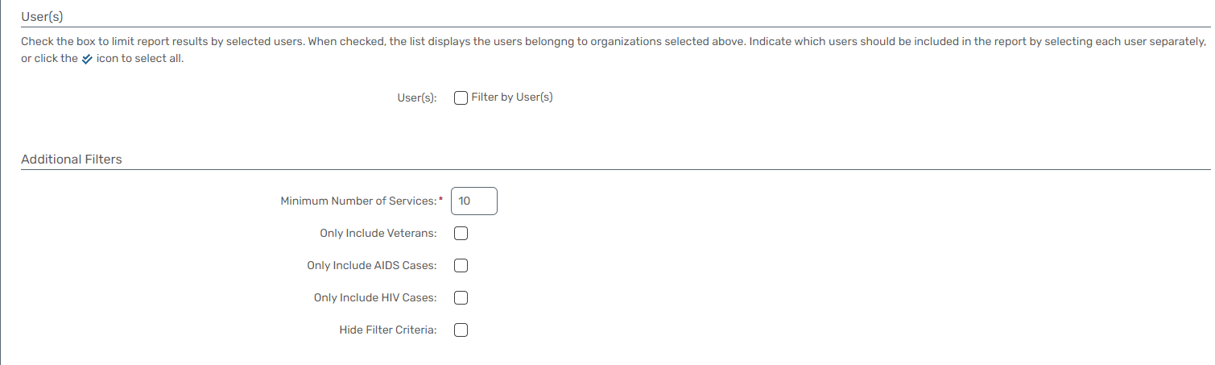

Service Summary
Report Description
- The Organization Services Report provides a detailed analysis of services provided by selected organizations.
- The report includes a breakdown of services based on zip codes, considering the client's address at the time of service creation, housing facility zip code, or last permanent address.
- Additionally, the report counts family members and provides demographic information based on the client's current family situation at the time of service.
- Provides a detailed analysis of services based on zip code criteria. Offers insights into the family size and composition of clients at the time of service.
- Enables users to customize the report based on selected organizations and specific zip code criteria.
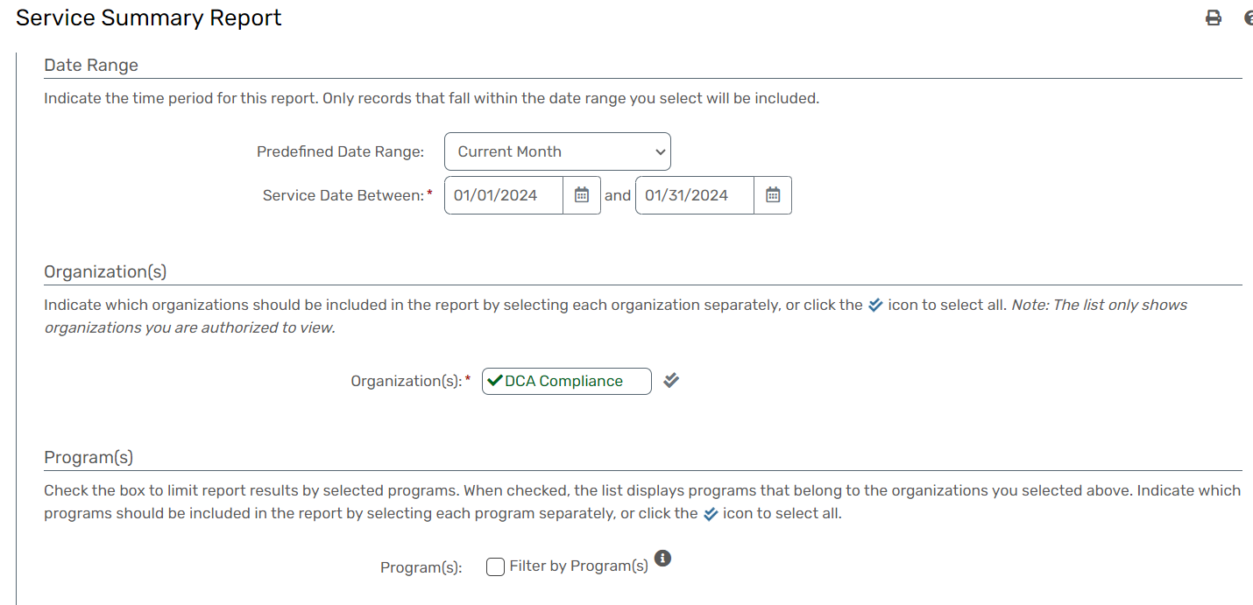
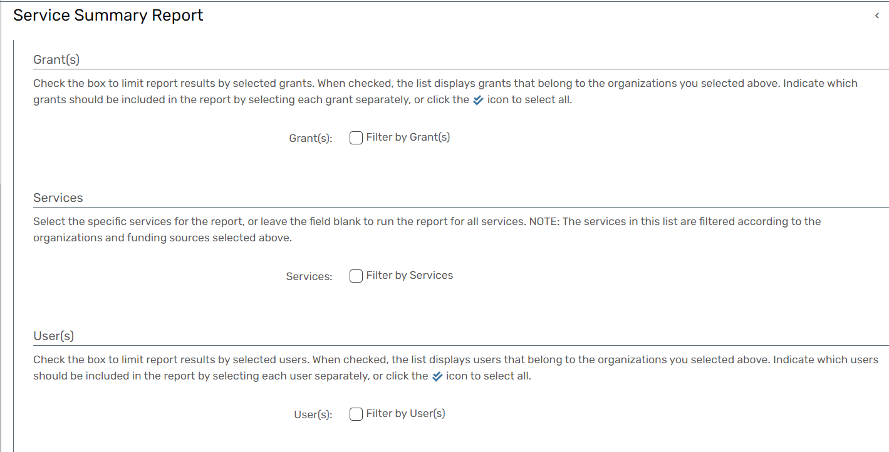
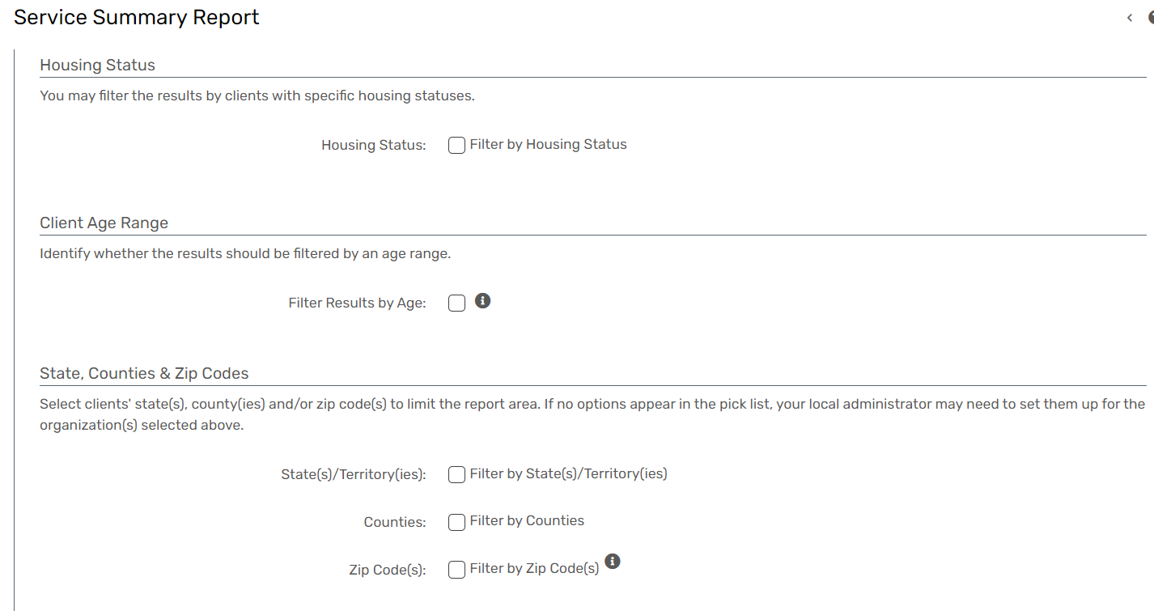
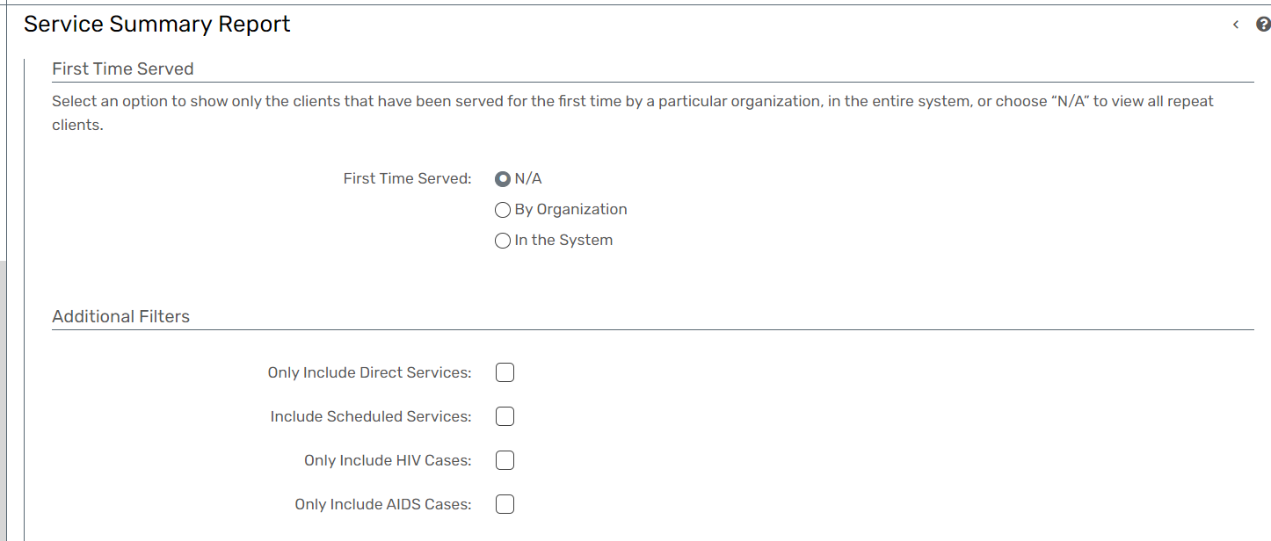
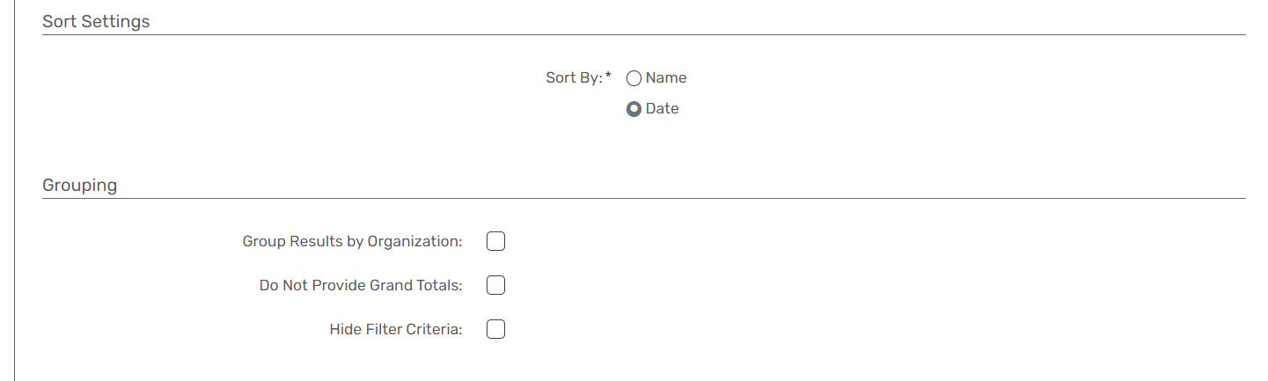

Zip Code & County
Report Description
- The Zip Code and County Service Area Report provides an overview of the counties and zip codes where services are provided.
- The report is designed to offer insights into the geographic distribution of services, considering factors such as the client's address at the time-of-service creation, housing facility zip code, last permanent address, or current address at the time of service.
- Provides insights into the geographic distribution of services based on zip code criteria. Identifies the counties corresponding to the service areas, aiding in understanding the broader service coverage.
- Allows users to customize the report based on specific criteria, such as client address or housing facility zip code.
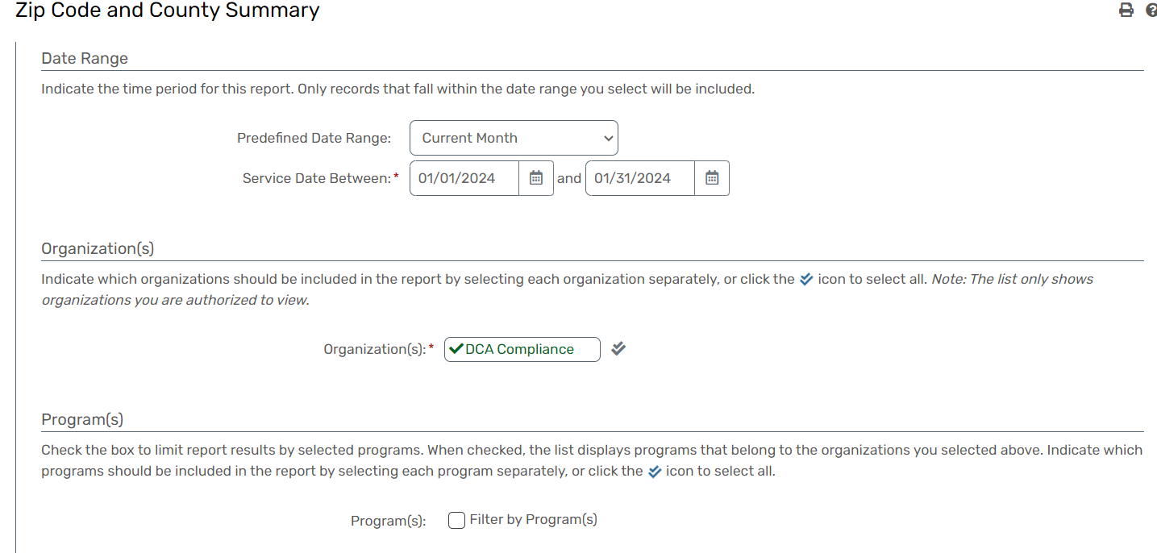
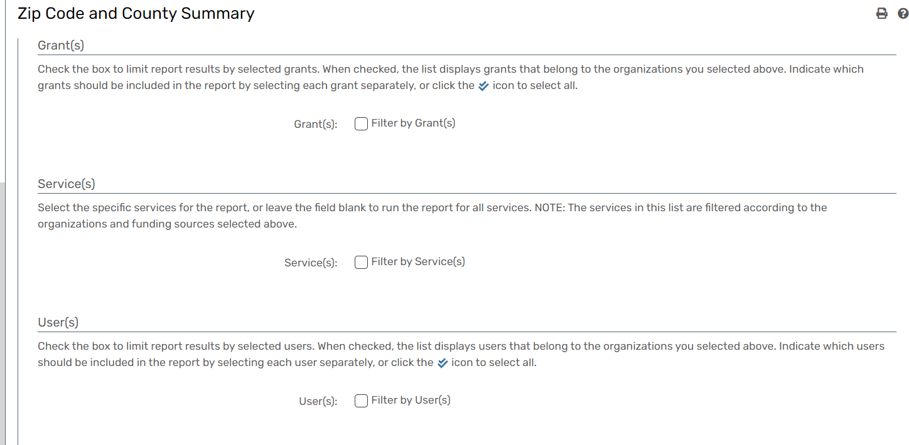
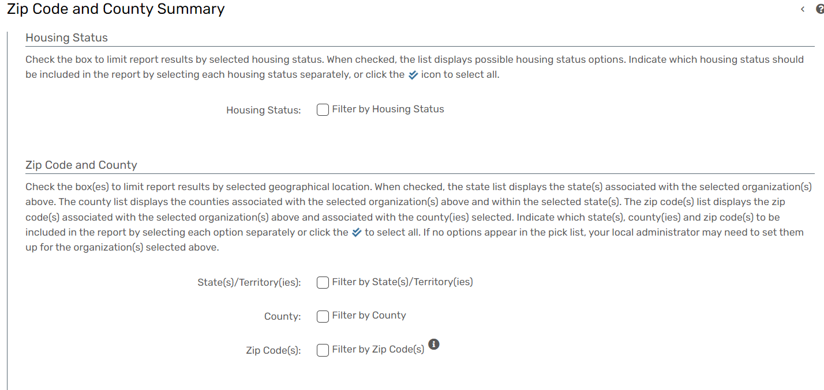
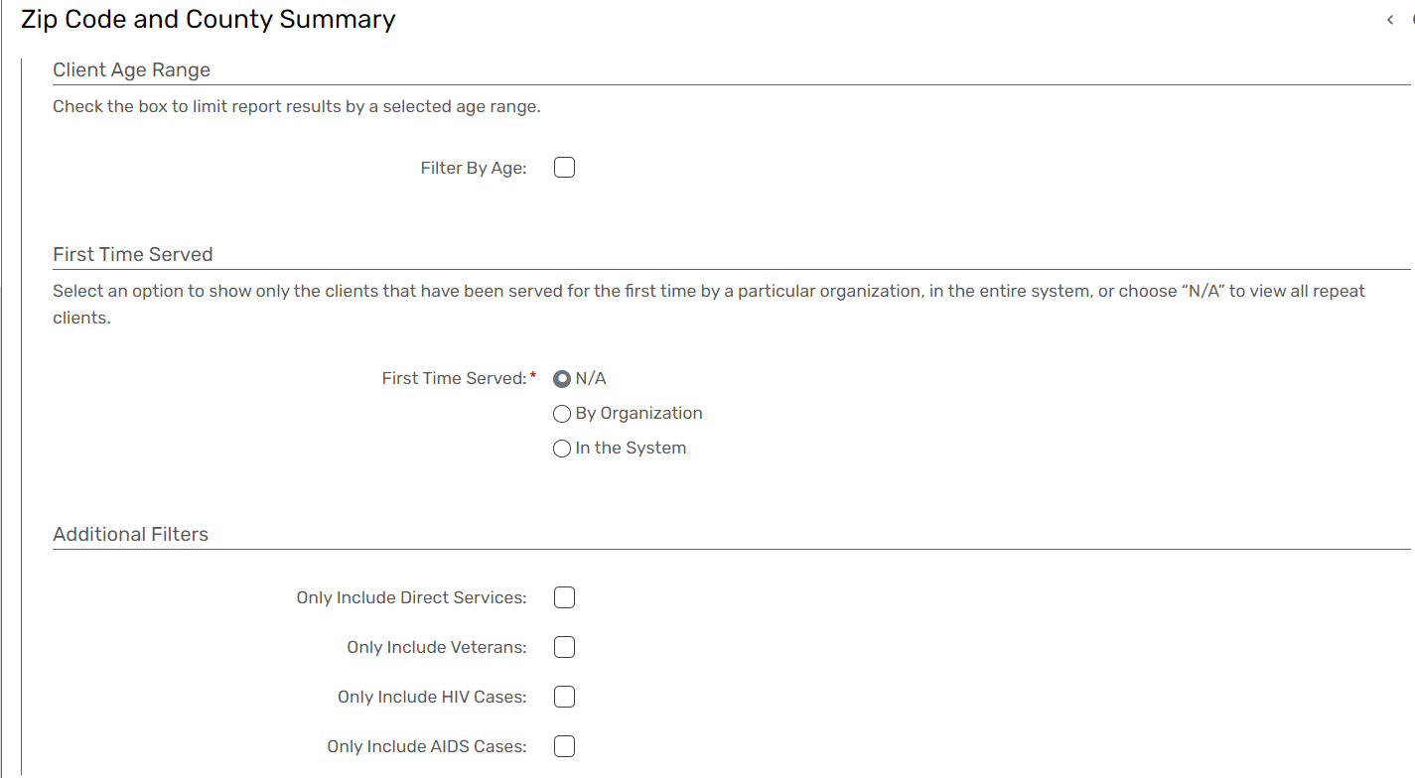

Clients Served
Report Description
- The Clients Served Report provides comprehensive data about clients served within a specific date range.
- This report is designed to aggregate data at the client level, making it valuable for reporting needs related to service utilization.
- It includes basic demographic and identifying information for clients and can be expanded to display detailed service information for each service within the specified date range such as: Grant, Units, and Units served, and Service total.
- Provides a client-centric view of service utilization, aiding in understanding individual client needs. Offers detailed service information, including service types, dates, grant details, units, unit values, and service totals. Allows users to configure the date range for flexible reporting.
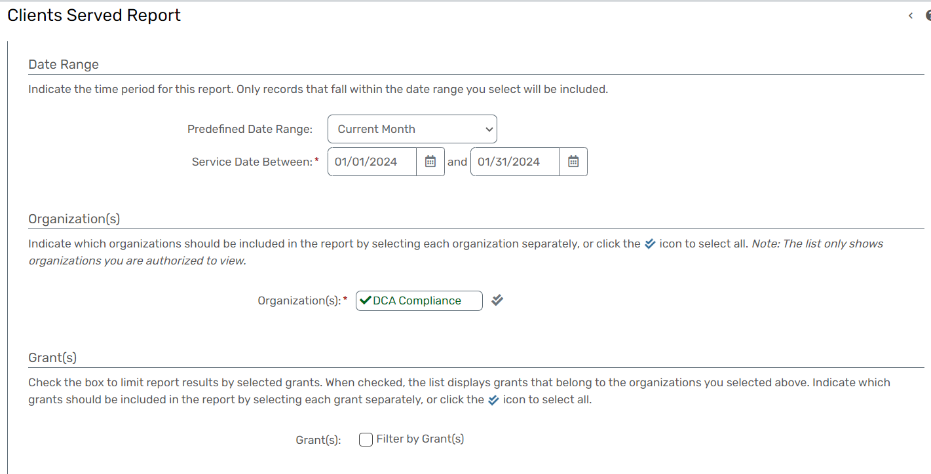
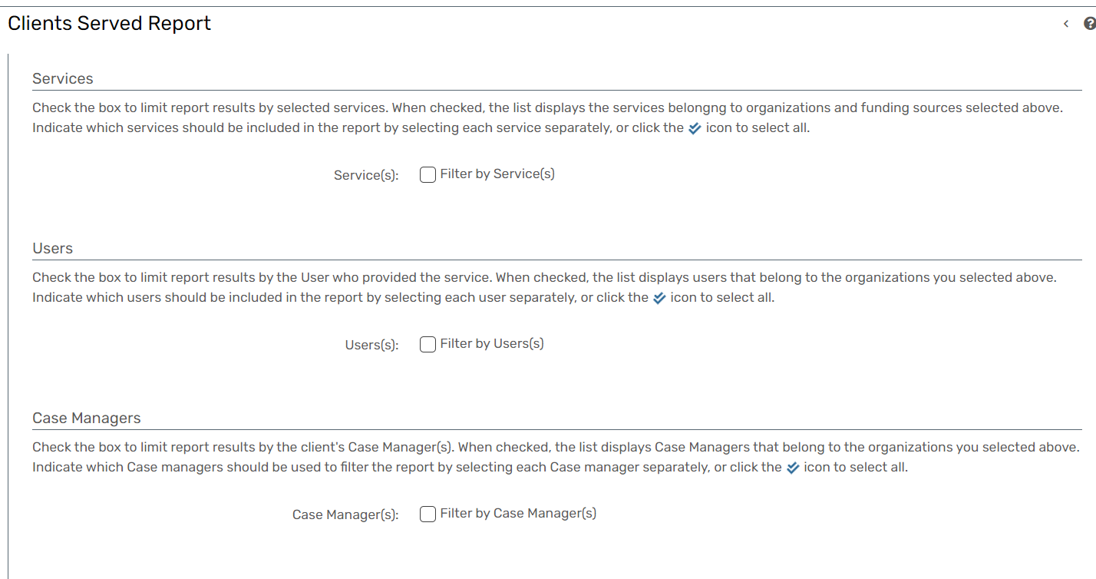
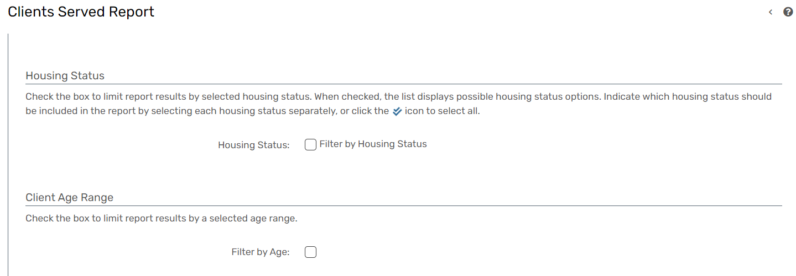
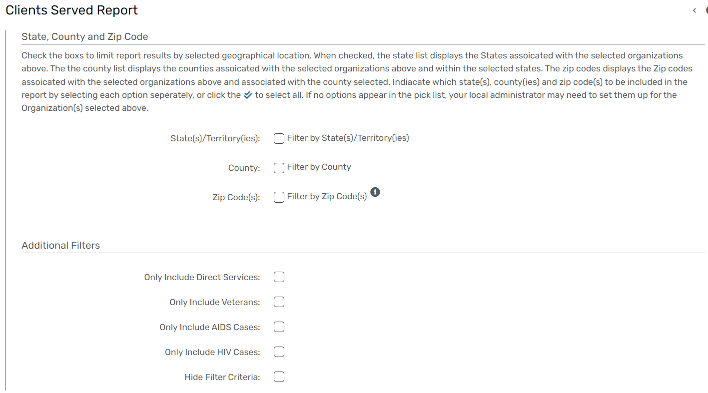

Reason for Service
Report Description
- The Reason for Service Report provides totals based on the reason for service and offers a detailed drill-down to count services, clients, and units.
- This report allows users to drill down by reason for service, displaying client-specific details such as SSN, family size, income, poverty percentage of the family, service date, name, grant details, unit value, and total value.
- Provides an overview of service utilization based on different reasons for service.
- Allows users to drill down into detailed information for each reason, including client-specific details.
- Offers a comprehensive set of client information, aiding in detailed analysis and reporting.
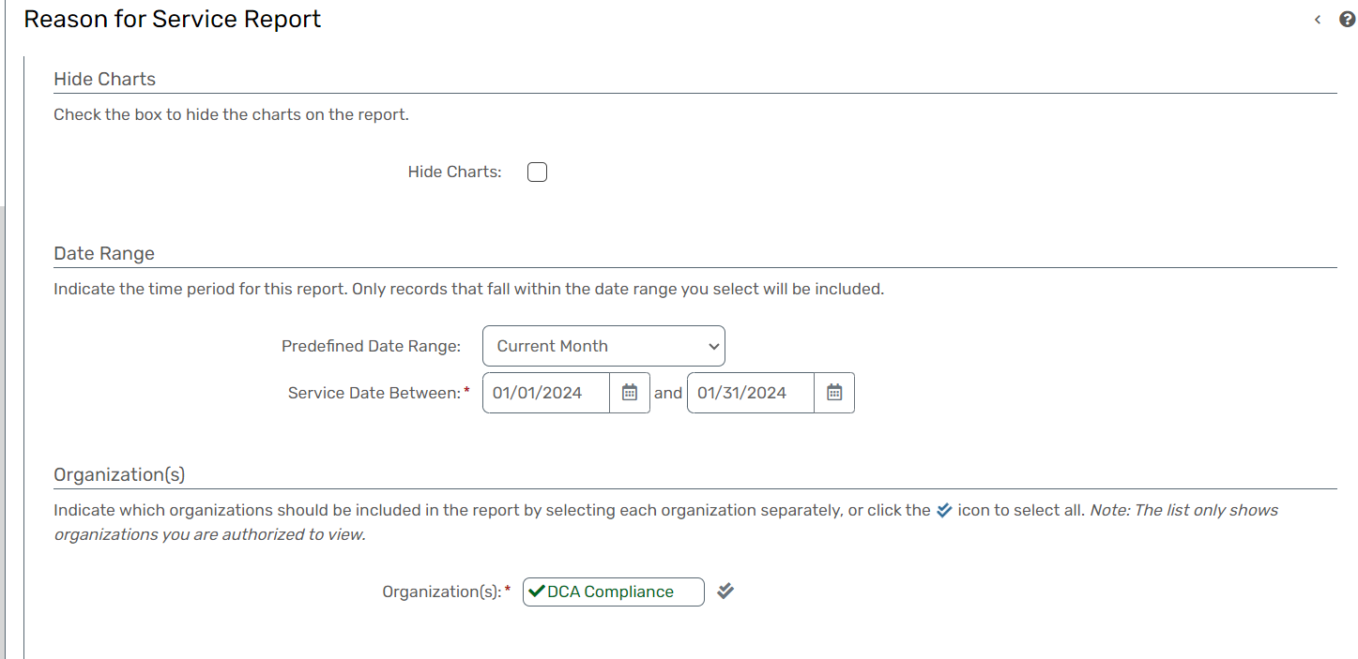
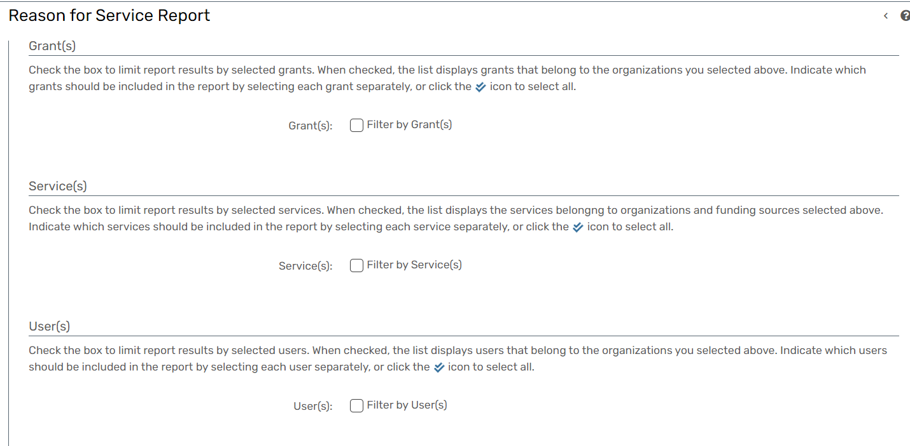
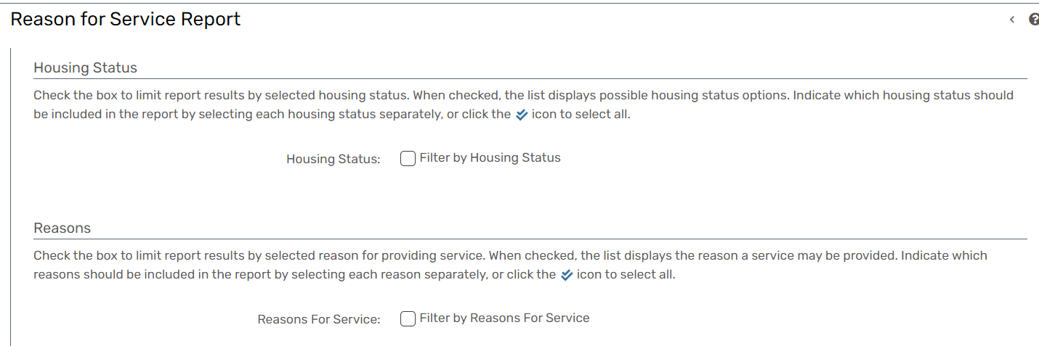
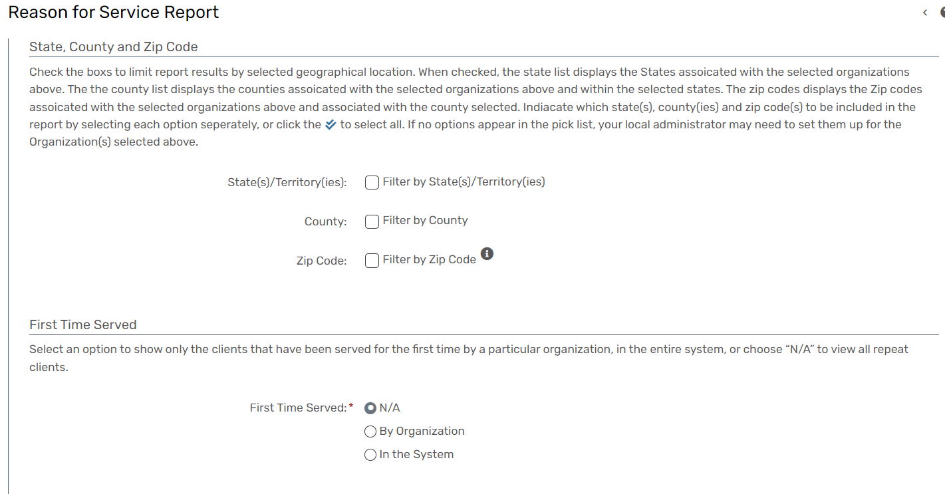
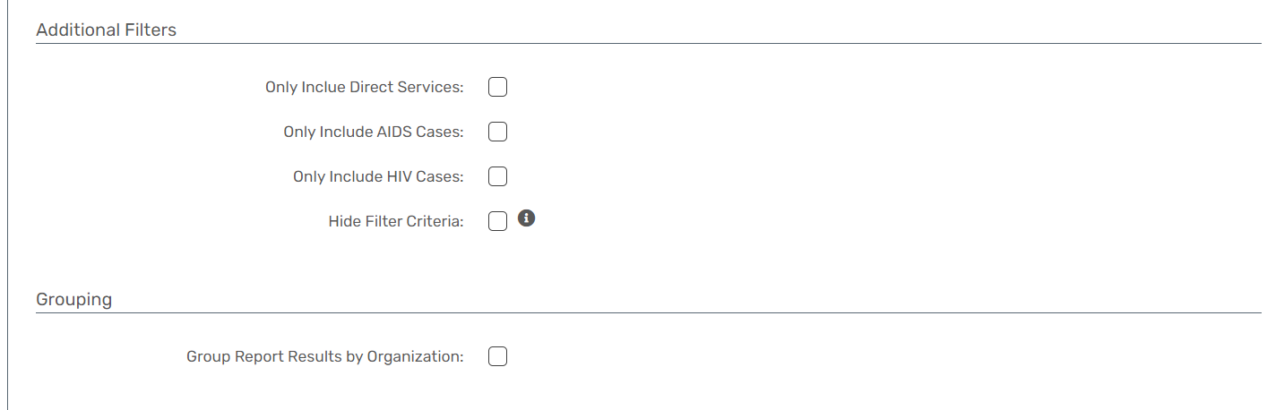

Family Size & Income
Report Description
- The Family Size and Income Report provides a detailed drill-down to count the number of families based on family size.
- The report includes information such as names of families within the group, the date the family was created, the last date the family received services, and detailed family income information.
- This income information includes the source of family income and the family member receiving the income.
- Provides an overview of the distribution of families based on different family sizes.
- Allows users to drill down into detailed information for each family size group, including family names and relevant dates.
- Offers a comprehensive set of family income details, including sources of income and the family members receiving the income.
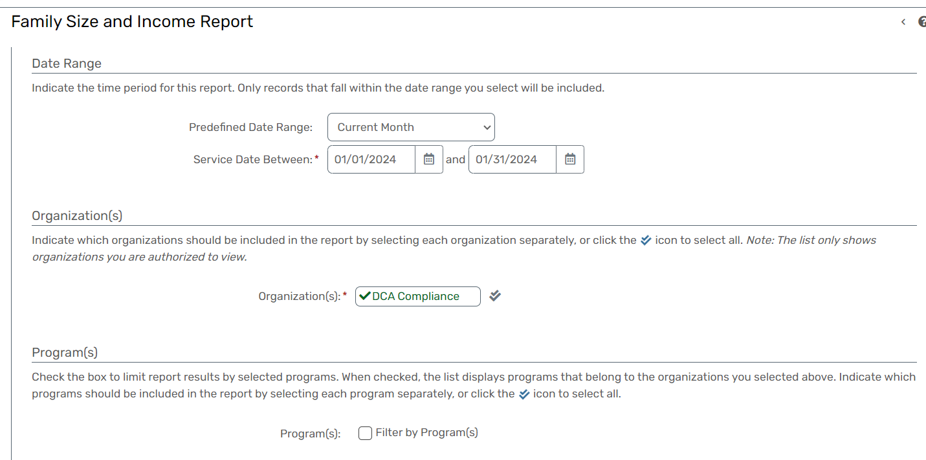
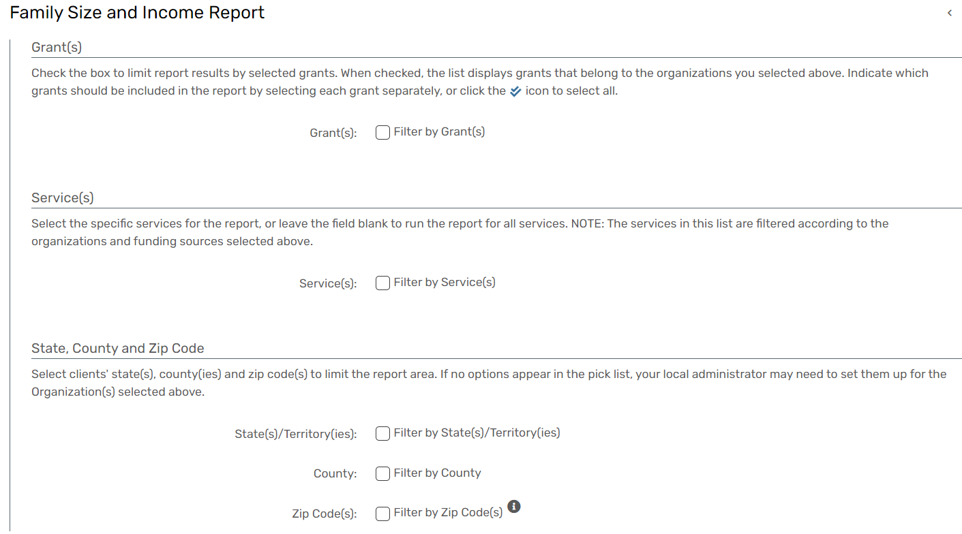
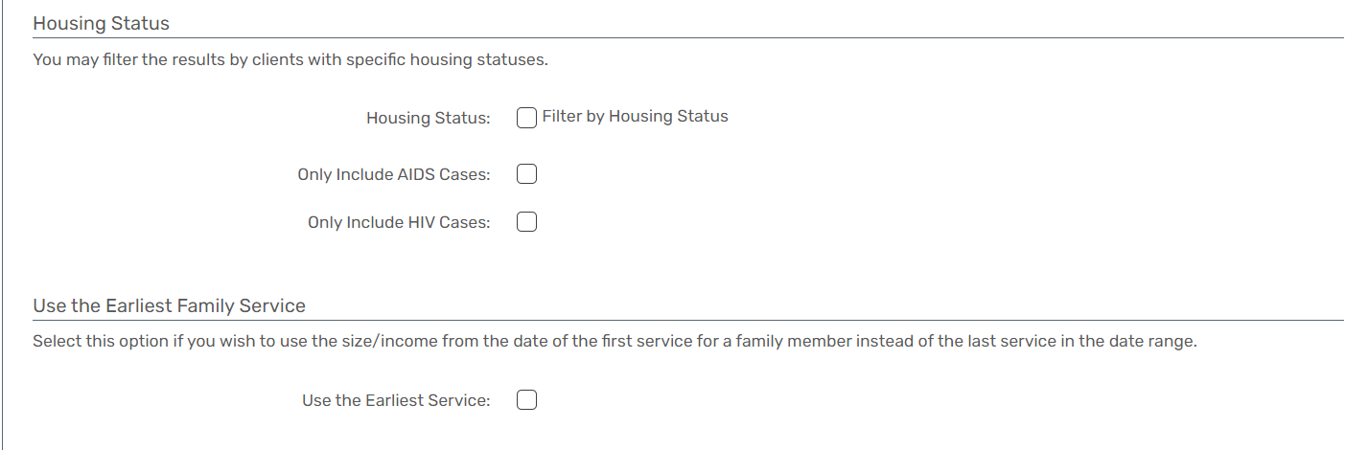

Service Demographic Totals
Report Description
- The Service Demographic Totals Report provides a summary of clients who received services during a specified reporting period.
- The report breaks down information by the number of distinct clients receiving a service, the total number of services received, the total dollar amount of services received, and demographic details such as race, ethnicity, gender, and age group.
- The report considers active information release requirements for both service and client intake records.
- Provides a comprehensive overview of clients and services based on demographic details.
- Allows for accurate counting of clients in each age group based on service dates.
- Ensures compliance with information release requirements for both service and client intake records.
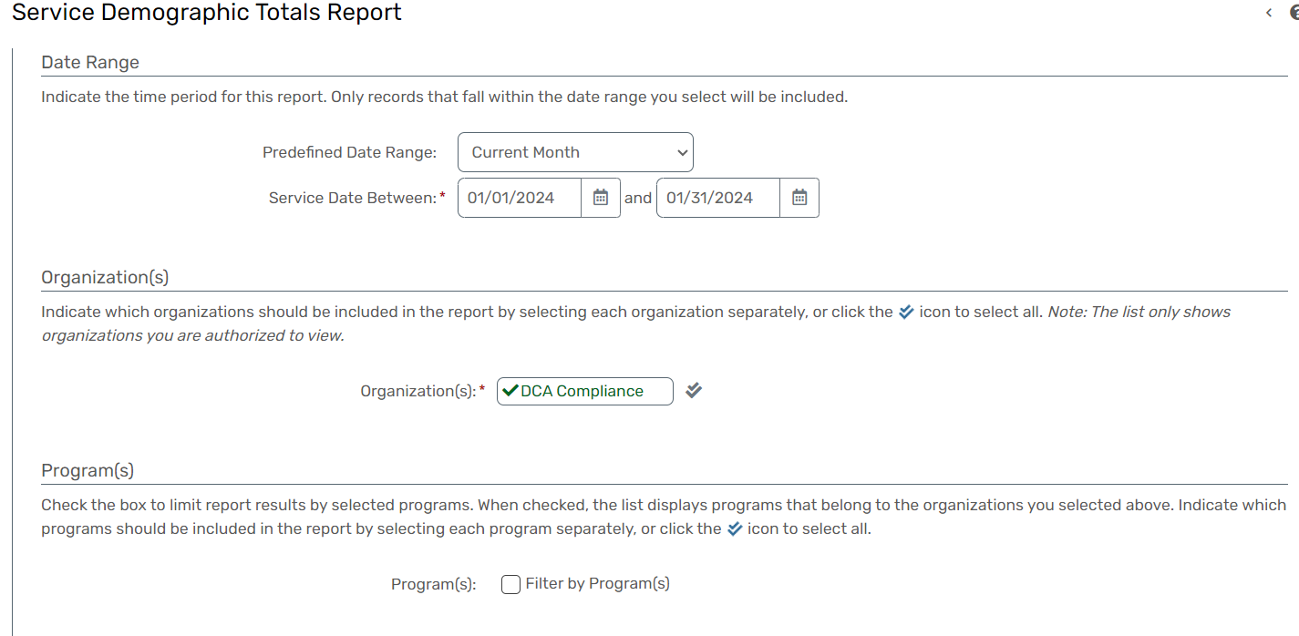
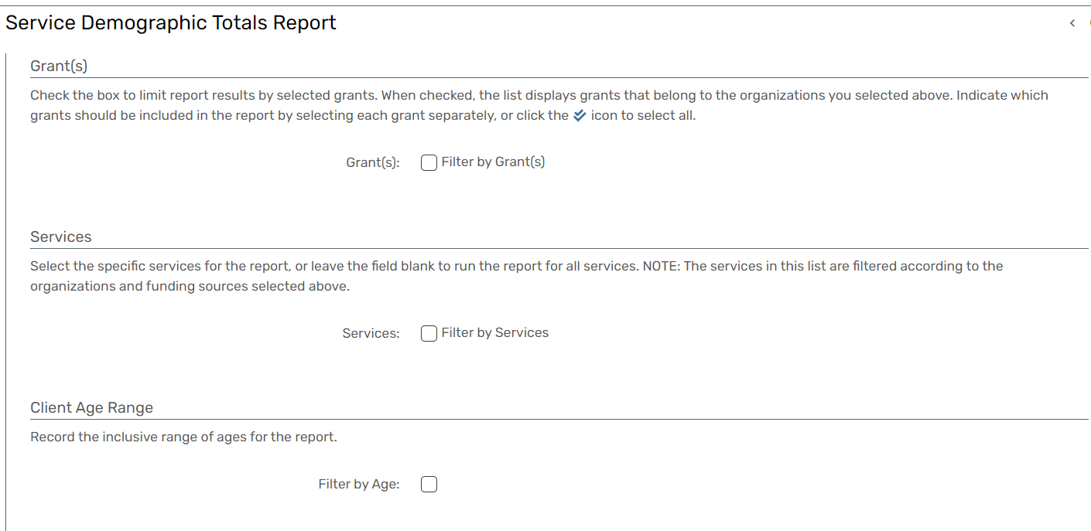
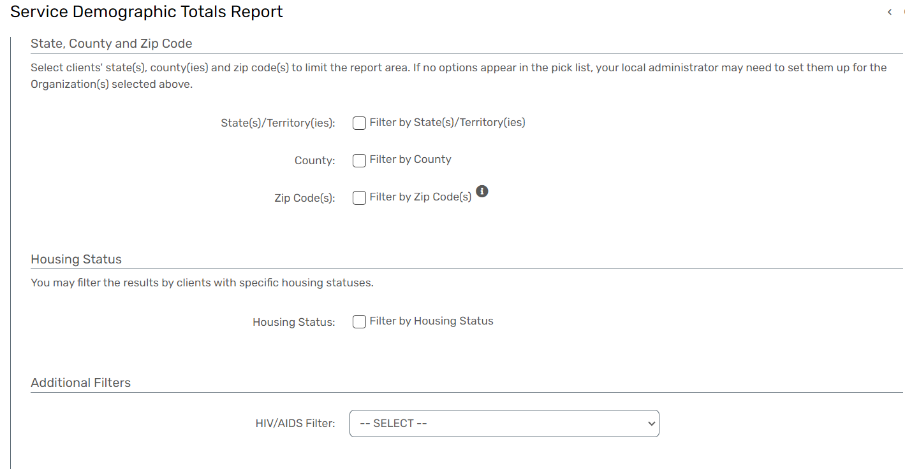
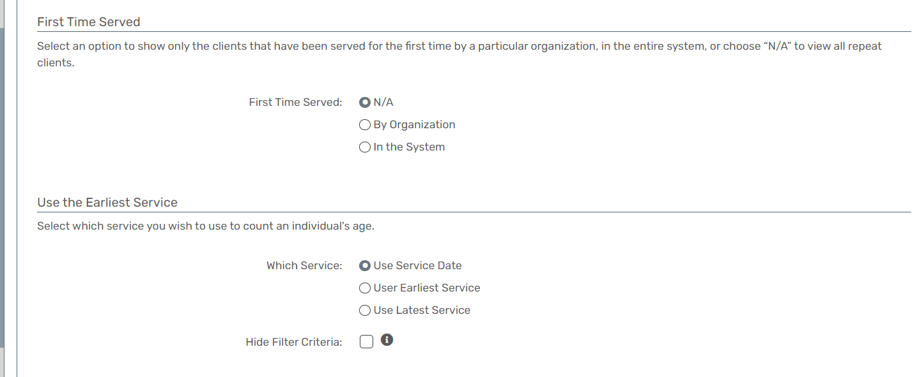

Family Demographics Totals
Report Description
- The Family Demographics Totals Report provides a count of family members and families within specified demographic groups.
- The report breaks down information by age, ethnicity, gender, and race, offering insights into the composition of families based on these demographic criteria.
- Provides a comprehensive overview of family members and families based on specified demographic criteria.
- Offers insights into the composition of families, aiding in demographic analysis.
- Allows users to customize the report based on specific demographic groups of interest.
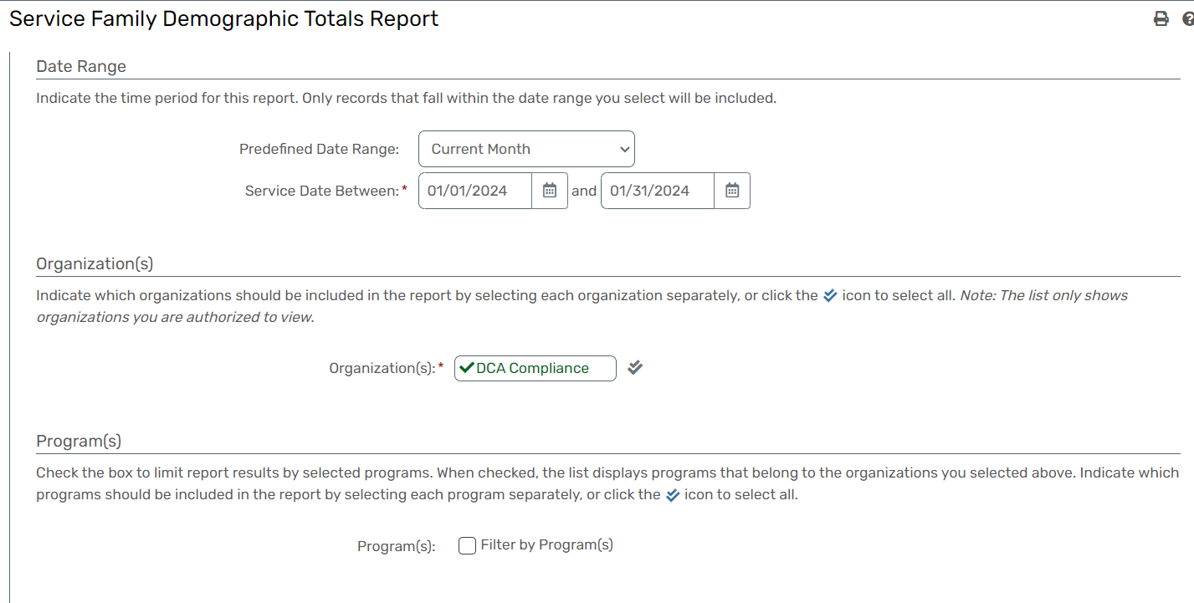
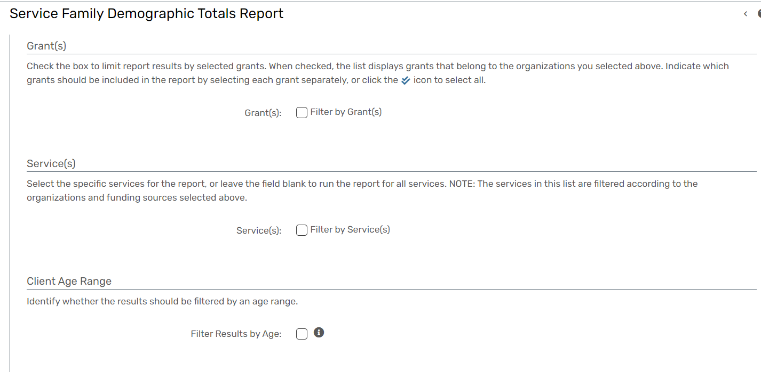
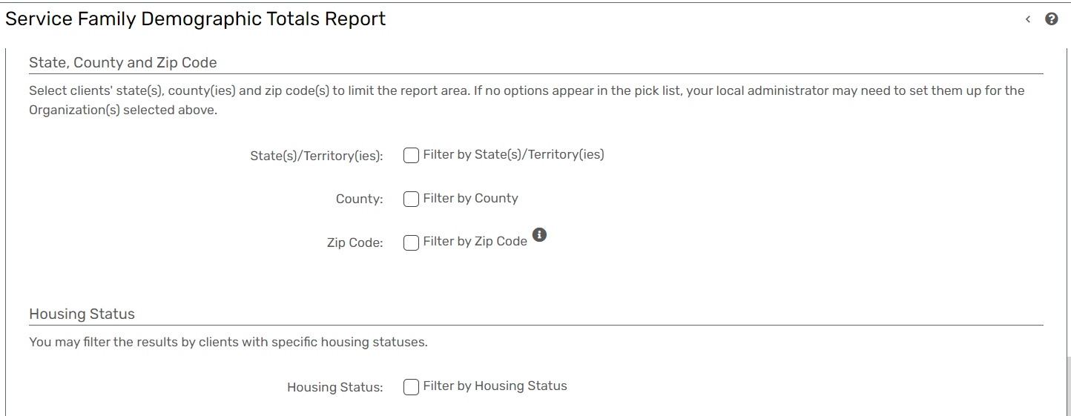
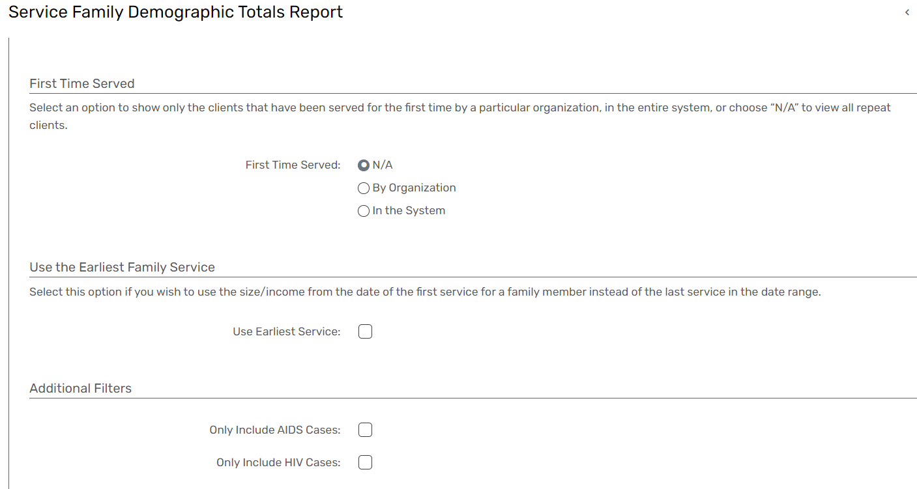

Service By Provider
Report Description
- The Service By Provider Report displays the count of services provided by the selected provider, broken down by various metrics, including clients, households, units, and total cost.
- This report offers insights into the service utilization patterns and associated costs for a specific provider.
- Provides provider-specific metrics, including client count, household count, unit count, and total cost.
- Enables analysis of the cost-effectiveness of services provided by the selected provider.
- Facilitates the evaluation of provider performance based on service utilization and associated costs.
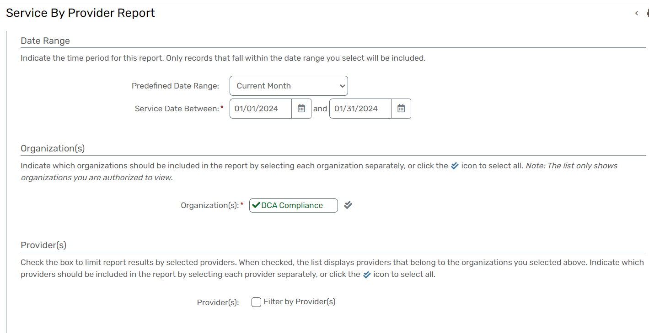
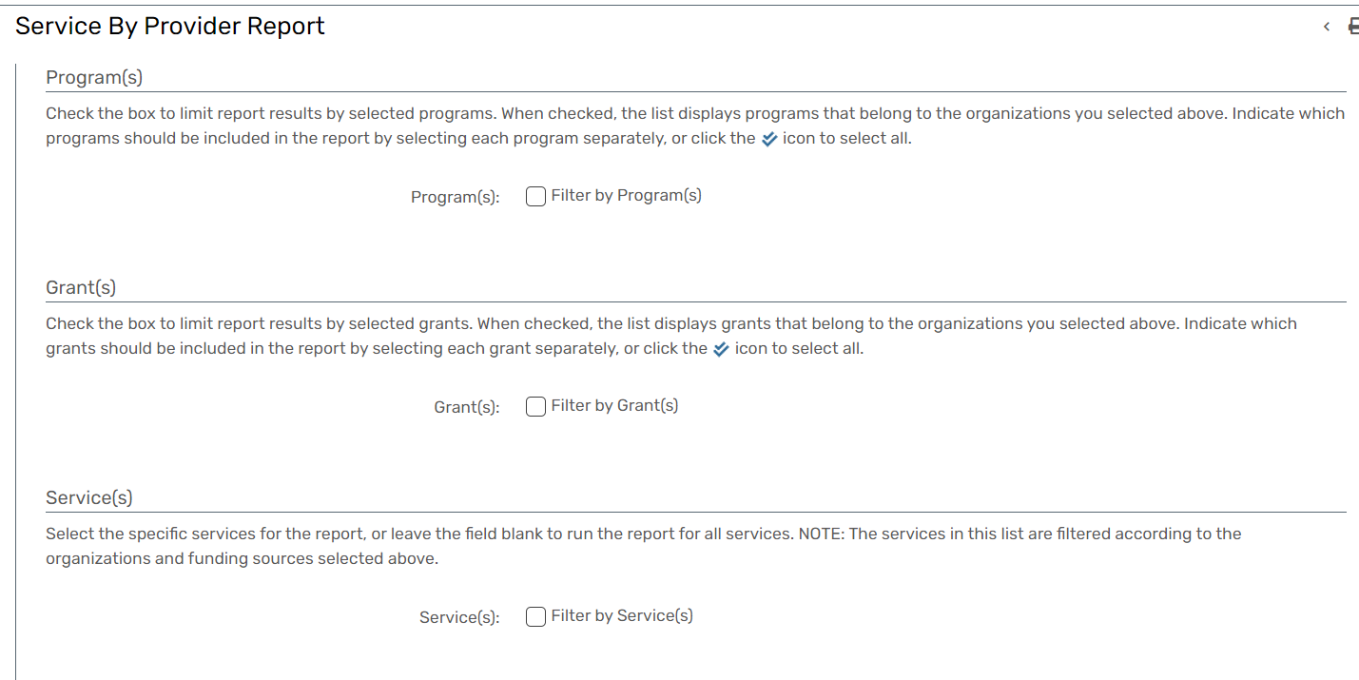
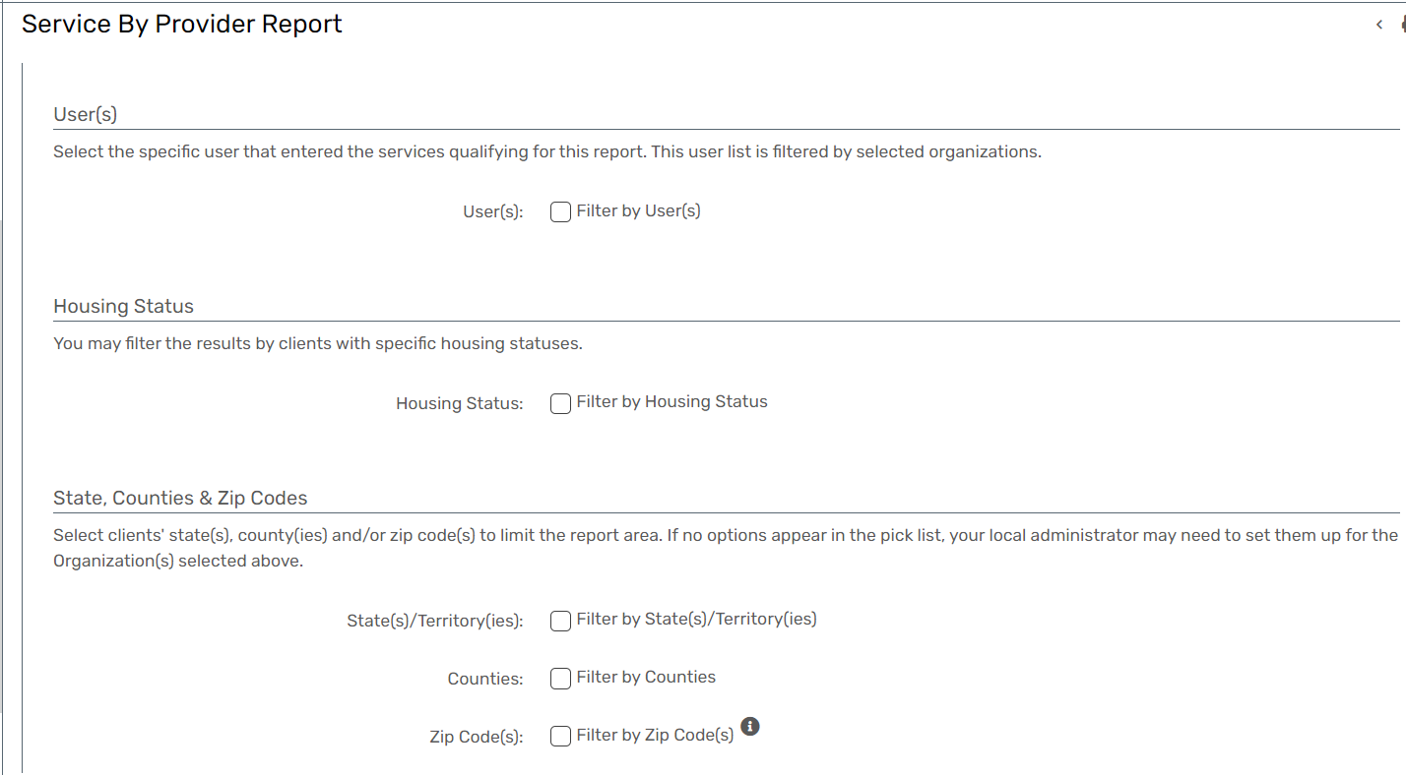
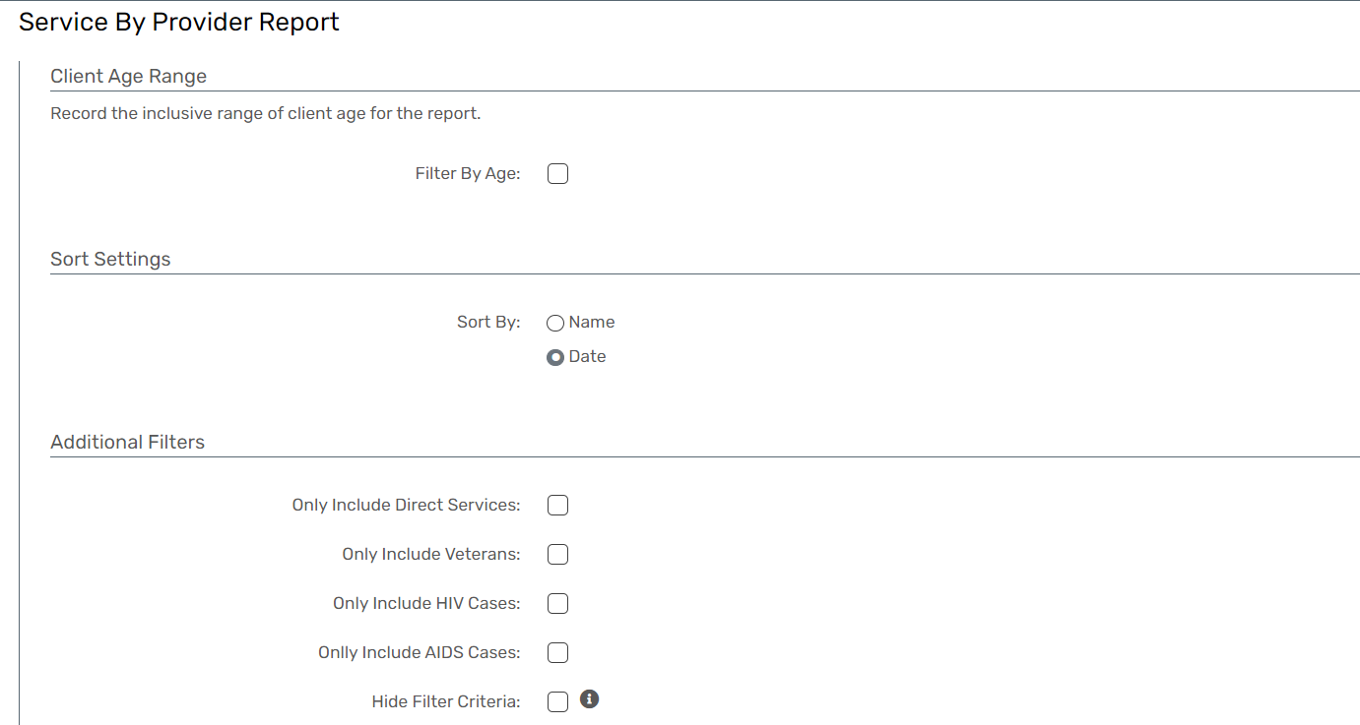

Turn Away Reason
Report Description
- The Turn Away Reason Report provides a drilled-down view that counts services, clients, units, and total amounts based on the turn-away reason of the service.
- The report allows for further detailing by additional data elements such as SSN, family size, family income, poverty percentage of the family, and name.
- Additionally, it provides detailed information about each service, including service date, grant details, unit value, and total value.
- Provides insights into the reasons for turning away clients and associated service metrics.
- Offers detailed client information, including SSN, family details, and poverty percentage.
- Provides detailed information about each service, aiding in a granular analysis.
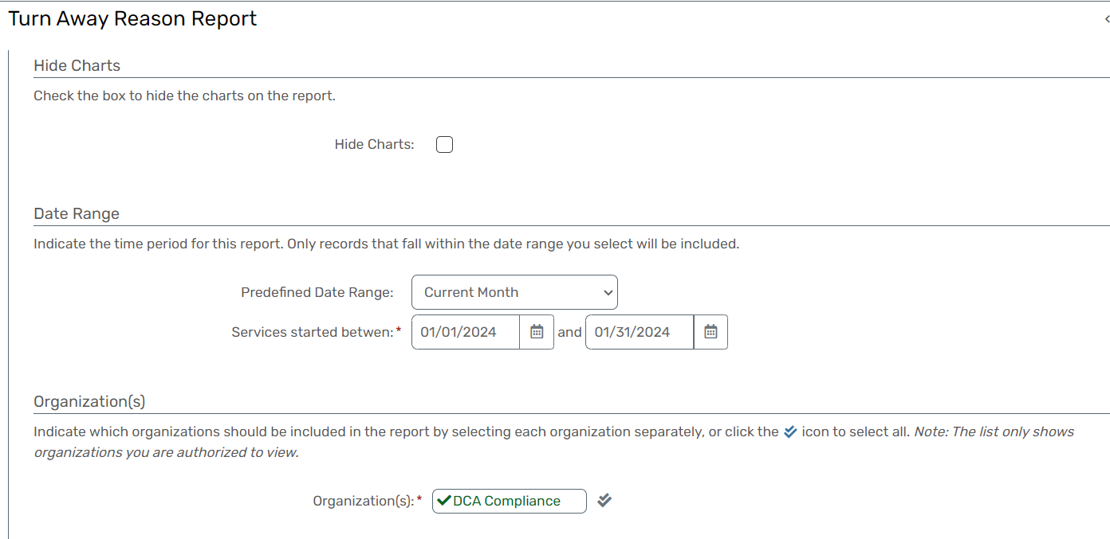
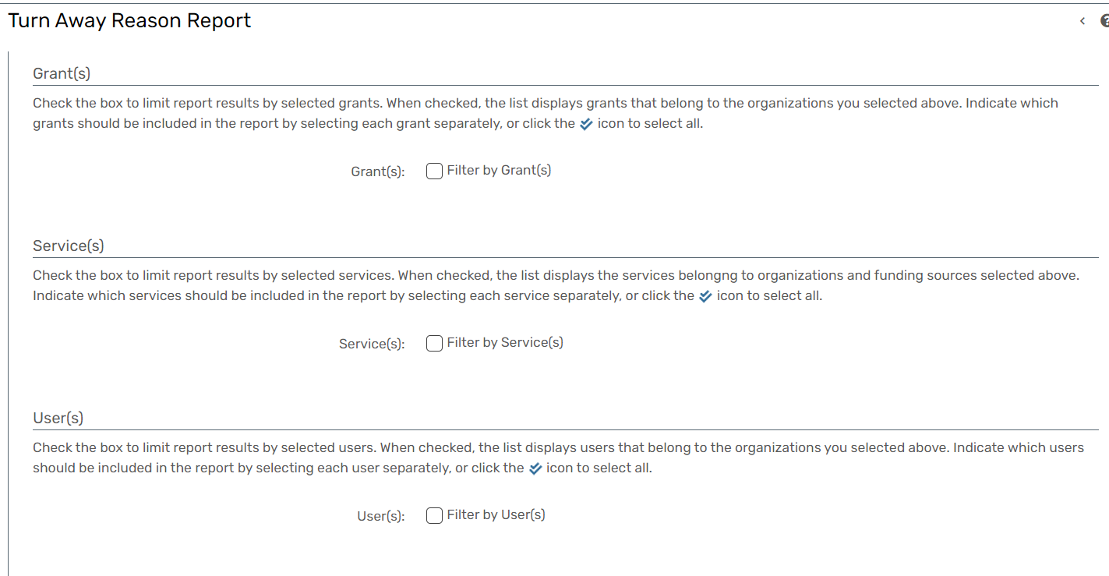
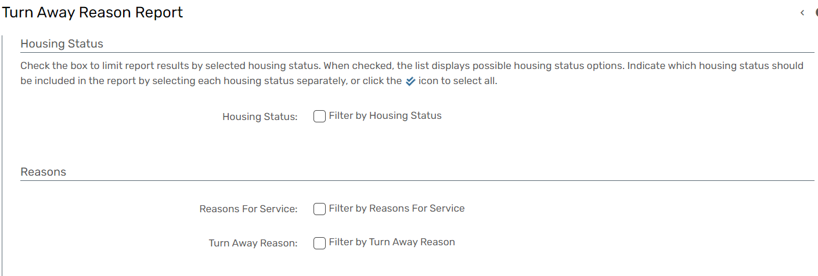
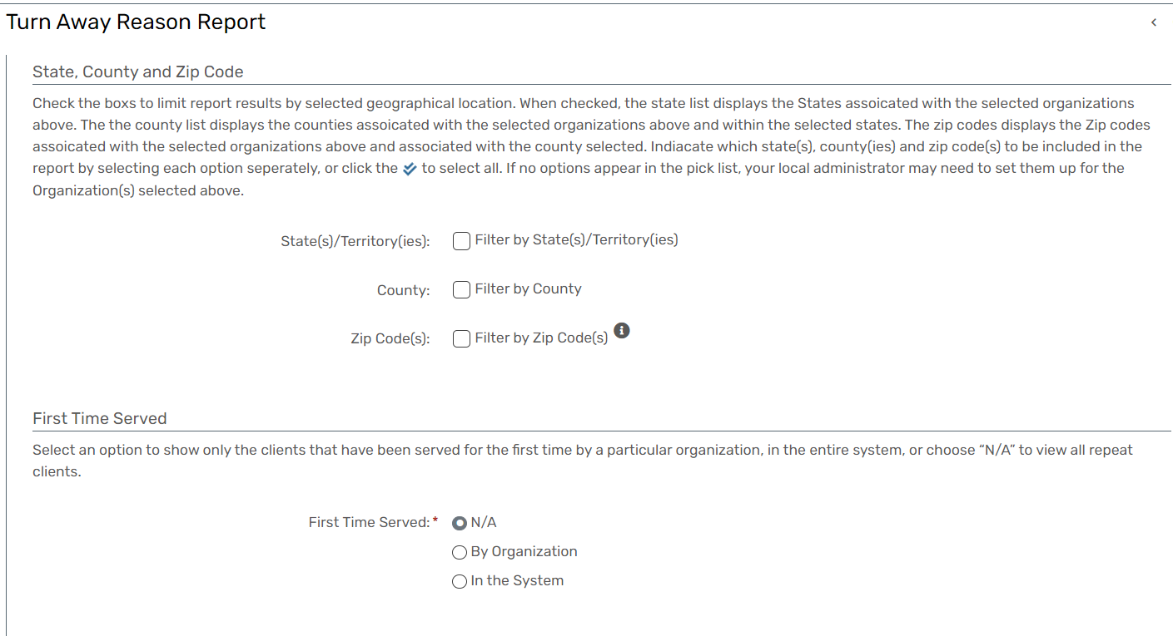
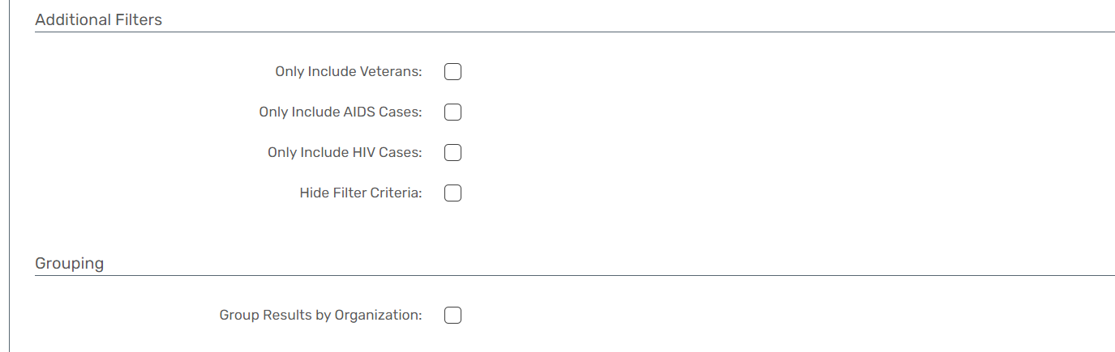

Household Composition
Report Description
- The Household Composition Report provides a count of families receiving services within a specified date range, broken down by household types, including Single Head of Household and Dual Head of Household.
- Additionally, the report offers insights into families with special needs and provides a breakdown based on the race of the head of the household.
- Provides insights into the composition of families based on household types and special needs.
- Clearly identifies families with Single Head of Household and Dual Head of Household.
- Offers a demographic breakdown based on the race of the head of the household.
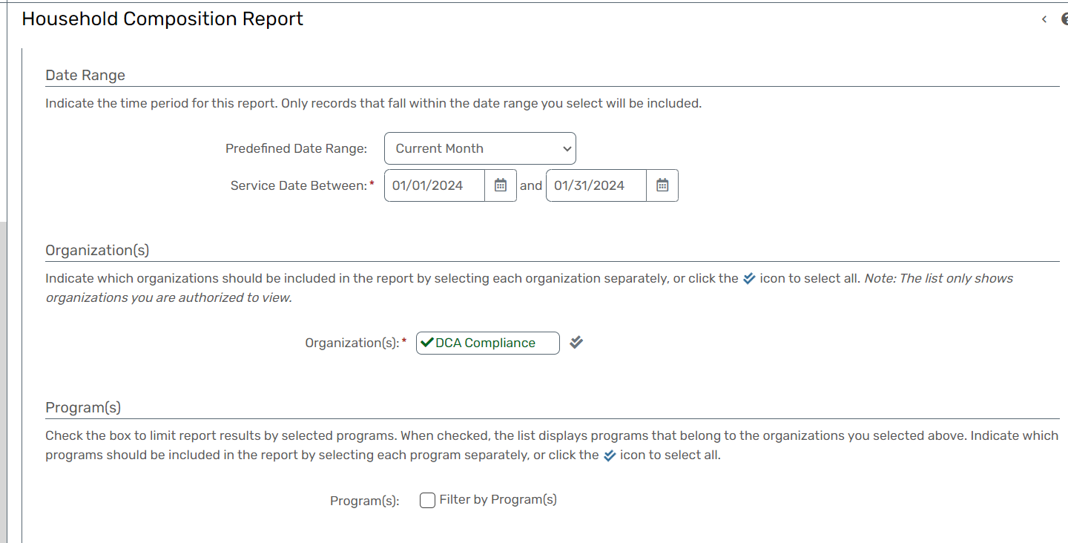
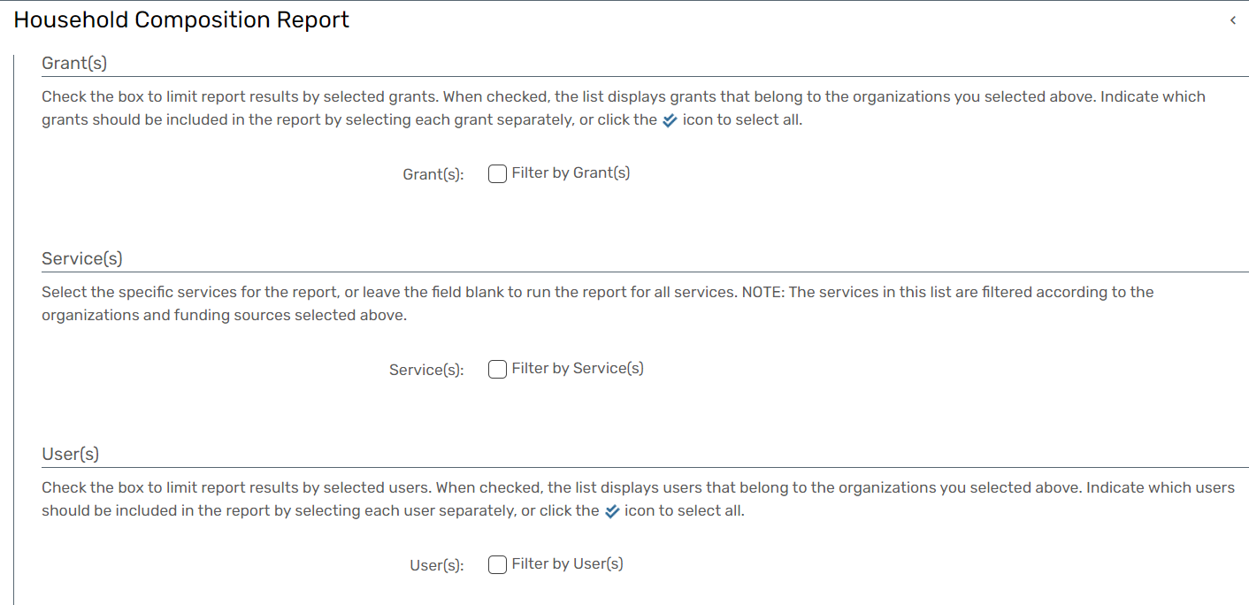
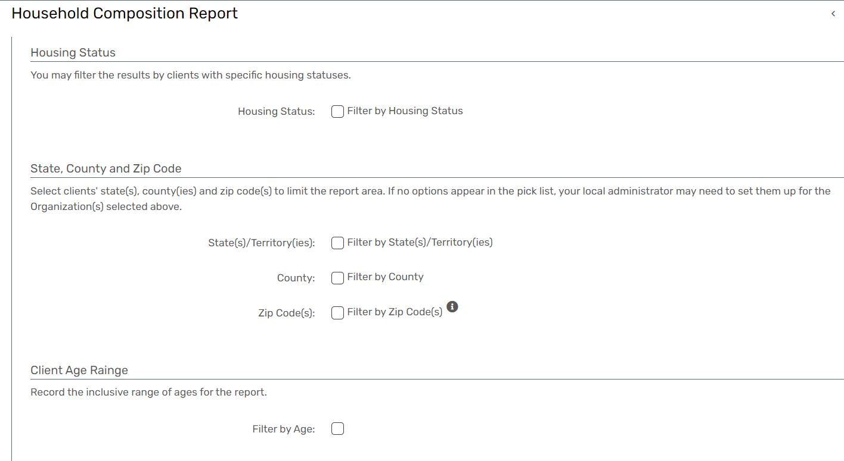
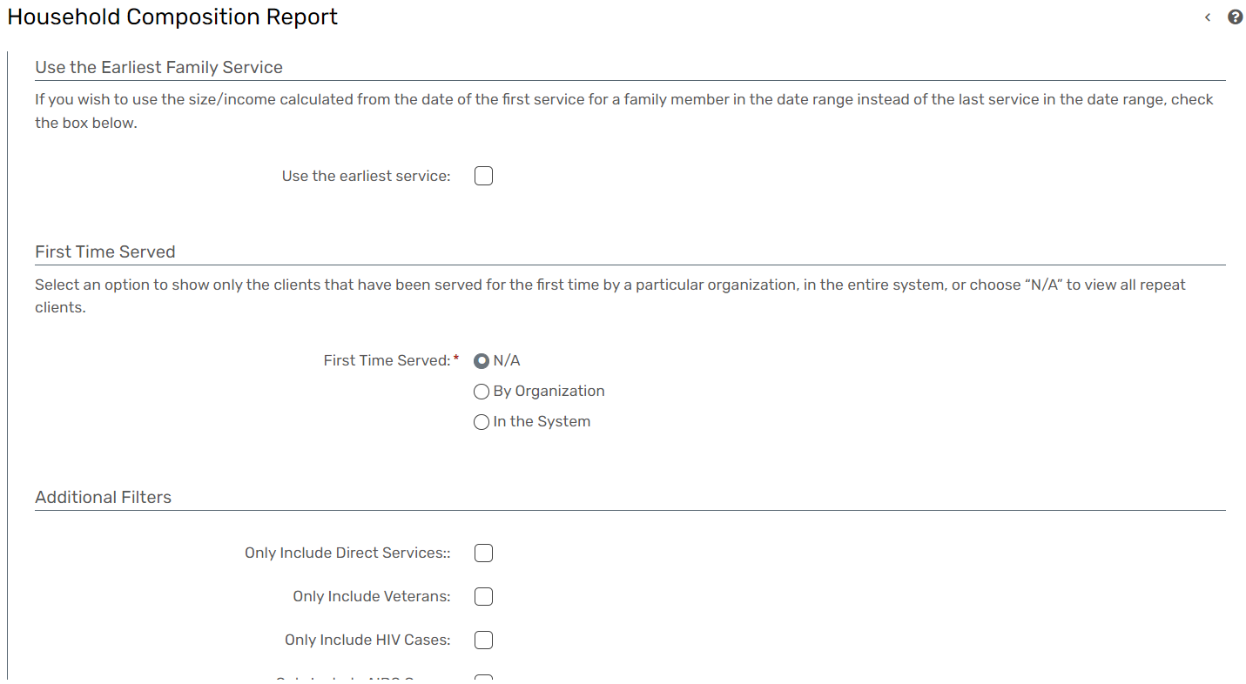

Section 2: Custom Reports
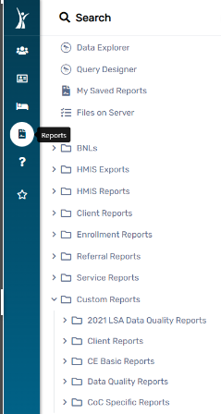
The following reports can be found by logging in, using the ‘Workgroup: GA HMIS: GA HMIS Programs’ and navigating to the ‘Reports Workspace’.

All Custom Reports

- All Custom Reports will have to be retrieved by executing a query in ClientTrack.
- Following is a diagram as to what the end-users will see when running a custom report.
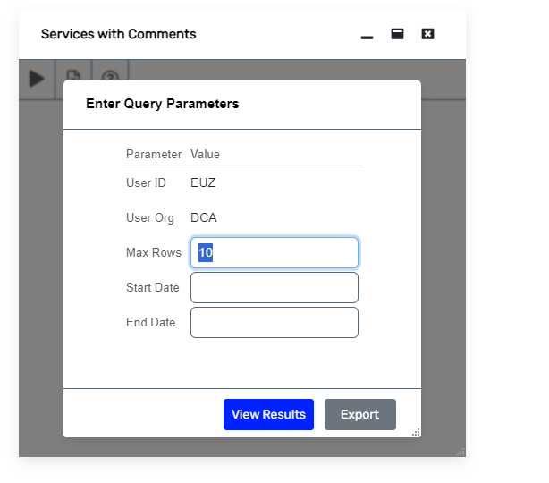

FYXX LSA Data Quality Reports

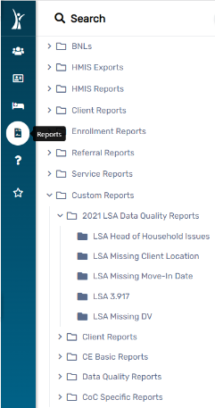

LSA Head of Household Issues
Report Description
- The LSA Head of Household Issues Report is designed to identify and report issues related to the Head of Household in the context of the Longitudinal Systems Analysis (LSA).
- This report focuses on highlighting potential discrepancies, errors, or missing information concerning the Head of Household within the HMIS Database.
- Aids in ensuring the quality and accuracy of data related to the Head of Household in LSA.
- Offers insights into specific issues, facilitating the resolution process. Contributes to maintaining the integrity of LSA data by addressing Head of Household-related issues.

LSA Missing Client Location
Report Description
- The LSA Missing Client Location Report is designed to identify and report instances where client location information is missing or incomplete within the context of the Longitudinal Systems Analysis (LSA).
- This report aids in ensuring data completeness and accuracy by highlighting areas where location details need attention.
- Aids in ensuring the completeness and accuracy of client location data within the context of LSA.
- Provides targeted information about clients with missing location details, facilitating efficient resolution.
- Contributes to maintaining the integrity of LSA data by addressing missing client location information.

LSA Missing Move-In Date
Report Description
- The LSA Missing Move-In Date Report is designed to identify and report instances where the move-in date information is missing within the context of the Longitudinal Systems Analysis (LSA).
- This report aims to ensure data completeness and accuracy by highlighting areas where move-in date details need attention.
- Aids in ensuring the completeness and accuracy of move-in date data within the context of LSA.
- Provides targeted information about clients with missing move-in date details, facilitating efficient resolution.
- Contributes to maintaining the integrity of LSA data by addressing missing move-in date information.

LSA 3.917
Report Description
- The LSA 3.917 Report is designed to provide comprehensive insights and data related to Universal Data Elements (UDE) 3.917 within the context of the Longitudinal Systems Analysis (LSA).
- This report focuses on presenting detailed information on the specified UDE to facilitate a thorough understanding of the associated client data.
- Provides an in-depth understanding of client data related to UDE 3.917 within the context of the Longitudinal Systems Analysis.
- Empowers users to make informed decisions based on the detailed data presented in the report.
- Contributes to effective data management by offering a focused view of UDE 3.917 information.

LSA Missing DV
Report Description
- The LSA Missing DV Report is designed to identify and report instances where Domestic Violence (DV) information is missing or incomplete within the context of the Longitudinal Systems Analysis (LSA).
- This report aims to ensure data completeness and accuracy by highlighting areas where DV details need attention.
- Aids in ensuring the completeness and accuracy of DV data within the context of LSA.
- Provides targeted information about clients with missing DV details, facilitating efficient resolution.
- Contributes to maintaining the integrity of LSA data by addressing missing DV information.

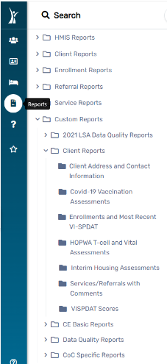
Client Reports

Client Address and Contact Information
Report Description
- The Client Address and Contact Information Report is designed to provide a comprehensive overview of client addresses and contact details within the HMIS Database.
- This report aims to facilitate efficient management of client information, ensuring accuracy, completeness, and accessibility.
- Ensures that client address and contact information are accurate and complete for effective service provision. Facilitates efficient communication with clients by providing up-to-date contact details. Contributes to overall data quality assurance within the HMIS Database.

Covid-19 Vaccination Assessments
Report Description
- The COVID-19 Vaccination Assessments Report is designed to provide a comprehensive overview of client assessments related to COVID-19 vaccination within the context of the HMIS Database.
- This report aims to facilitate monitoring and analysis of vaccination-related data to support public health initiatives and client well-being.
- Facilitates tracking and monitoring of COVID-19 vaccination trends within the client population.
- Provides valuable data to support public health initiatives related to COVID-19 vaccination.
- Empowers users to make informed decisions based on the assessment data presented in the report.

Enrollments and most Recent VI-SPDAT
Report Description
- The Enrollments and Most Recent VI-SPDAT Report is designed to provide a consolidated view of client enrollments along with the most recent Vulnerability Index - Service Prioritization Decision Assistance Tool (VI-SPDAT) assessments within the HMIS Database.
- This report aims to streamline the assessment and enrollment data, aiding in comprehensive client management.
- Provides a comprehensive overview of client enrollments along with their vulnerability status, aiding in effective client management.
- Facilitates trend analysis of VI-SPDAT assessments, helping in understanding changes in client vulnerability over time.
- Supports the assessment of program effectiveness by correlating enrollment data with vulnerability scores.

HOPWA T-cell and Vital Assessments
Report Description
- The HOPWA T-cell and Vital Assessments Report is designed to provide a comprehensive overview of T-cell and vital assessments for clients enrolled in Housing Opportunities for Persons With AIDS (HOPWA) programs within the HMIS Database.
- This report aims to support the monitoring of clients' health status and the effectiveness of interventions.
- Facilitates ongoing monitoring of clients' health through T-cell and vital assessments.
- Supports the assessment of the effectiveness of health interventions within HOPWA programs.
- Empowers users to make informed decisions based on the health assessment data presented in the report.

Interim Housing Assessments
Report Description
- The Interim Housing Assessments Report is designed to provide a detailed overview of assessments related to interim housing for clients within the HMIS Database.
- This report aims to assist in monitoring and evaluating the effectiveness of interim housing interventions and client progress.
- Facilitates the assessment of the effectiveness of interim housing programs based on assessment data.
- Provides insights into the progress of clients participating in interim housing interventions.
- Empowers users to make informed decisions regarding interim housing strategies and interventions.

Services/Referrals with Comments
Report Description
- The Services/Referrals with Comments Report is designed to provide a comprehensive overview of services and referrals that include comments or additional information within the HMIS Database.
- This report aims to enhance the understanding of client interactions, service provision, and referral processes by incorporating comments made by service providers or users.
- Provides a deeper understanding of client interactions by incorporating comments made during services and referrals.
- Facilitates the assessment of the quality of services provided and referrals made based on additional contextual information.
- Supports improved communication among service providers and users by capturing and displaying relevant comments.

VISPDAT Scores
Report Description
- The VI-SPDAT Scores Report is designed to provide a consolidated view of Vulnerability Index - Service Prioritization Decision Assistance Tool (VI-SPDAT) scores for clients within the HMIS Database.
- This report aims to assist in understanding client vulnerability levels, prioritizing service provision, and tailoring interventions based on assessment results.
- Facilitates the prioritization of services based on client vulnerability levels assessed through VI-SPDAT.
- Empowers users to make informed decisions on resource allocation and service provision based on VI-SPDAT scores.

CE Basic Reports
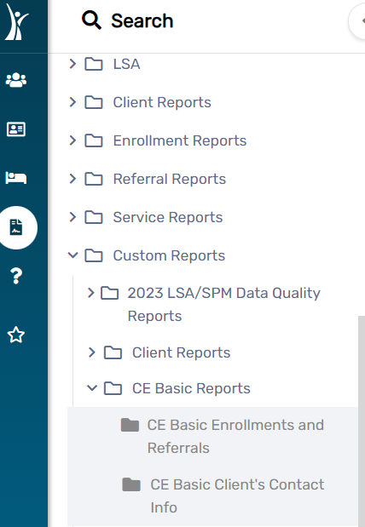

CE Basic Enrollments and Referrals
Report Description
- The Coordinated Entry (CE) Enrollments and Referrals Report is designed to provide a comprehensive overview of client enrollments and referrals within the Coordinated Entry System.
- This report aims to support the monitoring of client progress, assess the effectiveness of coordinated entry processes, and enhance overall service coordination.
- Facilitates the monitoring of service coordination efforts within the Coordinated Entry System.
- Supports the assessment of referral outcomes, helping to identify successful placements and areas for improvement.
- Empowers users to make informed decisions about resource allocation and service coordination based on the data presented in the report.

CE Basic Client’s Contact info
Report Description
- The Coordinated Entry (CE) Basic Client's Contact Info Report aims to provide essential contact information for clients within the Coordinated Entry System.
- This report serves as a foundational tool for efficient communication, outreach, and coordination among service providers involved in the CE process.
- Contributes to improved service coordination by ensuring that relevant stakeholders have access to the necessary contact details.
- Supports outreach efforts by providing accurate and up-to-date contact information for clients in the Coordinated Entry System.
- Facilitates efficient communication among service providers by providing quick access to essential client contact details.

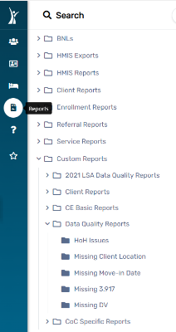
Data Quality Report

HoH Issues
Report Description
- The Head of Household (HoH) Issues Report is designed to identify and address any issues related to the head of household designation within the HMIS Database.
- This report aims to provide insights into data anomalies, discrepancies, or missing information associated with the HoH status, facilitating data quality improvement and accurate reporting.
- Facilitates the identification and correction of data anomalies related to the head of household designation, contributing to overall data quality improvement.
- Ensures accurate reporting by resolving issues associated with the head of household status in client records.
- Helps maintain compliance with reporting standards and ensures the integrity of head of household information in the HMIS Database.

Missing Client Location
Report Description
- Missing Client Location Report is a specialized report used to track and manage information about homeless individuals or clients whose current location is unknown.
- This report within an HMIS database is crucial for maintaining accurate and up-to-date information about homeless individuals, ensuring the continuity of services, and addressing the unique challenges faced by this population.
- It helps organizations coordinate efforts to locate and support clients who may be difficult to reach or have transient living situations.

Missing Move-In Date
Report Description
- "Missing Move-In Date Report" refers to a situation where the move-in date for a housing program participant is not available or has not been recorded. In the context of homeless services, accurate and detailed data is crucial for effective case management.
- This report is crucial for organizations providing homeless services to ensure accurate tracking of participant progress, report generation, and compliance with program requirements.
- It helps identify and address gaps in data, ensuring that the HMIS is a reliable tool for effective case management and reporting.

Missing 3.917
Report Description
- Universal Data Element 3.917 represents a crucial piece of information within the HMIS, essential for accurate tracking and reporting of homeless services.
- The purpose of this report is to address and resolve instances where Universal Data Element 3.917 is missing, ensuring data completeness and integrity.
- This report is crucial for maintaining data integrity within the HMIS, ensuring accurate reporting, and addressing any issues that may impact the quality of services provided to homeless individuals.

Missing DV
Report Description
- The Missing DV Report within the HMIS database is a crucial tool designed to identify and rectify instances where essential Domestic Violence data is absent.
- The purpose of this report is to ensure the comprehensive documentation of Domestic Violence incidents, supporting effective case management and intervention strategies for clients experiencing or at risk of domestic violence.

Homeless Information
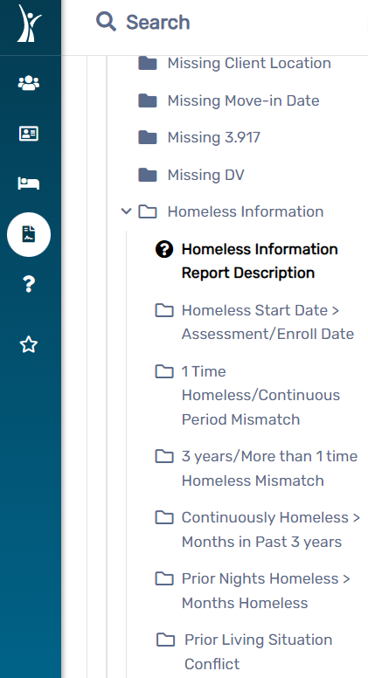

Homeless Start Date>Assessment/Enrollment Date
Report Description
- The Clients with Inconsistent Homeless Start Dates Report is designed to identify clients within the HMIS Database whose "Approximate Homeless Start Date" is recorded as greater than their Assessment Date or Enroll Date.
- This report aims to highlight inconsistencies in the data related to clients' homelessness start dates, facilitating data quality management and ensuring accuracy.
- Supports data quality management efforts by identifying and addressing inconsistencies in the recording of homeless start dates.
- Contributes to improved accuracy and reliability of client data by rectifying discrepancies related to homeless start dates.
- Ensures that data used for service planning and delivery is consistent and reliable, leading to improved client outcomes.

1 Time Homeless/ Continuous Period Mismatch
Report Description
- The Clients with Inconsistent Homelessness Duration Report is designed to identify clients within the HMIS Database who have reported an episode of homelessness in the past 3 years with an "Approximate Homeless Start Date" of less than 1 year.
- However, these clients also report being homeless for more than 1 year within the last 3 years, highlighting potential inconsistencies in reported homelessness duration.
- Supports data quality management efforts by identifying and addressing inconsistencies in reported homelessness duration.
- Contributes to improved accuracy and reliability of client data by rectifying discrepancies related to reported homelessness duration.
- Ensures that data used for service planning and delivery is consistent and reliable, leading to improved client outcomes.

3 years/More than 1-time Homeless Mismatch
Report Description
- The Clients with Inconsistent Homeless Start Date and Multiple Episodes Report aims to identify clients within the HMIS Database who have reported an "Approximate Homeless Start Date" that is 3 or more years ago but also report having experienced more than one episode of homelessness in the past 3 years.
- This report helps highlight potential discrepancies in reported homelessness start dates and episode counts.
- Supports data quality management efforts by identifying and addressing inconsistencies in reported homeless start dates and episode counts.
- Contributes to improved accuracy and reliability of client data by rectifying discrepancies related to homeless start dates and episode counts.
- Ensures that data used for service planning and delivery is consistent and reliable, leading to improved client outcomes.

Continuously Homeless Months in the Past 3 years
Report Description
- The Clients with Inconsistent Homelessness Duration Report is designed to identify clients within the HMIS Database who have reported an "Approximate Homeless Start Date" of greater than 1 year.
- However, these clients also report being homeless for less than 1 year over the last 3 years, highlighting potential discrepancies in reported homelessness duration.
- Supports data quality management efforts by identifying and addressing inconsistencies in reported homelessness duration.
- Contributes to improved accuracy and reliability of client data by rectifying discrepancies related to reported homelessness duration.
- Ensures that data used for service planning and delivery is consistent and reliable, leading to improved client outcomes.

Prior Nights Homeless> Months Homeless
Report Description
- The Clients with Inconsistent Reporting of Homeless Start Date and Prior Residence Duration Report aims to identify clients within the HMIS Database who have reported a prior residence where they were homeless for 1 year or longer.
- However, these clients report an "Approximate Homeless Start Date" of less than 1 year, highlighting potential discrepancies in reported homeless start dates and prior residence durations.
- Supports data quality management efforts by identifying and addressing inconsistencies in reported homeless start dates and prior residence durations.
- Contributes to improved accuracy and reliability of client data by rectifying discrepancies related to homeless start dates and prior residence durations.

Prior Living Situation Conflict
Report Description
- The Inconsistent Project Enrollment and Prior Housing Status Report aims to identify clients within the HMIS Database who have been enrolled in a Homeless Prevention project but reported being homeless the night before, or clients enrolled in a Permanent Housing project but reported being in permanent housing the night before.
- This report helps highlight potential discrepancies between project enrollment and reported housing status.
- Supports data quality management efforts by identifying and addressing inconsistencies between project enrollment and reported housing status.
- Contributes to improved accuracy and reliability of client data by rectifying discrepancies related to project enrollment and prior housing status.
- Ensures that project enrollment data aligns with reported housing status, providing more accurate insights for program planning and evaluation.

CoC Specific Reports:

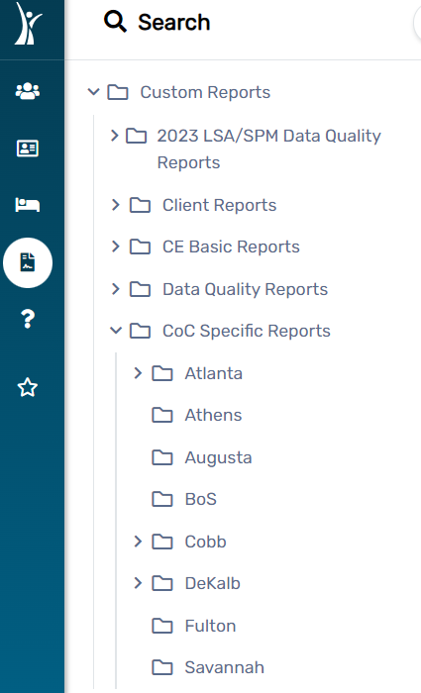

- This section provides an overview of reports that are specific to your Continuum of Care (COC) within the HMIS Database.
- These reports are tailored to meet the unique needs and requirements of the COC, offering insights into client demographics, program effectiveness, and compliance with COC-specific standards.
- The COC-Specific Reports section serves as a valuable resource for COC stakeholders, offering targeted reports to support data-driven decision-making and improve overall operations within the HMIS Database.

Section 3: CoC Admin Queries

- Accessing reports within the HMIS Database involves using the designated workgroup and navigating to the Reports Workspace.
- The 'Workgroup: GA HMIS: GA HMIS Programs' provides specific access to reports tailored to Georgia's HMIS programs.
- This section outlines the steps to access reports within this
- workgroup.
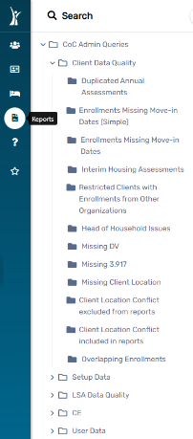
Client Data Quality

All COC Admin Queries

- All Custom Reports will have to be retrieved by executing a query in ClientTrack.
- Following is a diagram as to what the end-users will see when running a custom report.
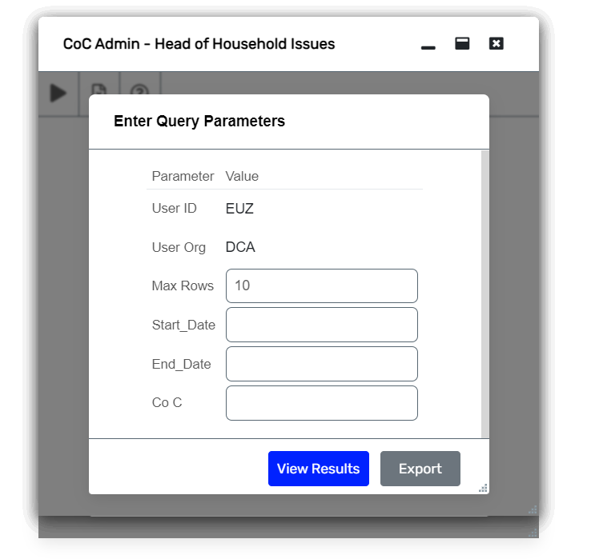

Duplicated Annual Assessments
Report Description
- The Duplicated Annual Assessments Data Quality Report is designed to identify and address instances of duplicated annual assessments within the HMIS Database.
- This report aims to ensure data accuracy, integrity, and compliance with data quality standards by highlighting any potential duplicates in annual assessment records for clients.
- Facilitates the assurance of data quality by identifying and addressing potential duplications in annual assessment records. Contributes to enhanced accuracy and integrity of client data within the HMIS Database.
- Supports compliance with data quality standards and guidelines, ensuring the reliability of annual assessment information.

Enrollments Missing Move-in Dates (Simple)
Report Description
- The Enrollments Missing Move-in Dates (Simple) Data Quality Report is designed to identify instances within the HMIS Database where move-in dates are missing for client enrollments.
- This report aims to ensure data completeness and integrity by highlighting enrollments that lack essential move-in date information.
- Facilitates the assurance of data completeness by identifying and addressing enrollments missing essential move-in date information.
- Contributes to enhanced integrity and reliability of client enrollment data within the HMIS Database.
- Supports compliance with data quality standards and guidelines, ensuring the availability of crucial move-in date details.

Enrollments Missing Move-in Dates
Report Description
- The Enrollments Missing Move-in Dates Data Quality Report is designed to identify instances within the HMIS Database where move-in dates are missing for client enrollments.
- This report aims to ensure data completeness and integrity by highlighting enrollments that lack essential move-in date information.
- Facilitates the assurance of data completeness by identifying and addressing enrollments missing essential move-in date information.
- Contributes to enhanced integrity and reliability of client enrollment data within the HMIS Database.
- Supports compliance with data quality standards and guidelines, ensuring the availability of crucial move-in date details.

Interim Housing Assessments
Report Description
- The Interim Housing Assessments Data Quality Report is designed to assess and ensure the completeness and accuracy of interim housing assessments within the HMIS Database.
- This report aims to identify any instances where assessments for interim housing may be missing or incomplete, enabling users to address data quality issues.
- Facilitates the assurance of data completeness by identifying and addressing missing or incomplete interim housing assessments.
- Contributes to enhanced integrity and reliability of client assessment data within the HMIS Database.
- Ensures that assessments related to interim housing are complete, providing accurate information for service planning and delivery.

Restricted Clients with Enrollments from Other Organizations
Report Description
- The Restricted Clients with Enrollments from Other Organizations Report is designed to identify clients within the HMIS Database who are marked as restricted but have enrollments recorded from other organizations.
- This report aims to highlight instances where clients with restricted access have enrollments originating from organizations outside the restricted access scope.
- Helps ensure compliance with data security policies by identifying and addressing instances where restricted clients have enrollments from unauthorized organizations.
- Contributes to maintaining the integrity of restricted client data by rectifying inconsistencies related to enrollments from other organizations.
- Supports access control measures by identifying potential breaches in restricted client access and allowing for corrective actions.

Head of Household Issues
Report Description
- The Head of Household (HoH) Issues Report is designed to identify and address any issues related to the head of household designation within the HMIS Database.
- This report aims to provide insights into data anomalies, discrepancies, or missing information associated with the HoH status, facilitating data quality improvement and accurate reporting.
- Facilitates the identification and correction of data anomalies related to the head of household designation, contributing to overall data quality improvement.
- Ensures accurate reporting by resolving issues associated with the head of household status in client records.
- Helps maintain compliance with reporting standards and ensures the integrity of head of household information in the HMIS Database.

Missing DV
Report Description
- The Missing DV Report within the HMIS database is a crucial tool designed to identify and rectify instances where essential Domestic Violence data is absent.
- The purpose of this report is to ensure the comprehensive documentation of Domestic Violence incidents, supporting effective case management and intervention strategies for clients experiencing or at risk of domestic violence.

Missing 3.917
Report Description
- Universal Data Element 3.917 represents a crucial piece of information within the HMIS, essential for accurate tracking and reporting of homeless services.
- The purpose of this report is to address and resolve instances where Universal Data Element 3.917 is missing, ensuring data completeness and integrity.
- This report is crucial for maintaining data integrity within the HMIS, ensuring accurate reporting, and addressing any issues that may impact the quality of services provided to homeless individuals.

Missing Client Location
Report Description
- Missing Client Location Report is a specialized report used to track and manage information about homeless individuals or clients whose current location is unknown.
- This report within an HMIS database is crucial for maintaining accurate and up-to-date information about homeless individuals, ensuring the continuity of services, and addressing the unique challenges faced by this population.
- It helps organizations coordinate efforts to locate and support clients who may be difficult to reach or have transient living situations.

Missing Location Conflict Excluded from Reports
Report Description
- The Missing Location Conflict Excluded from Reports Report aims to identify clients within the HMIS Database whose data may have conflicts related to missing location information.
- Clients with missing or conflicting location data may be excluded from certain reports, impacting the accuracy of data analysis and reporting.
- This report assists in identifying and addressing such data quality issues.
- Contributes to improved data accuracy by identifying and addressing missing or conflicting location data that may impact report inclusion.
- Ensures the integrity of reporting by resolving issues related to location data, allowing for accurate analysis and decision-making.
- Facilitates timely correction of missing or conflicting location data, preventing potential discrepancies in reports and analyses.

Client Location Conflict Included in Reports
Report Description
- “The Client Location Conflict Included in Reports” Report is designed to identify clients within the HMIS Database whose data may have conflicts related to location information.
- This report focuses on clients with conflicting location data that may impact the accuracy of reports and analyses.
- The goal is to highlight and address data quality issues associated with conflicting location information.
- Contributes to improved data accuracy by identifying and addressing conflicting location data that may impact the reliability of reports.
- Ensures the integrity of reporting by resolving issues related to conflicting location information, allowing for accurate analyses and decision-making.
- Facilitates timely correction of conflicting location data, preventing potential discrepancies in reports and analyses.

Overlapping Enrollments
Report Description
- The Overlapping Enrollments Data Quality Report aims to identify instances within the HMIS Database where clients may have overlapping enrollments.
- Overlapping enrollments can lead to data inaccuracies and may impact the reliability of reports.
- This report assists in identifying and addressing data quality issues associated with overlapping client enrollments.
- Contributes to improved data accuracy by identifying and addressing instances of overlapping enrollments that may impact the reliability of reports.
- Ensures the integrity of reporting by resolving issues related to overlapping enrollment periods, allowing for accurate analyses and decision-making.
- Facilitates timely correction of overlapping enrollment data, preventing potential discrepancies in reports and analyses.

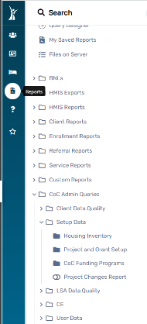
Setup Data

Housing Inventory
Report Description
- The Data Housing Inventory Report involves configuring and establishing parameters for generating a comprehensive report on housing inventory within the HMIS Database.
- This report provides essential insights into the availability, utilization, and characteristics of housing resources, contributing to effective decision-making and resource allocation.
- Empowers stakeholders with data-driven insights into housing inventory, facilitating informed decision-making.
- Supports optimization of resource allocation by identifying trends in housing unit availability and utilization.
- Facilitates the assessment of program effectiveness by examining occupancy rates and demographic characteristics of individuals served.
- Aids in geographical planning by providing information on the distribution of housing units across different locations.

Project and Grant Setup
Report Description
- The Project and Grant Setup Data Report Setup involves configuring and establishing parameters for generating a detailed report on project and grant setup within the HMIS Database.
- This report provides essential information about the configuration and characteristics of projects and grants, supporting effective management, oversight, and decision-making.
- Provides a comprehensive overview of project and grant configurations, aiding in effective management and oversight.
- Enhances financial transparency by detailing funding sources associated with grants and projects.
- Offers insights into program-specific details, allowing for a deeper understanding of program configurations.

CoC Funding Programs
Report Description
- The CoC Funding Programs Data Report Setup involves configuring and establishing parameters for generating a detailed report on Continuum of Care (CoC) funding programs within the HMIS Database.
- This report provides essential information about the funding programs associated with the CoC, supporting transparency, financial oversight, and programmatic evaluation.
- Provides a transparent overview of CoC funding programs, including detailed information on grants, program types, and funding allocation.
- Enhances financial oversight by detailing funding sources and allocations associated with CoC programs.
- Offers insights into program-specific details, allowing for a deeper understanding of CoC funding programs.

Project Changes Report
Report Description
- The Project Changes Data Report Setup involves configuring and establishing parameters for generating a detailed report on changes made to projects within the HMIS Database.
- This report provides essential information about modifications, updates, and revisions to projects, supporting historical tracking, transparency, and auditability.
- Enables historical tracking of changes made to projects, supporting documentation and audit trails.
- Enhances transparency by providing insights into who made specific changes and the reasons behind each modification.
- Provides valuable information for decision-making by offering a clear understanding of project adjustments over time.

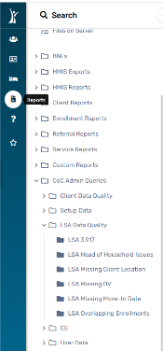
LSA Data Quality

LSA 3.917
Report Description
- The LSA 3.917 Report is designed to provide comprehensive insights and data related to Universal Data Elements (UDE) 3.917 within the context of the Longitudinal Systems Analysis (LSA).
- This report focuses on presenting detailed information on the specified UDE to facilitate a thorough understanding of the associated client data.
- Provides an in-depth understanding of client data related to UDE 3.917 within the context of the Longitudinal Systems Analysis.
- Empowers users to make informed decisions based on the detailed data presented in the report.
- Contributes to effective data management by offering a focused view of UDE 3.917 information.

LSA Head of Household Issues
Report Description
- The LSA Head of Household Issues Report is designed to identify and report issues related to the Head of Household in the context of the Longitudinal Systems Analysis (LSA).
- This report focuses on highlighting potential discrepancies, errors, or missing information concerning the Head of Household within the HMIS Database.
- Aids in ensuring the quality and accuracy of data related to the Head of Household in LSA.
- Offers insights into specific issues, facilitating the resolution process.
- Contributes to maintaining the integrity of LSA data by addressing Head of Household-related issues.

LSA Missing Client Location
Report Description
- The LSA Missing Client Location Report is designed to identify and report instances where client location information is missing or incomplete within the context of the Longitudinal Systems Analysis (LSA).
- This report aids in ensuring data completeness and accuracy by highlighting areas where location details need attention.
- Aids in ensuring the completeness and accuracy of client location data within the context of LSA.
- Provides targeted information about clients with missing location details, facilitating efficient resolution.
- Contributes to maintaining the integrity of LSA data by addressing missing client location information.

LSA Missing DV
Report Description
- The LSA Missing DV Report is designed to identify and report instances where Domestic Violence (DV) information is missing or incomplete within the context of the Longitudinal Systems Analysis (LSA).
- This report aims to ensure data completeness and accuracy by highlighting areas where DV details need attention.
- Aids in ensuring the completeness and accuracy of DV data within the context of LSA.
- Provides targeted information about clients with missing DV details, facilitating efficient resolution.
- Contributes to maintaining the integrity of LSA data by addressing missing DV information.

LSA Missing Move-In Date
Report Description
- The LSA Missing Move-In Date Report is designed to identify and report instances where the move-in date information is missing within the context of the Longitudinal Systems Analysis (LSA).
- This report aims to ensure data completeness and accuracy by highlighting areas where move-in date details need attention.
- Aids in ensuring the completeness and accuracy of move-in date data within the context of LSA.
- Provides targeted information about clients with missing move-in date details, facilitating efficient resolution.
- Contributes to maintaining the integrity of LSA data by addressing missing move-in date information.

LSA Overlapping Enrollments
Report Description
- The LSA Overlapping Enrollments Data Quality Report aims to identify instances where information is missing within the context of the Longitudinal Systems Analysis (LSA) may have overlapping enrollments.
- Overlapping enrollments can lead to data inaccuracies and may impact the reliability of reports.
- This report assists in identifying and addressing data quality issues associated with overlapping client enrollments.
- Contributes to improved data accuracy by identifying and addressing instances of overlapping enrollments that may impact the reliability of reports.
- Ensures the integrity of reporting by resolving issues related to overlapping enrollment periods, allowing for accurate analyses and decision-making.
- Facilitates timely correction of overlapping enrollment data, preventing potential discrepancies in reports and analyses.

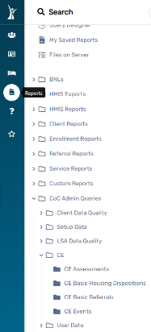
CE

CE Assessments
Report Description
- The Coordinated Entry (CE) Assessments Data Report aims to provide comprehensive insights into assessments conducted within the CE system of the HMIS Database.
- This report offers valuable information about clients' assessments, their prioritization status, and key demographic details, supporting the efficient and equitable allocation of resources.
- Supports equitable resource allocation by providing insights into clients' prioritization status and needs.
- Aids in program planning by offering a detailed understanding of client demographics and assessment outcomes.
- Facilitates enhanced client engagement by tracking access events and referral events associated with CE assessments.
- Empowers stakeholders to make data-driven decisions related to housing placement, services, and support for clients in the CE system.

CE Basic Housing Dispositions
Report Description
- The Coordinated Entry (CE) Basic Housing Dispositions Report is designed to offer essential insights into the housing dispositions of clients within the CE system of the HMIS Database.
- This report provides valuable information on the outcomes of housing interventions, aiding in program evaluation, resource allocation, and overall improvement of housing services.
- Supports program evaluation by providing detailed information on the success rates of different housing interventions.
- Aids in resource allocation by offering insights into the effectiveness of various housing strategies and programs.
- Facilitates demographic analysis, helping stakeholders understand the housing outcomes for different client populations.
- Provides outcome metrics that contribute to the overall improvement of housing services and interventions.

CE Basic Referrals
Report Description
- The Coordinated Entry (CE) Basic Referrals Report is designed to provide comprehensive insights into the referral activities within the CE system of the HMIS Database.
- This report offers valuable information on the referrals made for clients, their outcomes, and key demographic details, facilitating a better understanding of service utilization and referral effectiveness.
- Supports the evaluation of referral effectiveness by providing insights into the outcomes of referrals and service access patterns.
- Facilitates demographic analysis, helping stakeholders understand the referral activities for different client populations.
- Provides metrics that contribute to the overall understanding of service utilization patterns and client engagement.
- Aids in program improvement by offering data-driven insights into the success rates and challenges of referral processes.

CE Events
Report Description
- The Coordinated Entry (CE) Events Report is designed to provide a detailed overview of events and activities within the CE system of the HMIS Database.
- This report offers valuable information on key events related to client interactions, assessments, and service provision, aiding in program evaluation, coordination, and overall improvement of services.
- Supports program evaluation by providing detailed information on client interactions, assessments, and service provision events.
- Facilitates coordination among service providers by offering a consolidated view of events related to client care and support.
- Provides outcome metrics that contribute to the overall improvement of services and client engagement within the CE system.
- Aids in data-driven decision-making by offering insights into the types of events that contribute to positive client outcomes.

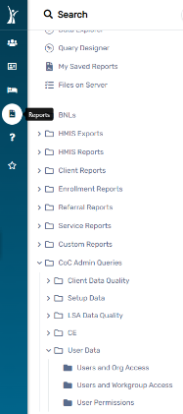
User Data

Users and Org Access
Report Description
- The Users and Organization Access Report serves as a comprehensive tool to monitor and analyze user access and organization permissions within the HMIS Database.
- This report provides insights into the user roles, their associated organizations, and the level of access granted, contributing to effective user management and security oversight.
- Supports effective user management by providing a consolidated view of user details, roles, and organization access.
- Facilitates security oversight by offering insights into user activity, access levels, and changes in user roles.
- Helps monitor and manage organizational affiliations of users, ensuring proper alignment with roles and responsibilities.
- Aids in compliance monitoring by providing a comprehensive overview of user access and activity within the HMIS Database.

Users and Workgroup Access
Report Description
- The Users and Workgroup Access Report serves as a comprehensive tool to monitor and analyze user access and permissions within specific workgroups in the HMIS Database.
- This report provides insights into the workgroups to which each user belongs, their associated roles, and the level of access granted, contributing to effective user management and collaboration.
- Facilitates collaborative oversight by offering insights into user collaboration within specific workgroups.
- Supports effective user management by providing a consolidated view of user details, roles, and workgroup access.
- Helps monitor and assess user contributions to collaborative activities within workgroups.
- Aids in clarifying role assignments within workgroups, ensuring users have appropriate permissions for collaborative tasks.

User Permissions
Report Description
- The User Permissions Report serves as a detailed guide to understanding and managing user permissions within the HMIS Database.
- This report provides comprehensive information about the specific permissions granted to each user, ensuring transparency and effective user management.
- Enhances transparency in user management by detailing the specific permissions granted to each user.
- Facilitates effective oversight by providing a clear view of user access rights, data entry capabilities, and reporting permissions.
- Aids in customizing user access based on specific roles and responsibilities within the HMIS system.
- Helps identify users with administrative privileges, ensuring accountability for system configurations and user account management.

UDA
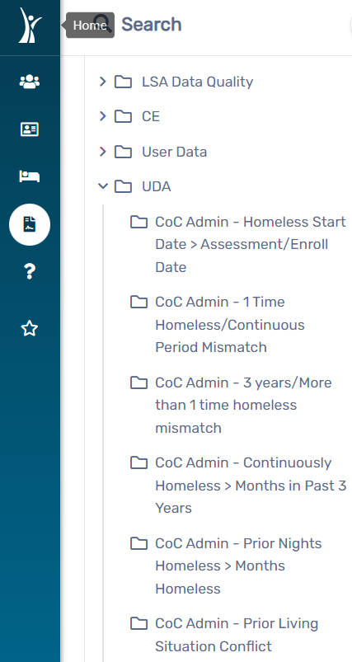

COC Admin-Homeless Start Date> Assessment/Enroll Date
Report Description
- The “COC Admin-Homeless Start Date Greater Than Enroll Date “Report is designed to identify clients with inconsistencies between their reported "Approximate Homeless Start Date" and the actual enrollment or enroll date in the HMIS Database.
- This report helps ensure data accuracy and flag instances where clients may have provided conflicting information regarding their homelessness history.
- Supports agencies in maintaining accurate and reliable data by identifying and addressing discrepancies.
- Assists in the ongoing effort to ensure data quality and integrity within the HMIS system.
- Enables agencies to efficiently correct data inconsistencies and maintain a high standard of data quality.
- Contributes to the overall integrity of client records in the HMIS Database.

COC Admin-1 time Homeless/Continuous Period Mismatch
Report Description
- The "COC Admin 1-Time Homeless/Continuous Period Mismatch Report" is designed to identify clients with discrepancies between their reported homelessness status, specifically distinguishing between those who claim to be homeless for a single episode and those indicating a continuous period of homelessness.
- This report helps ensure consistency in client-reported data and supports data quality management.
- Promotes consistency in the reporting of client homelessness status. Supports agencies in maintaining high-quality and accurate data within the HMIS system.
- Contributes to the overall integrity of client records by ensuring alignment in reported homelessness details.
- Enables agencies to efficiently address discrepancies and maintain accurate client information.

COC Admin-3 Years/More Than 1 Time Homeless Mismatch
Report Description
- The "COC Admin - 3 Years/More Than 1 Time Homeless Mismatch Report" is designed to identify clients with inconsistencies in their reported homelessness status, specifically targeting cases where clients claim to have been homeless for more than one episode within the last 3 years while the COC administration indicates a different status.
- This report is crucial for maintaining accurate and reliable data in the HMIS system. Helps agencies ensure that client-reported homelessness status aligns with COC administration records.
- Helps agencies ensure that client-reported homelessness status aligns with COC administration records.
- Supports agencies in maintaining high-quality and accurate data within the HMIS system.
- Contributes to the overall integrity of client records by ensuring alignment in reported homelessness details.
- Enables agencies to efficiently address discrepancies and maintain accurate client information.

COC Admin-Prior Nights Homeless >Months Homeless
Report Description
- The "COC Admin - Prior Nights Homeless Greater Than Months Homeless Report" aims to identify instances where there is a discrepancy in the data reported by clients regarding the duration of homelessness. Specifically, the report focuses on cases where the number of nights reported as homeless exceeds the number of months reported as homeless according to COC administration records.
- This report assists in maintaining data accuracy and consistency within the HMIS system.
- Helps agencies ensure that client-reported durations of homelessness align with COC administration records.
- Supports agencies in maintaining high-quality and accurate data within the HMIS system.
- Contributes to the overall integrity of client records by ensuring consistency in reported durations of homelessness.
- Enables agencies to efficiently address discrepancies and maintain accurate client information.

COC Admin-Prior Living Situation Conflict
Report Description
- The "COC Admin - Prior Living Situation Conflict Report" is designed to identify instances where there is a conflict or discrepancy in the data related to a client's prior living situation.
- The report focuses on cases where the information provided by clients conflicts with the records maintained by the COC administration.
- This report assists agencies in maintaining accurate and consistent data within the HMIS system.
- Helps agencies ensure that client-reported prior living situations align with COC administration records.
- Supports agencies in maintaining high-quality and accurate data within the HMIS system.
- Contributes to the overall integrity of client records by ensuring consistency in reported prior living situations.
- Enables agencies to efficiently address conflicts and maintain accurate client information.

Section 4: Agency Monitoring Reports

- This guide provides instructions on accessing specific reports within the GA HMIS Programs workgroup in the HMIS Database.
- By following these steps, users can navigate to the Reports Workspace and explore the available reports tailored for GA HMIS Programs.
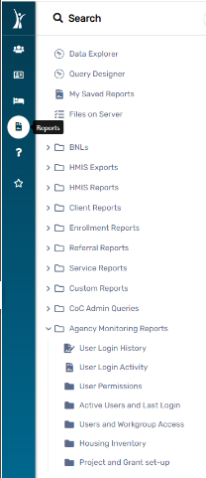
.

User Login History
Report Description
- The "Agency Monitoring User Login History" report serves as a comprehensive tool for tracking and analyzing the login activities of users within an agency.
- This report provides valuable insights into user interactions with the system, ensuring transparency, security, and accountability.
- Timestamps are provided for each login event, indicating the date and time when a user accessed the system.
- This feature aids in tracking login patterns and identifying any irregularities.
- Information related to user authentication is included, helping agencies ensure that only authorized personnel are accessing the system.
- This is crucial for maintaining data security and system integrity. Agencies can gain insights into how frequently users are logging into the system.
- Unusual login patterns or unexpected spikes in activity can be flagged for further investigation.
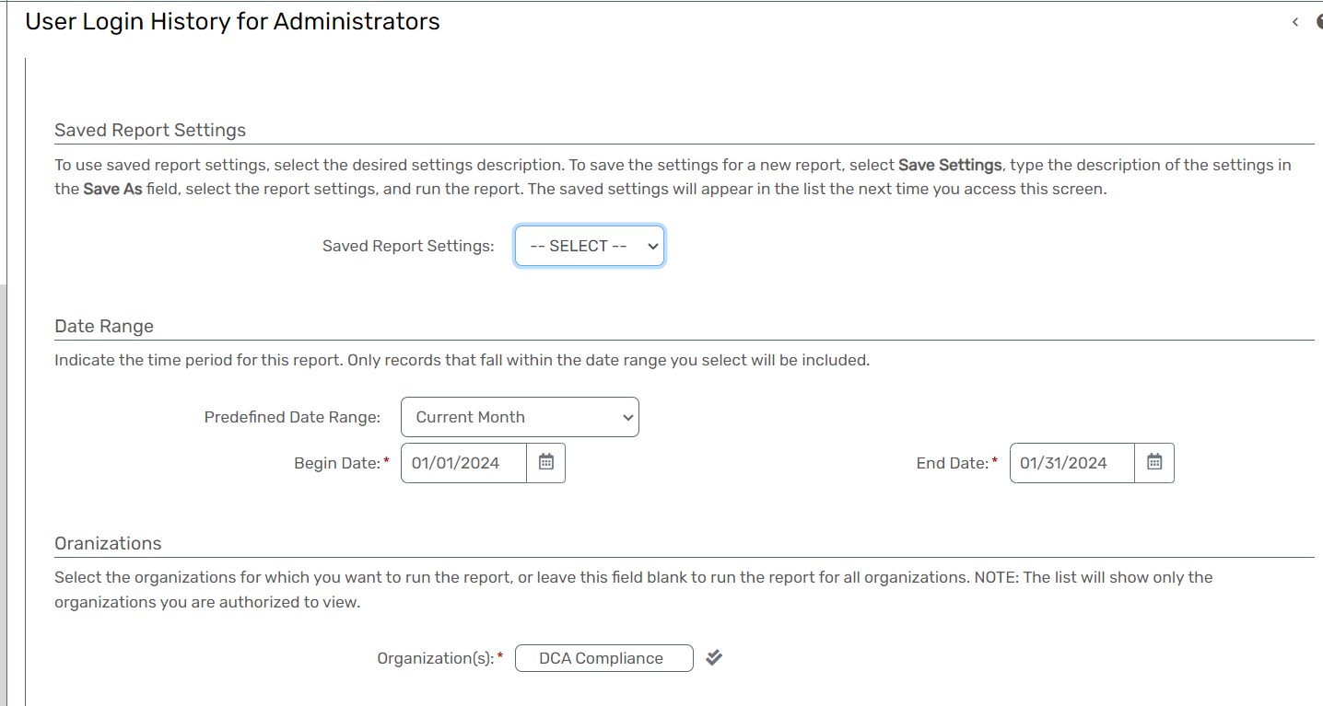

User Login Activity
Report Description
- The "User Login Activity" report provides a summarized overview of login activities within a specified date range for selected organizations and users.
- This report serves as a valuable tool for monitoring and analyzing login patterns, ensuring security, and understanding user engagement with the system.
- The report includes detailed information on individual user logins, allowing agencies to monitor the activities of each user associated with their account.
- Information related to user authentication is included, helping agencies ensure that only authorized personnel are accessing the system.
- This is crucial for maintaining data security and system integrity. Agencies can gain insights into how frequently users are logging into the system. Unusual login patterns or unexpected spikes in activity can be flagged for further investigation.
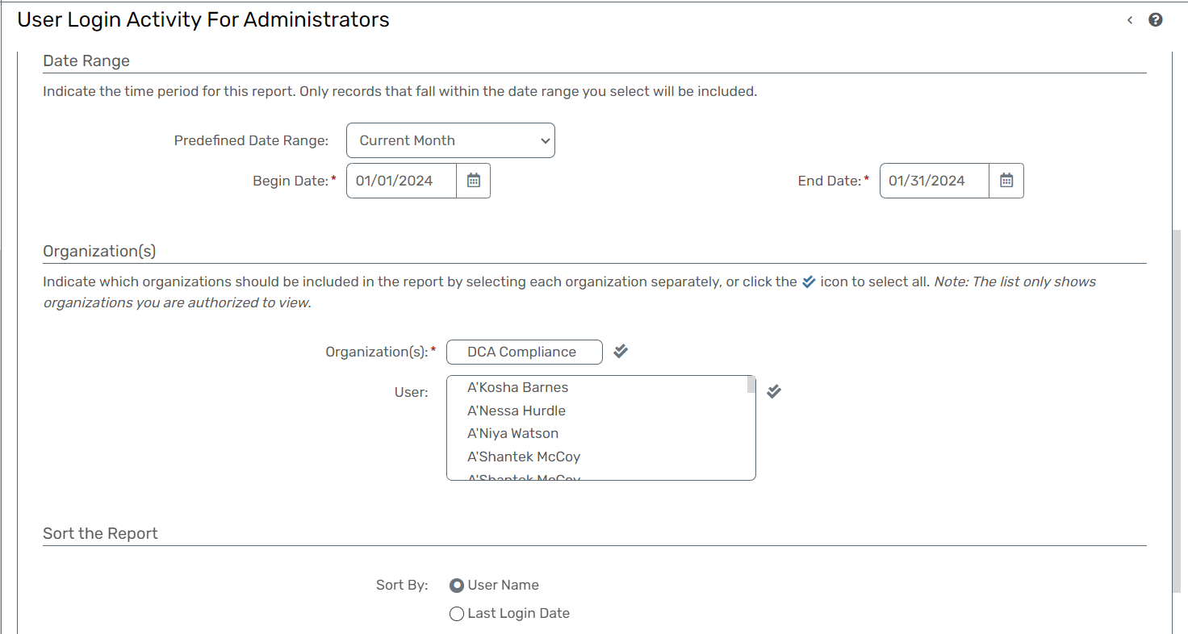

User Permissions
Report Description
- The "User Permissions" report is a comprehensive tool that provides a detailed overview of the permissions granted to individual users within the system.
- This report is crucial for administrators and system managers to monitor and manage user access levels, ensuring the appropriate distribution of permissions across different roles and responsibilities.
- The report displays a breakdown of permissions assigned to each user.
- This includes specific actions, tasks, or functionalities that a user is authorized to perform within the system.
- The report is designed to reflect permissions based on Role-Based Access Control (RBAC) principles.
- RBAC assigns permissions to roles, and users are then assigned to these roles.
- This structured approach streamlines permission management and ensures consistency.

Active Users and Last Login
Report Description
- The "Active Users and Last Login" report is a valuable tool for administrators and system managers to monitor user activity and assess the engagement of users within the system.
- This report provides key insights into the current status and login patterns of users, facilitating effective management of user accounts.
- For each active user, the report displays the date and time of their last login.
- This information is crucial for assessing user engagement and determining whether users are regularly accessing the system.
- The report may provide insights into login patterns, such as the frequency of logins for each user.
- Understanding how frequently users access the system helps administrators gauge user involvement and responsiveness.

Users and Workgroup Access
Report Description
- The "Users and Workgroup Access" report is a comprehensive tool designed to provide administrators and system managers with insights into how users are organized within workgroups and the corresponding access levels.
- This report offers valuable information about user roles, workgroup memberships, and the associated permissions.
- Users within workgroups often have specific access levels or permissions.
- The report details the access levels assigned to each user, indicating the actions and functionalities they can perform within the system.
- Users and workgroups are often organized within the context of larger organizational structures.
- The report may present this information to help administrators comprehend the hierarchical relationships between users and their respective workgroups.

Housing Inventory
Report Description
- The "Housing Inventory" report is a comprehensive tool designed to provide insights into the available housing resources within a specific context, such as a Continuum of Care (CoC) or a related program.
- This report is particularly valuable for organizations, agencies, and authorities involved in managing and coordinating housing services for individuals and families experiencing homelessness.
- The report indicates the occupancy status of each housing facility, highlighting whether the facility is currently at full capacity, has available beds, or is underutilized.
- This information assists in optimizing resource allocation.
- Housing programs often have specific details related to eligibility criteria, program duration, and support services offered.
- The report may include relevant program details to guide individuals or referring agencies in making informed decisions.
- The report may integrate with Coordinated Entry Systems (CES) to facilitate seamless referrals and placements.
- This integration streamlines the process of matching individuals or families with suitable housing options based on their needs and priorities.

Project and Grant Set-Up
Report Description
- The "Project and Grant Set-Up" report is a crucial component of the Housing Management Information System (HMIS) designed to provide comprehensive details about the setup of projects and grants within a Continuum of Care (CoC) or a similar organizational structure.
- This report is essential for administrators, program managers, and stakeholders involved in the planning, implementation, and oversight of housing projects and related grants.
- The report provides an overview of all housing projects established within the designated timeframe, CoC, or program.
- It includes details about the names, types, and objectives of the projects.
- Grants play a pivotal role in funding housing projects.
- The report includes information on the grants associated with each project, such as grant names, funding sources, and award amounts.
- Housing projects consist of different components or services, such as case management, counseling, or employment assistance.
- The report delineates the various program components associated with each project.

User Permissions, Active Users and Last Login, Users and Workgroup Access, Housing Inventory, Project and Grant Set-Up

- All the above reports will have to be retrieved by executing a query in ClientTrack.
- Following is a diagram as to what the end-users will see when running a custom report.
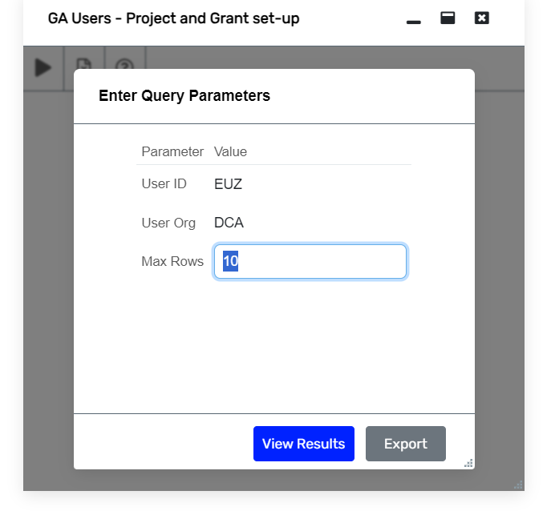

Current Bed and Unit Inventory
Report Description
- The "Current Bed and Unit Inventory" report is a critical component of the Housing Management Information System (HMIS) designed to provide up-to-date information on the availability and utilization of beds and housing units within a specified context, such as a Continuum of Care (CoC) or a similar organizational structure.
- This report is essential for administrators, shelter managers, and stakeholders involved in housing management and allocation.
- Beds and housing units may vary in type, such as emergency shelter beds, transitional housing units, or permanent supportive housing units.
- The report categorizes the inventory based on these types, offering insights into the diversity of available housing options.
- One of the primary functions of the report is to convey the current occupancy status of each bed or unit.
- This information includes details on occupied, available, reserved, or temporarily unavailable beds/units.
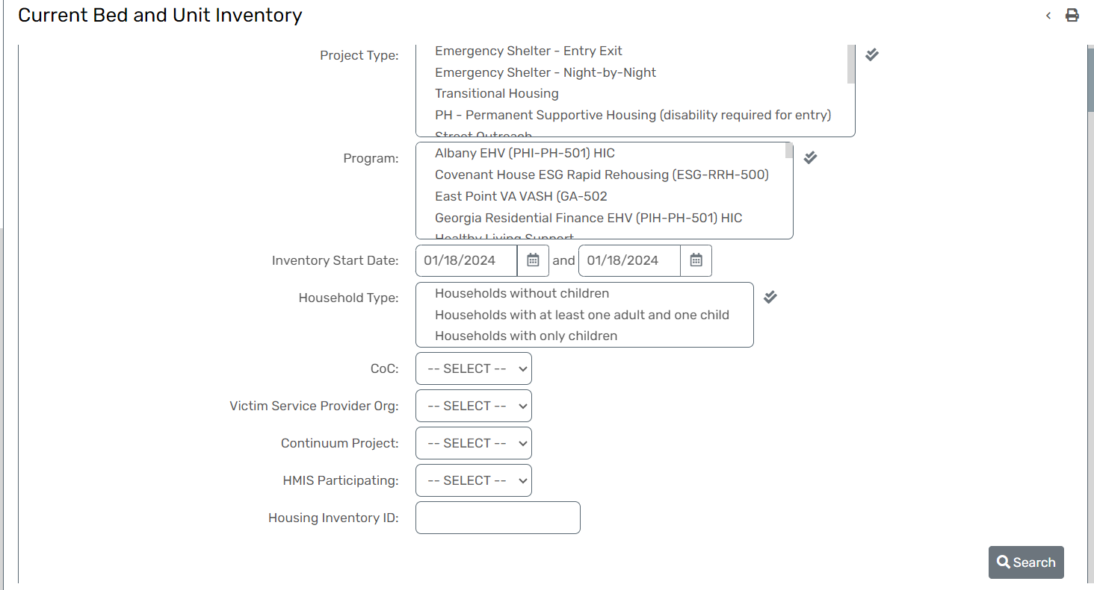

Reporting Glossary

Active Client Method- The Report Glossary method will run the report based on the Report Glossary definitions for Active Client. Selecting Entry/Exit Dates will only consider the client's project start and end dates.
Age Range- Enter a minimum and maximum age to restrict the report to a specified age range.
Anonymous- Select the Anonymous checkbox if you want the report to display the Client ID instead of the Client Name.
Bar Code Type- Choose which barcode the report will display Scan Card or Client ID.
Birth Date- Check this to see all clients who have the same birth date.
Case Manager(s)- Check the box to limit report results by selected Case Managers. You must be authorized to view the Case Managers by Organization.
Client Demographics- From the demographic information entered in the client record, enter the desired demographic options for further restricting the client list or leave them blank to show all.
Client Name- Select Client Name to filter by client name.

Client Type- Select Client type to filter by client type.
COC Filter- You may, optionally, identify a single CoC to filter the report results (HMIS implementations with only one CoC do not need to do so).Note: This filter only applies to the initial client universe.
If specified, this CoC must match either the client's enrollment head of household CoC or (if that is blank) then this location must match one of the CoC locations identified for the associated program.
Date By- Choose one for the indicated specified date range. Goal Begin Date: Goal End Date: Goal Target Date: Still Open:
Date Range- Indicates the time period for the report. Only records that fall within the date range you select will be included in the report.
Detail Export- Click the Run Export button to generate a separate task to generate the Detail Export. Indicate the SSN Masking to be used in the Detail Export.
Employment Classification- This list displays the available employment classification options. Select one or multiple employment status options. Leave this section "Unselected" to view all.
Exclude deleted records- Un-check this box to include deleted records.
Exit Codes- Select the Exit reason you would like the report to show a specific reason why the client was exited or leave blank to select all.
First Name- Check this to see all clients who have the same first name and check "First Name Sound Like" to see all clients who have similar first names.
First Name Initial- Check this to see all clients who have the same first name initial.
First Name Starts With- Select First Name Starts With to filter clients with the same letter.
First Time Served- Select an option to show only the clients that have been served for the first time by a particular organization, in the entire system, or choose “N/A” to view all repeat clients.
From Providers- Select “From Providers” or leave the field blank to run the report for all Providers.
Gender- Check this to see all clients of the same gender.
Goals- When a goal is created, the organization creating the goal is referenced on the goal record. For the range of goal dates as referenced above, select the specific goals that you choose to view based on the other selection criteria of organizations, program enrollments, and goals.
Grants-Check the box to limit report results by selected grants. When checked, the list displays grants that belong to the organizations you selected above. Indicate which grants should be included in the report by selecting each grant separately or clicking the icon to select all. Additionally, on this report, you can only filter by PATH grants.
Grant Program- Use the Grant Program and Grant Component drop-down selections to narrow down the list of Grants.
HMIS Participating- This term indicates involvement in the HMIS system and the commitment to contribute data and utilize HMIS functionalities for managing homelessness-related information.
Head of Household- This box allows the user to choose whether to see all clients or only the heads of household in the enrollment case.
Hide Client Name- Select the checkbox if you want the report to display the Client ID instead of the Client Name.
HOPWA Type- The HOPWA Type allows you to specify the type of HOPWA program you want the report to reflect. Please choose the appropriate HOPWA Type to ensure accurate reporting. If you have specific options or details related to HOPWA Types that users need to consider, you may want to include that information for clarity.
Household Type- You may filter the results by household composition, such as with and without children, with one or multiple adults.
Housing Status- You may filter the results by clients with specific housing statuses.
Inventory Start Date- When running a bed and inventory count report, you can filter when the bed/Inventory was initially available to assign clients to the said bed/inventory.

Last Name- Check this to see all clients who have the same last name and check "Last Name Sound Like" to see all clients who have similar last name.
Last Name Initial- Check this to see all clients who have the same last name initial.
Last Name Starts with- Select Last Name Starts With to filter clients with the same letter.
LSA Scope- Systemwide LSA - For submission to HUD. Designates that the report includes all relevant projects and project types for your submission. Project-Focused LSA - Designates that the report only includes a selected group of projects, and not for the submission to HUD.
Official- If generating a CE APR for an official HUD submission, users should select Official Submission. Checking this will use the client universe from the CE APR to look system-wide. Not Checking the Official Submission will allow users to run a CE APR based on the Organization and/or Project selected rather than a full system-wide report.
Organization(s)- Indicate which organizations should be included in the report by selecting each organization separately or click the icon to select all. Note: The list only shows organizations you are authorized to view.
Other Program Enrollment Criteria- Allows users to filter reports by Primary Program(s), Primary Enrollment, and Inclusion of Predefined Date Range and Other Enrollment Between.
PATH Grants- Check the box to limit report results by selected grants. When checked, the list displays PATH Grants that belong to the organizations you selected above. Indicate which PATH grants should be included in the report by selecting each PATH grant separately or clicking the icon to select all.
PATH Program(s)- Check the box to limit report results by selected PATH programs. When checked, the list displays PATH programs that belong to the organizations you selected above. Indicate which programs should be included in the report by selecting each program separately or click the icon to select all.
PII (Personal Identifying Information)- The value set here will control the data export parameters regardless of the parameters changed or updated in the report window.
Program(s)- Check the box to limit report results by selected programs. When checked, the list displays programs that belong to the organizations you selected above. Indicate which programs should be included in the report by selecting each program separately or click the icon to select all.
Program Enrollment Criteria- Allows users to filter reports by Primary Program(s), Primary Enrollment, and Inclusion of Predefined Date Range and Primary Enrollment Between.
Project- The list displays projects that belong to the organizations you selected. Indicate which projects should be included in the report by selecting each project type and/or project separately or click the icon to select all. Unchecking the HMIS Projects Only checkbox will allow the APR to be run on any project in the system. If running an APR for a non-HMIS project, please be aware that there may be missing information where information wasn’t collected.
Referral Recipient- Select the provider(s) for which referrals should appear.
Referral Service(s)- Select the specific services for the report.
Relation to the Household- Leave this section "unselected" if you choose not to restrict the report by relationship to the household.
Relationship Types- Check the box to only show Clients with a specific relationship to the Head of Household or click the icon to select all. For example, select Self to show Heads of Households.
Report Type- Select Active at any point to show clients who were in the project(s) at any time in the report range. Select Begin Enrollment to show clients with a project start date in the time frame. Select Exited to show clients with a project exit date in the time frame. Select Still Enrolled to show clients with open enrollments in the time frame.
Run Report By- Select Enroll to run the report filtered by program enroll date fall in the report date range. Select Exited to filter by the program exit date. Select Enroll at any time to show all the clients still in the program during the report date range.
Saved Report Setting- To use previously saved report settings, select the desired settings description. To save the current report settings, select Save Settings, type a description of the settings in the Save As field, select the report criteria, and run the report. The saved settings will appear in the list the next time you access this screen.
Schedule Detail Report- Select the checkbox and click the Schedule Detail Report button to schedule an export of all the data used for the PIT Report based on the filters selected. The data in this export is not filtered like the interactive report when clicking a particular number representing a category. The export is not broken up into sections as the interactive report is.
Service(s)- Select the specific services for the report or leave the field blank to run the report for all services. NOTE: The services in this list are filtered according to the organizations and funding sources selected above.
Sheltered Special Population & Veteran Determination- "The 'Sheltered Special Population and Veteran Determination' process involves filtering identifying and categorizing individuals within special populations, including veterans, who are accessing sheltered services or programs. This determination helps ensure targeted assistance and support for vulnerable groups within our community.
Source Type- Identify where the export is being generated from. This populates fields in the Export.csv. This is not a filter.
SSN- Check this to see all clients who have the same social security number.
State, County & Zip Code- Select clients' state(s), county(ies), and zip code(s) to limit the report area. If no options appear in the pick list, your local administrator may need to set them up for the Organization(s) selected above.
Status and Result- Select the Status or Result for the referral. Without selecting any Status or Result will select All Status and Result.
Sub-population- Select to show only clients that are part of that sub-population. Leave at SELECT to not apply this filter.
Unsheltered Count Criteria- The 'Unsheltered Count Criteria filters report by the specific guidelines and parameters used to identify individuals experiencing homelessness who are living in unsheltered conditions. This includes people residing on streets, in parks, vehicles, or other locations not designated for human habitation.
Use the Earliest Service- Select which service you wish to use to count an individual's age.
Users- Check the box to limit report results by selected users. When checked, the list displays users that belong to the organizations you selected above. Indicate which users should be included in the report by selecting each user separately or click the icon to select all.
Validation File- Checking this box will generate a separate task to generate a validation file once the file export task has been completed. This will not affect the running of or delay the main export. THIS MUST be selected to get details of numbers in the APR and the report used to review the export.
Victim Service Provider Org- When running a bed and inventory count, you can filter whether the org is a victim service provider org or not.
Zip- Check this to see all clients who have the same zip code.

Additional Support

For any inquiries or issues concerning reporting within ClientTrack, we kindly request that you submit a ticket directly through the ClientTrack system and notify your COC Administrator. This process ensures that your concerns are addressed promptly and efficiently by our team.

In the event of emergencies requiring immediate attention, please reach out via email to GAHMISSupport@dca.ga.gov. We are committed to providing timely assistance and support, especially during critical situations.

Your cooperation in following these protocols is greatly appreciated and contributes to the smooth operation of our services.

