**2018 ARCHITECTURAL MANUAL**

**APPENDIX III**

**AMENITIES GUIDE**

**TABLE OF CONTENTS**

**INTRODUCTION**

**ALL AMENITIES**

• General Guidelines

**REQUIRED AMENITIES**

• Community Room / Community Building

• Exterior Gathering Area

• On-site Laundry Facility and/or Washers/Dryers installed in each unit

• Interior Conditioned and Furnished Gathering Areas (for multi-story senior tenancy projects)

**ADDITIONAL AMENITIES SELECTIONS**

• Fenced Community Garden

• Equipped Walking Path

• Equipped Playground

• Covered Pavilion with Picnic/barbecue Facilities

• Furnished Arts & Craft /Activity Center

• Equipped Computer Center

• Furnished Exercise / Fitness Center

• Wellness Center

**INTRODUCTION:**

This guidebook is an outline of minimum standards for site amenities required by the Low Income Housing Tax Credit (LIHTC) and HOME funding programs and establishes a baseline for the quality of construction and financial investment in amenities. More requirements for unit amenities may be found in the Architectural Manual.

**ALL AMENITIES:**

New construction and rehabilitation property amenities must meet accessibility requirements outlined in the DCA Accessibility Manual. For tenant safety and security, exterior amenities should be within view of at least one apartment building. Amenity lighting should be sufficient for its purpose (i.e. evening mail collection, etc.), and be directed down to diminish nuisance light. Rules posted at all amenities must be in accordance with the Federal Fair Housing Amendments Act. Amenities should be usable beyond leasing office hours and on weekends.

Qualified substitutions may be submitted for approval prior to Application submission; equivalency standards will be applied to amenity substitutions.

**REQUIRED AMENITIES**

**Community Room / Community Building**

The community gathering room/building should provide a space for tenants to gather for lounging, special events, meetings, parties, classes, and workshops. The space should comfortably accommodate the tenants in the community and be designed to meet Minimum State Code requirements for occupant load and means of egress. Signage, as required by *UFAS*, shall be provided.

Furnishing must include, but are not limited to:

• Seating Area

• Coffee Table

• Task Lighting

**\*\*NO FOLDING FURNITURE ALLOWED\*\***

Suggested furnishings include:

• Television

• Sound System

• Musical Instruments

• Game / Card Table

Additional Requirements:

Kitchen and bath facilities intended for tenant use must be accessible. See the DCA Accessibility Manual for further guidance.

**Exterior Gathering Area**

The exterior gathering area shall provide proper shelter from the elements and be reserved exclusively for the social interaction of the tenants and their guests.

Additional Requirements:

• The gathering area must be covered by a roof;

• Porches may not be used for other purposes, such as a driveway or parking space;

• Examples of exterior areas that do not meet the requirements of this amenity:

* Porte-cocheres
* Carports
* Small awnings that can shelter only one person
* Pergolas

• The exterior gathering area structure must be permanently attached/anchored to a concrete foundation/slab.

**On-site Laundry Facility and/or Washers / Dryers installed in each unit**

All communities must provide washer/dryer facilities and equipment on site and washer and dryer hookups in each unit. An onsite laundry is not required if washers and dryers are installed in units and maintained at no additional cost to tenants. Laundry facilities shall be large enough to accommodate the required number of washers and dryers. Laundry facilities must be accessible. See the DCA Accessibility manual for further guidance.

Signage and Equipment:

• Post signage that addresses machine operation, safety guidelines, and hours of operation.

• There shall be one washer and one dryer per every 25 units.

• All washers in mobility units and community laundry facilities must be front loading. All washers must be Energy Star rated.

Additional Requirements:

• Free-standing laundry buildings must be within a reasonable walking distance of the residential units.

• The facility must be accessible to the disabled. Each laundry facility must include at least one accessible washer and dryer placed in required clear floor spaces.

• Access must be provided to this area "beyond" leasing office business hours.

• Laundry facilities, including those within units, must be vented to the exterior, controlling humidity levels to prevent the growth of bacteria, mold, mildew, and dust mite infestations.

**Interior Conditioned and Furnished Gathering Areas (for multi-story Senior tenancy projects)**

Interior conditioned and furnished gathering areas should be located throughout the complex including but not limited to areas near elevators. A minimum of one (1) interior conditioned and furnished gathering area per floor shall be provided in addition to the required gathering area at each lobby. These areas provide a space for rest as well as small gathering spaces for conversation. 24 hour access must be provided to these areas.

Minimum Equipment:

• Table, chairs/sofa, task lighting

**\*\*NO FOLDING FURNITURE ALLOWED\*\***

**ADDITIONAL AMENITIES**

**Fenced Community Garden**

A fenced community garden will provide a minimum planting area of 200 square feet. Community gardens, which for various reasons are not used, must be kept. Community gardens that are allowed to deteriorate through management neglect will not be tolerated.

Signage and Equipment**:**

• Post rules and safety guidelines at garden entrance.

• Provide a water source within the fenced area of the community garden located near the entrance or to one side of the planting area. The water source should take into consideration best practices for water conservation. Rain barrels may be used, but not as the primary source of water.

Additional Requirements:

• The soil must be properly prepared for planting.

• Gardens shall be surrounded on all sides with a minimum 4’ high fence of weatherproof construction to discourage small children and animals from entering the garden. If pressurized wood is used for fencing or raised-beds, ensure the manufacturer verifies that it is safe to grow edible plants in soil surrounded by their wood product.

• The effects of all contaminants discovered in the Phase I Environmental Assessment must be considered before choosing to build the garden.

• A portion of these plots must be accessible to those with mobility impairments. The route to the fenced community garden, garden water source and to the accessible planting area or areas must be paved and meet all accessibility requirements for an accessible route. Accessible planting areas must have accessible reach ranges from the accessible route.

**Equipped walking path with exercise stations or sitting areas**

The walking path should be a minimum of 500 feet long and 5 feet wide and provide a safe and accessible path for fitness and leisure. Rules and safety guidelines should be posted along entry points to the path.

• Walking surface should provide proper firmness, stability, and slip resistance. Asphalt paving, crushed stone or fines, packed soil, and other natural materials can provide surfaces that are firm and stable and accessible. A surface stabilizer may be needed to create a firm and stable surface. Concrete paths shall have a brushed finish.

• Base material should be laid over a geo-textile fabric to prevent vegetation growth and compacted with the correct moisture content, similar to the preparation of a roadbed.

• Walking paths must be separate from the sidewalks that access parking and buildings and must not disturb more than 1/10th of an acre of wetland.

Equipment (either benches or fitness stations):

Benches:

• Benches must have backrests and an armrest at one end of the bench for use by the elderly and disabled.

• A fully accessible clear floor space measuring 30”x48” minimum shall be provided at one end of each bench.

• Benches must be secured to the ground or walking path and protected against ground subsidence.

• Benches shall be made of a weatherproof material.

• There must be at least one bench for every 100 feet of walking path.

Fitness Stations:

• Provide one piece of equipment per every 100 feet of walking trail.

• All strength, cardiovascular, flexibility, or balance/coordination equipment must be intended for outdoor use and made of a durable and weatherproof material (see [http://www.triactiveamerica.com/).](http://www.triactiveamerica.com/))

**Equipped Playground**

The design of the playground should provide a safe, accessible play area for children of different ages and shall be designed following the guidelines set forth in Publication Number 325, the U.S. Consumer Product Safety Commission’s (CPSC) Handbook for Public Playground Safety. <https://www.cpsc.gov/s3fs-public/325.pdf>

Signage and Equipment:

• Post rules and safety guidelines that include guidance as to the age appropriateness of the equipment.

• Provide three or more separate pieces of equipment.

• A minimum of one bench for adult supervision is required. An accessible route is required within the playground area from the accessible entrance to the bench. An accessible space next to the bench is also required.

Additional Requirements:

• In playgrounds intended to serve children of all ages, the layout of pathways and the landscaping of the playground should show the distinct areas for the different age groups.

* Groundcover must be provided as specified in Publication Number 325, the U.S. Consumer Product Safety Commission’s (CPSC) Handbook for Public Playground Safety.

• Equipment intended for younger children (ages 2 -5) must be separated at least by a buffer zone, which may be an area with shrubs or benches. Short fencing is preferable.

• A portion of the playground equipment must be accessible to those with mobility impairments. The route to the playground must be paved and meet all accessibility requirements for an accessible route. See the DCA Accessibility Manual for further guidance.

* Access must be provided to this area "beyond" leasing office business hours.

**Covered Pavilion with picnic/barbecue facilities**

The pavilion encourages residents to hold community or family reunion type functions. The shelter should be a permanent structure made of weatherproof material and be permanently attached to a concrete foundation/slab.

Signage and Equipment:

• Post rules and safety guidelines for grill use.

• One picnic table for "every 25 units". At least one picnic table shall have an extension that allows clear knee space for handicap access. Picnic table shall have permanent anchorage to the ground.

• One permanent barbeque grill (gas or charcoal) for every 50 units. At least one grill shall be accessible an accessible path and have permanent anchorage to the ground.

• The pavilion area shall have a durable surface with defined edges such as concrete.

**Furnished Arts & Craft /Activity Center**

The activity center will provide either children or seniors, as appropriate to tenant base, an indoor gathering space for games and craft activities. 200 square feet is the minimum room size.

Signage & Equipment:

• Handicap accessible sink

• Storage for games

• Work tables and seating.

• TV with capability to broadcast instructional videos

• One corkboard or dry-erase board

Additional Requirements:

• Access must be provided to this area "beyond" leasing office business hours.

**\*\*NO FOLDING FURNITURE ALLOWED AS PRIMARY FURNITURE\*\***

**Equipped Computer Center**

The computer center, of at least 150 square feet, should provide tenants high-speed access for educational or leisurely web-surfing as well as basic software applications to help facilitate personal, educational and career development.

Signage and Equipment:

• Post rules and guidelines for computer use.

• Computer desk or desk area; folding tables are not allowed

• Seating: chairs specifically designed for computer use

• One computer for every 25 units

• One printer at a minimum

• One fax machine, at a minimum

• High speed internet access

• Basic word processing and spreadsheet software

Additional Requirements:

• Appropriate controls to restrict internet surfing must be installed.

• Access must be provided to this area "beyond" leasing office business hours.

**Furnished Exercise / Fitness Center**

The exercise/fitness center, of at least 200 square feet, should provide tenants with access to equipment that will improve the fitness and well-being of residents.

Signage and Equipment:

• Post rules for operating each piece of equipment in addition to general exercise and safety guidelines.

• Provide at least one piece of equipment per 25 units.

• One wall must have mirrors covering 70% of the wall area.

Additional Requirements:

• Access must be provided to this area beyond leasing office business hours.

Additional Recommendations:

• A balance of cardio-vascular and strength equipment is optimal.

• A mix of free weights is recommended.

• A small library with information on exercise, nutrition, and exercise videos is recommended.

**Wellness Center**

A wellness center, of at least 150 square feet, will provide tenants with onsite access to professional medical screenings and health education.

Equipment:

• Prep sink

• Exam Table

• Task Lighting

• Library with wellness information appropriate to tenancy

Additional Recommendations:

• A separate private restroom adjacent to the exam room is highly recommended.

**AMENITIES GUIDEBOOK PHOTOS**

This appendix to the Amenities Guidebook provides pictures of Georgia Department of Community Affairs projects representing good and bad examples of site amenities listed in the Guidebook. Refer to the Guidebook for detailed requirements and specifications for these amenities.

**REQUIRED AMENITIES**

**Community Building/Room**

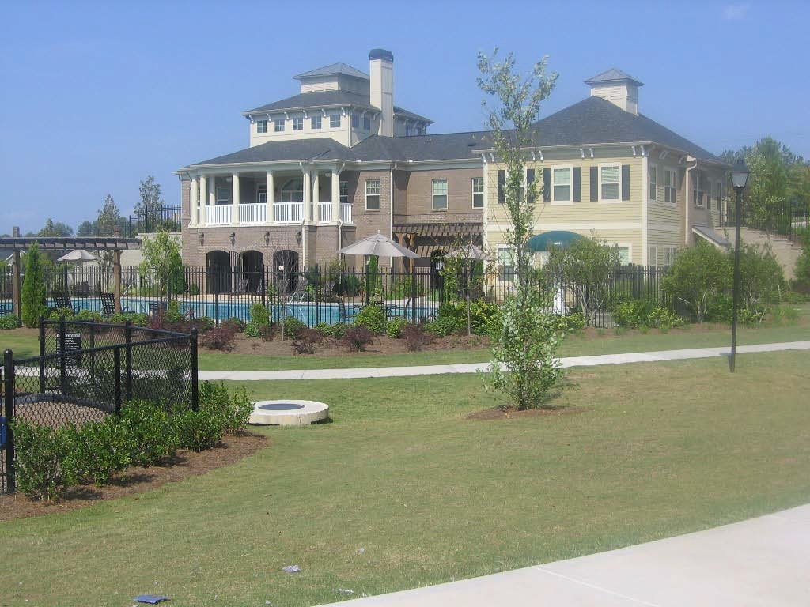

Acceptable Community Building Exterior

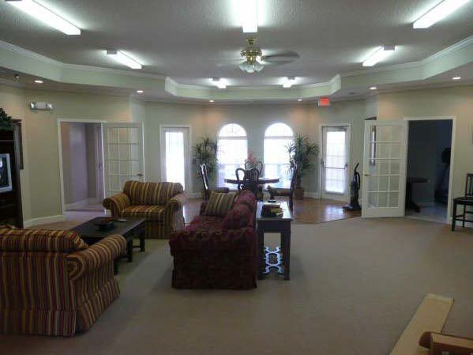

Acceptable Community Room Interior

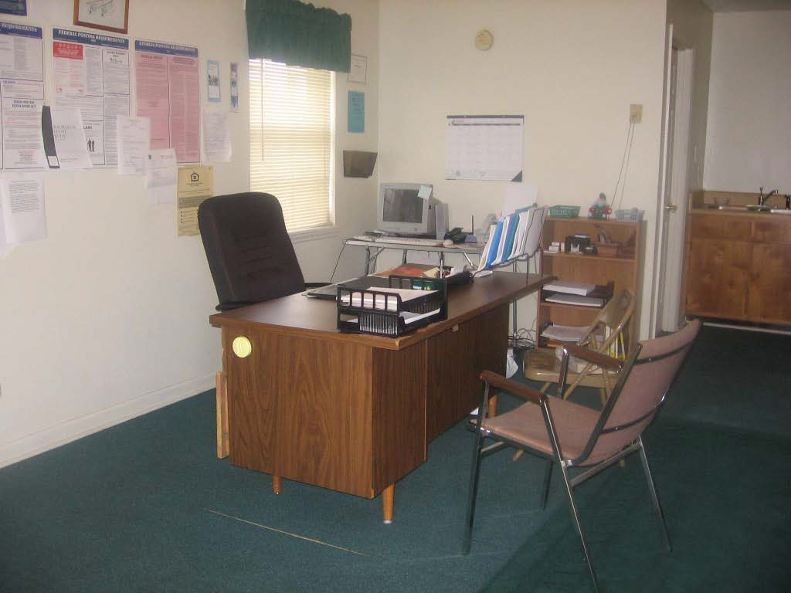

Not Acceptable Community Room Interior

The property manager’s office must be separate from the community room.

**Exterior Gathering Area**

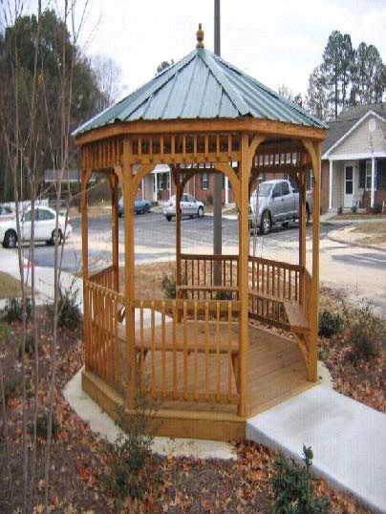

Acceptable

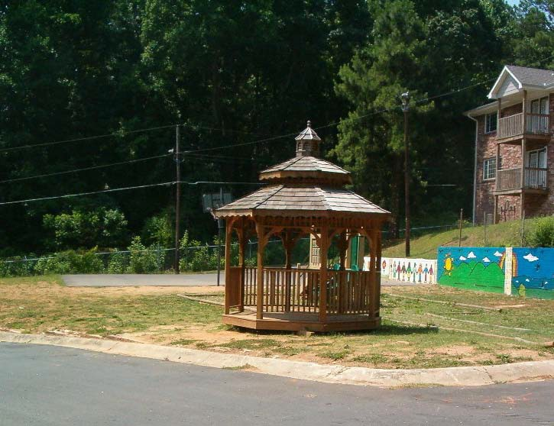

Not Acceptable

The gazebo is not permanently set, has no landscaping, and no accessible path.

**On-site Laundry Facility or Washers/Dryers installed in each unit**

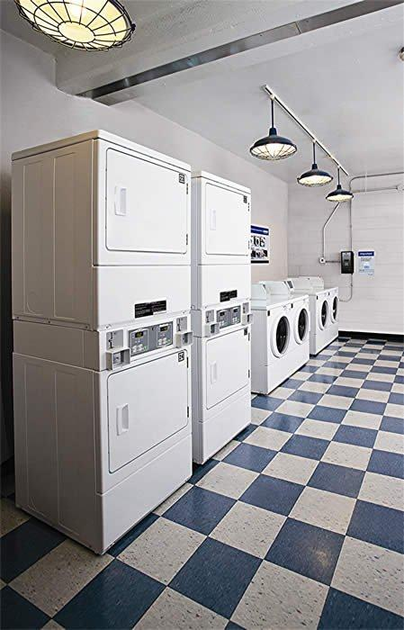

Acceptable

Note the front loading machine at right.

**Interior Furnished Gathering Areas (Senior Only)**

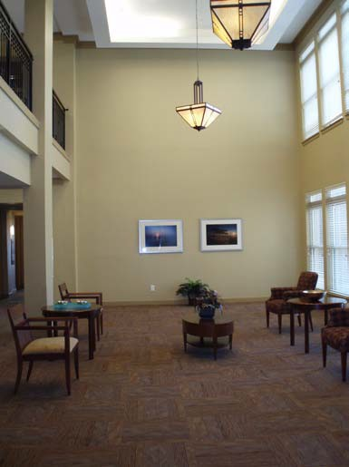

Acceptable

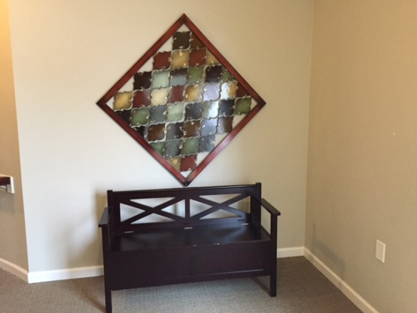

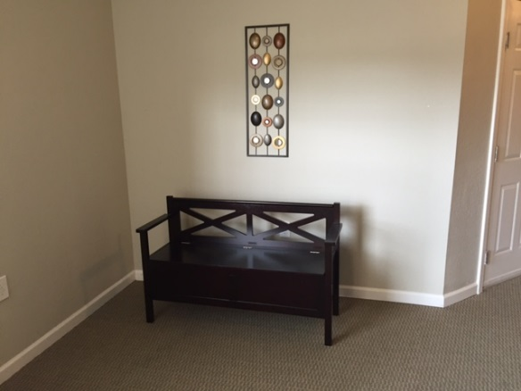

Not Acceptable

(No table or task lighting)

**OPTIONAL AMENITIES**

**Attractively Fenced Community Garden**

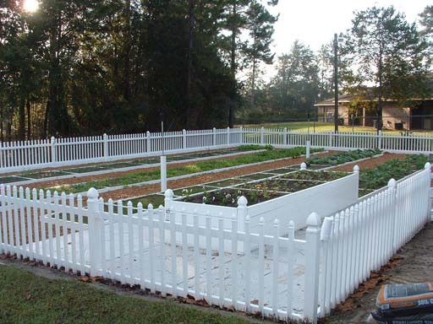

Acceptable

The garden beds are elevated to an accessible height, each plot has a water source, and the plots are on an accessible path.

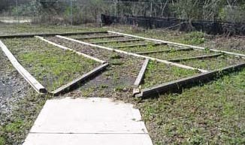

Not Acceptable

No fence; overgrown with weeds.

**Equipped Playground**

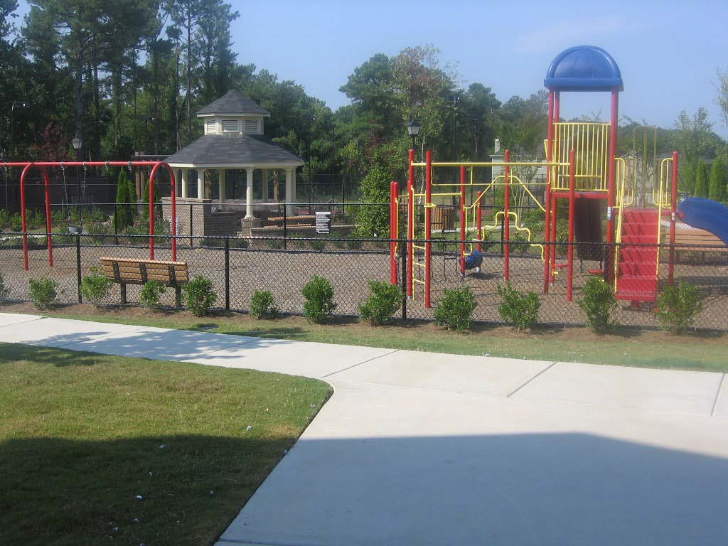

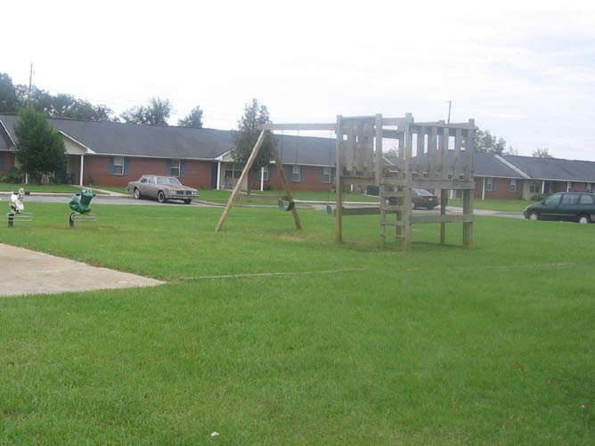Acceptable

Not Acceptable

Equipment does not appear to be constructed in compliance with CPSC guidelines for materials, ladder handrails, or ground cover.

**Covered pavilion with picnic/barbecue facilities**

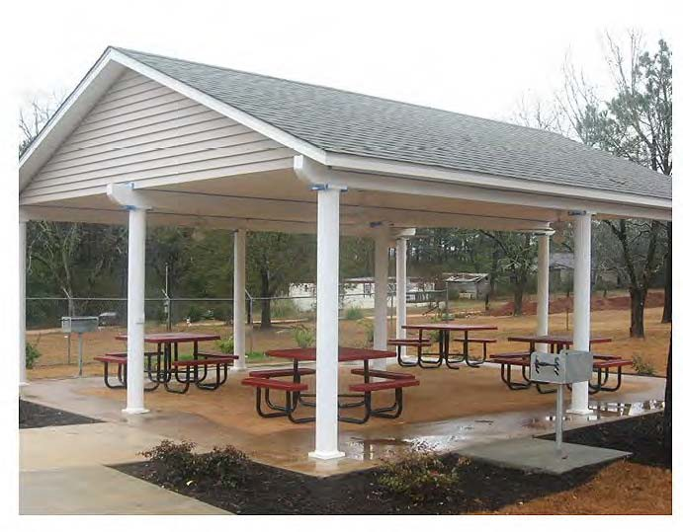

Acceptable

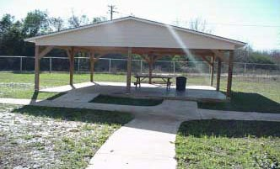

Not acceptable

The pavilion structure is borderline permanent, weatherproof structure. There are no grills, there are not enough picnic tables, and the absence of landscaping makes the pavilion appear uninviting.

**Furnished Children’s Activity/Seniors Craft Center**

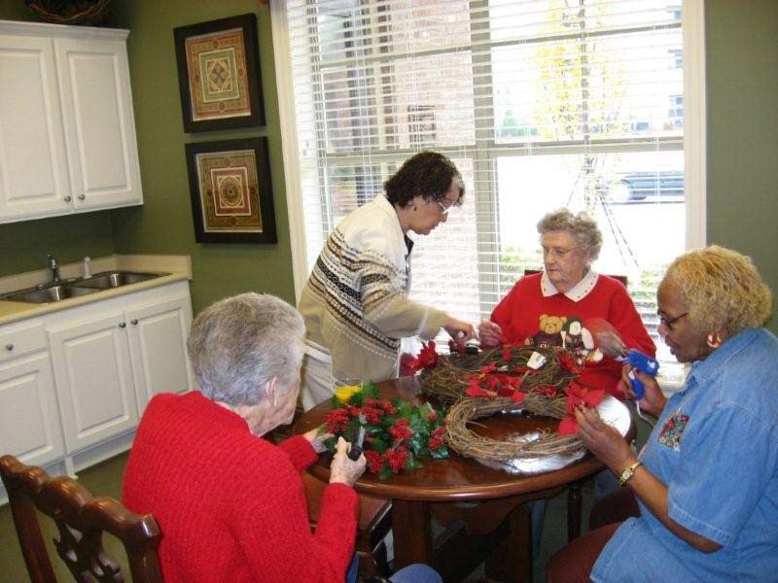

Acceptable



Not Acceptable

(Folding Furniture)

**Computer Center**

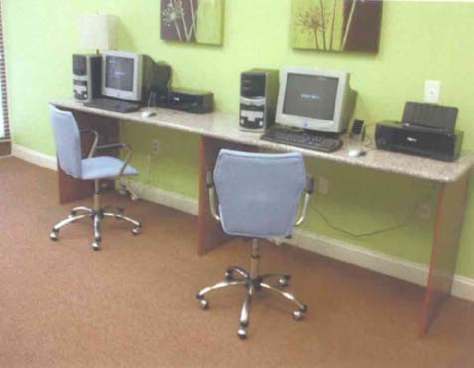

Acceptable

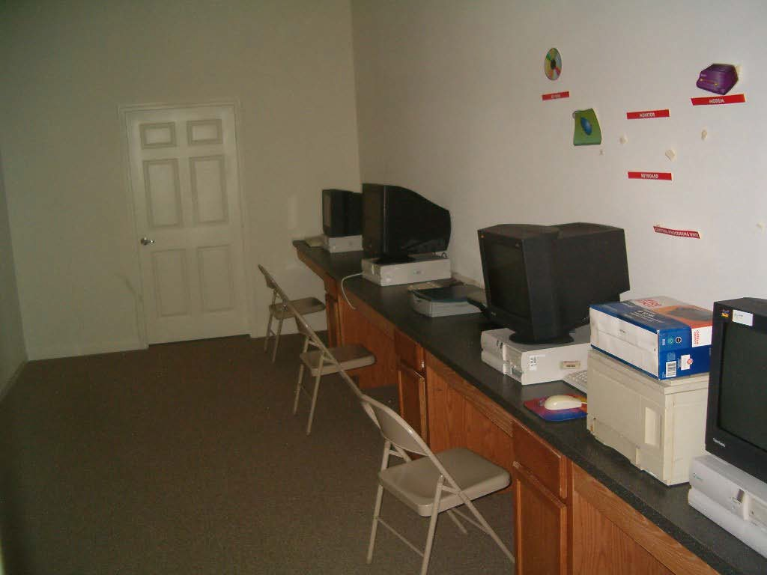

Not acceptable

Folding chairs are not acceptable. Equipment should be new; the condition of this equipment is questionable.

**Furnished Exercise / Fitness Center**

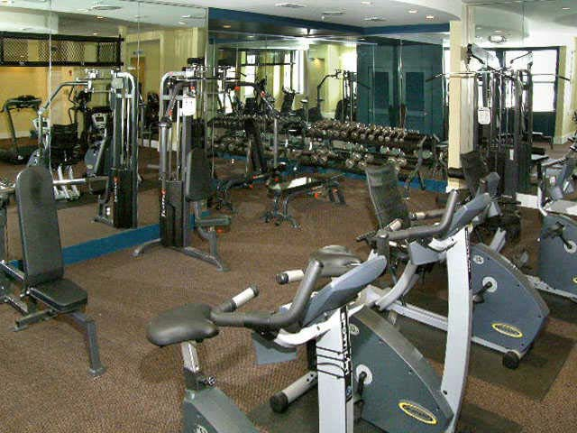

Acceptable

There is a variety of commercial grade equipment, cardiovascular equipment rests on slip-resistant mats, and the room is mirrored.

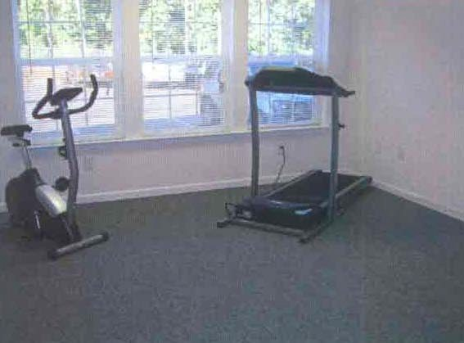

Not Acceptable

Equipment is used and not commercial grade.

There is not enough equipment for the size of the complex.

**Wellness Center**

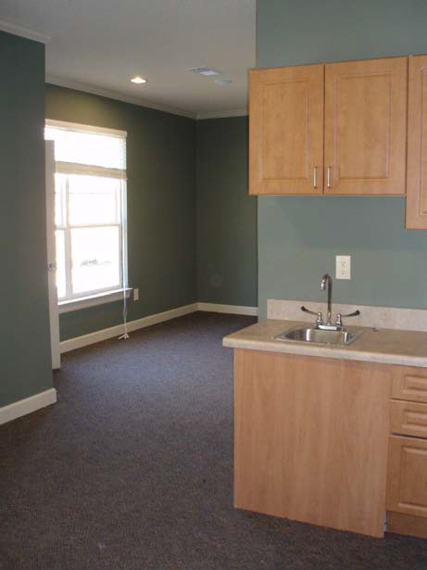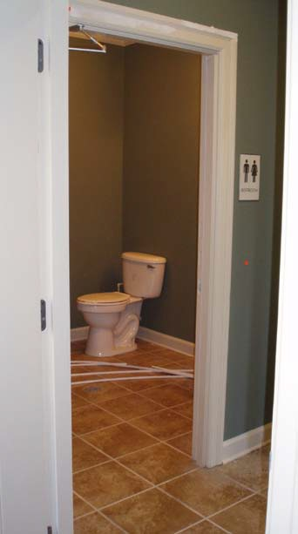

Almost Acceptable

This Wellness Suite includes a prep sink, and exam area, a library waiting area and a bathroom that services the suite. The suite requires an exam table and furnished library with health literature to be acceptable.