SUMMARY OF PROPOSED NATIONAL REGISTER/GEORGIA REGISTER NOMINATION

Name: New Ford Baptist Church and Cemetery

Location: 402 Bradford Road, Danburg Community (Tignall Vicinity), Wilkes County GA, 30668

Description: New Ford Baptist Church and Cemetery is a one-story, double tower church. Typical of double tower churches, the building has two towers topped with pyramidal roofs that project in front of a main gable roof. The towers extend past a lower shed roof and the central double-door entrance. There are air vents which are seen on three sides of each tower with another air vent in the center of the front portion of the gable roof. Below the towers of the front elevation are two windows. There are several steps leading up to the front entrance which also have metal handrails. The building sits on stone piers which have been pinned in with brick and mortar. Sitting next to the front entrance is the Cornerstone of the church indicating its church history. Three large windows are on both the side elevations of the building, and the church building is covered with vinyl siding. Two additions, joined by a shed roof, spans the entire length of the rear elevation. The addition has two doors topped with awnings and accessed from concrete handicap ramps with metal handrails. The cemetery surrounds the church building on the north, east and south sides of the property. Since the church sits on a slightly elevated granite mound, the north and south sides of the cemetery slope slightly downward, while the east side of the cemetery has a deep sloping hill.

Acreage & Boundary Explanation: 9.98 acres. The National Register boundary is comprised of the historic and legal property boundary.

Period of Significance: 1832-1975

NR Criterion & Area of Significance: Criterion A: Black Ethnic Heritage, Social History

Statement of Significance: New Ford Baptist Church and Cemetery is significant at the local level under Criterion A in the areas of Black Ethnic Heritage and Social History for its association with a historic Black congregation, consisting of the formerly enslaved members of the same church, which purchased the church from its original white owners. New Ford functioned as a rural Georgia church that served as an important center for the area’s Black community who worshipped and were buried at the property during the historic period. The church and the cemetery together represent a wide spectrum of Black history and the lifeways of the historic Black community in the area. The church and cemetery retains sufficient integrity to be clearly recognizable for its historic association with its Black congregation.

Suggested Level of Significance: Local
N

Sponsor: The nomination is sponsored by and had nomination materials prepared by Edward and Kathryn Anderson
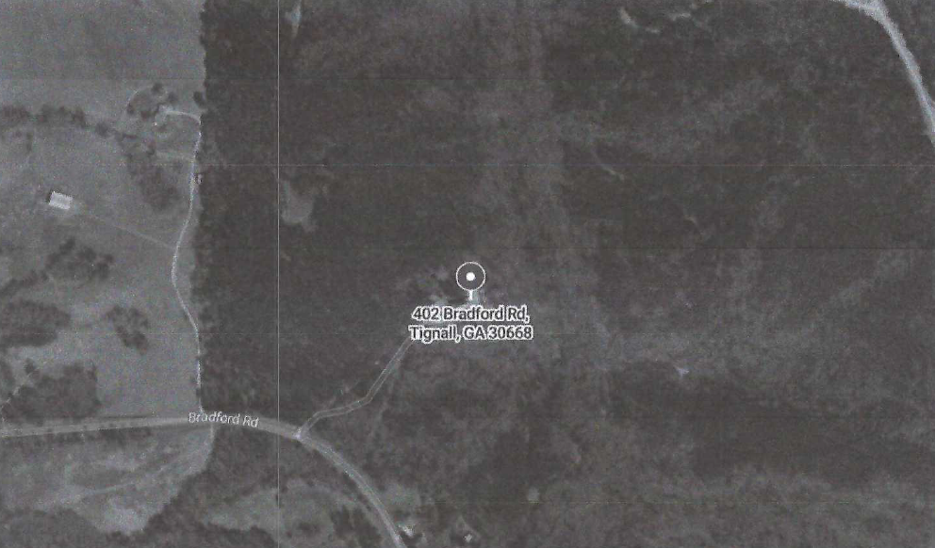


N
N
N
N
N
N

